Questions – Lipids
Section A: Multiple Choice Questions
1. Which of the following is a characteristic of lipids?
(A) They are not soluble in water
(B) They are either fats or oils
(C) They are polar molecules
(D) They are composed of nitrogenous chains

2. What are the components of triglyceride molecule?
(A) One glycerol and three fatty acids
(B) One glycerol and two fatty acids
(C) One cholesterol and two fatty acids
(D) One glycerol and one cholesterol

3. How are triglycerides formed?
(A) Triglycerides are formed through hydrolysis, which results in the loss of H₂O molecules.
(B) Triglycerides are formed through dehydration synthesis, which results in the addition of H₂O molecules
(C) Triglycerides are formed through dehydration synthesis, which results in the loss of H₂O molecules
(D) Triglycerides are formed through hydrolysis, which results in the production of H₂O molecules

4. Both vegetable oil and butter are made up of fats. Why is butter a solid at room temperature, while vegetable oil is a liquid?
(A) Butter is an unsaturated fat and vegetable oil is a saturated fat
(B) Butter is a nonpolar molecule and vegetable oil is a polar molecule
(C) Butter is a saturated fat and vegetable oil is an unsaturated fat
(D) Butter is a polar molecule and vegetable oil is a nonpolar molecule

5. Which of the following occurs when hydrogen is reacted with vegetable oil?
(A) The hydrogenated vegetable oil will contain fewer trans fats.
(B) The hydrogenated vegetable oil will become solid at room temperature.
(C) The hydrogenated vegetable oil will become polarized.
(D) The hydrogenated vegetable oil will become a saturated fat.

6. The image below shows a molecule of Octanoic Acid. Which type of molecule is it?
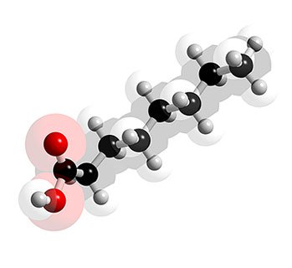
(A) An alcohol
(B) An unsaturated fatty acid
(C) A saturated fatty acid
The molecule only exhibits single bonds between carbons (C-C)

(7) In an aqueous environment, phospholipids will form which of the following?
(A) micelles
(B) liposomes
(C) bilayers
(D) all of the above
(E) only a & c
All 3 can form, depending on concentration. They form spontaneously, based on hydrophobic-hydrophilic interactions.

(8) This is a molecule of Linoleic acid. Which statement best describes it?
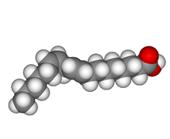
(A) It is an unsaturated fatty acid.
(B) It is a saturated fatty acid.
(C) It is a triglyceride fat.
(D) It is a sterol.
The carboxyl group at one end (red) and the bent shape of the molecule, indicating a double or triple Carbon bond, make this an unsaturated fatty acid.

9. The first cells likely developed from spontaneous associations of phospholipids, called....?
(A) liposomes
(B) micelles
(C) macrophages
(D) lipoproteins
(E) microlipids
Liposomes are hollow spheres; capturing the right chemical mix plus a little DNA or RNA gives you a primitive cell.

10. The breakdown of lipids involves the breaking of a bond using water. This is a process called...?
(A) hydration
(B) dehydration
(C) hydrophobia
(D) hydrophilia
(E) hydrolysis
The breaking (lysis) of a molecule using water (hydro) is hydrolysis.

11. Which of the following functional groups would be found in typical lipids?
(A) Carboxyl -COOH (O=C-O-H)
(B) Hydroxyl -OH
(C) Carbonyl -C=O
(D) All of these are possible
Fatty acids have carboxyl groups; glycerol has hydroxyl groups; triglycerides form by reacting these two, and a carbonyl group remains

12. Which of these is NOT a typical role for lipids in a living organism?
(A) provide stored energy reserves
(B) form a structural component of cell membranes & many tissues
(C) a source of glucose, when broken down
(D) a material from which hormones can be produced
(E) protection of internal organs, insulation beneath skin
Vertebrates store lipids for future nutritional energy, and even as insulation & protection of internal organs. Lipids make up all eukaryotic cell membranes. Steroid hormones are of lipid origin. Only starches produce glucose when digested.

13. All plant lipids are liquids, or oils.
(A) True
(B) False
Many plant lipids are solids, i.e. cocoa butter.

14. Which of these statements best describes these molecules?
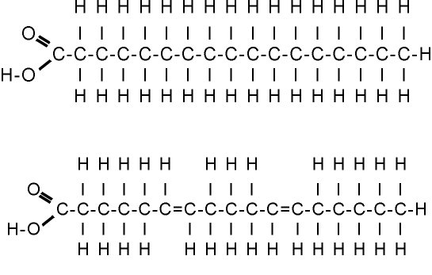
(A) They are both fatty acids.
(B) They are both saturated fatty acids.
(C) The top one is an unsaturated fatty acid; the lower one is saturated.
(D) The top one is a saturated fatty acid; the lower one is polyunsaturated.
(E) They are both unsaturated fatty acids.
Only the lower molecule shows any double bonds; it is unsaturated - specifically, because it has two C=C double bonds, it is a polyunsaturated fat.

15. Which of the following best describes the formation of lipids?
(A) isomerization
(B) polymerization
(C) dehydration synthesis
(D) ammonification

16. The basic backbone of most fat or oil molecules is an alcohol called....
(A) glycerol
(B) glycerin
(C) glyceric acid
(D) glycogen
Glycerol is a very simple 3 carbon molecule. Each carbon carries a hydroxyl functional group. (OH)

17. Which of the following common materials behaves as an amphoteric molecule?
(A) olive oil
(B) detergent
(C) lard
Detergent molecules are amphoteric.

18. Which of the following would be true of this molecule?
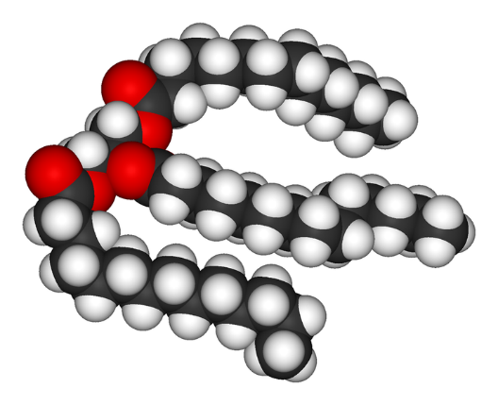
(A) it is a triglyceride fat

(B) It is most likely liquid at room temperature

(C) It is most likely a solid at room temperature

(D) only a & b

(E) only a & c
This is clearly a triglyceride: Glycerol bonded to 3 fatty acids. The second and third fatty acids have bent chains, indicating that they're unsaturated fatty acids. Hence this is more likely to be an oil than a solid fat.
19. Examine the diagram below, showing a phospholipid. The areas labelled A, B, C, D are (in order...)...
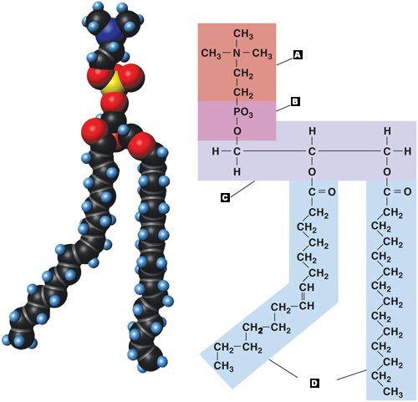
(A) protein, phosphate, carbohydrate, lipid

(B) phosphate, glycerol, carbohydrate, fatty acids

(C) Amino acid residue, phosphate group, glycerol, fatty acids

(D) fatty acids, phosphate, carbohydrate, hydrocarbon

(E) Amino acid residue, fatty acid, glycerol, phosphate

20. Examine the image of a phospholipid, below. Note that some areas are labelled hydrophobic, and others are hydrophilic. What is the term we use for molecules, like this one, that have both properties?
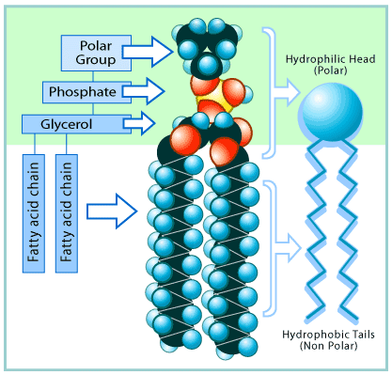

(A) hydrogenous
(B) ambivalent
(C) amphoteric
(D) ambidextrous
(E) antipasto

21. Which of these statements best describes the composition of Lipids?
(A) C, H, O in a 1:2:1 Ratio
(B) C, H, O, N, P all present
(C) C, H, O in no specific ratio
(D) C, H, O, S
Lipids have a very similar chemical composition to the carbohydrates, but generally lower O content.

22. The main role of phospholipids in living cells is to...
(A) store energy for future nutritional leads
(B) make the cell wall in plant cells
(C) make insect exoskeletons
(D) form cell membranes in all eukaryotic cells
(E) form the basis of many hormones
Phospholipids arranged in a bilayer are the basis of all cell membranes.

23. Which molecule is shown below?
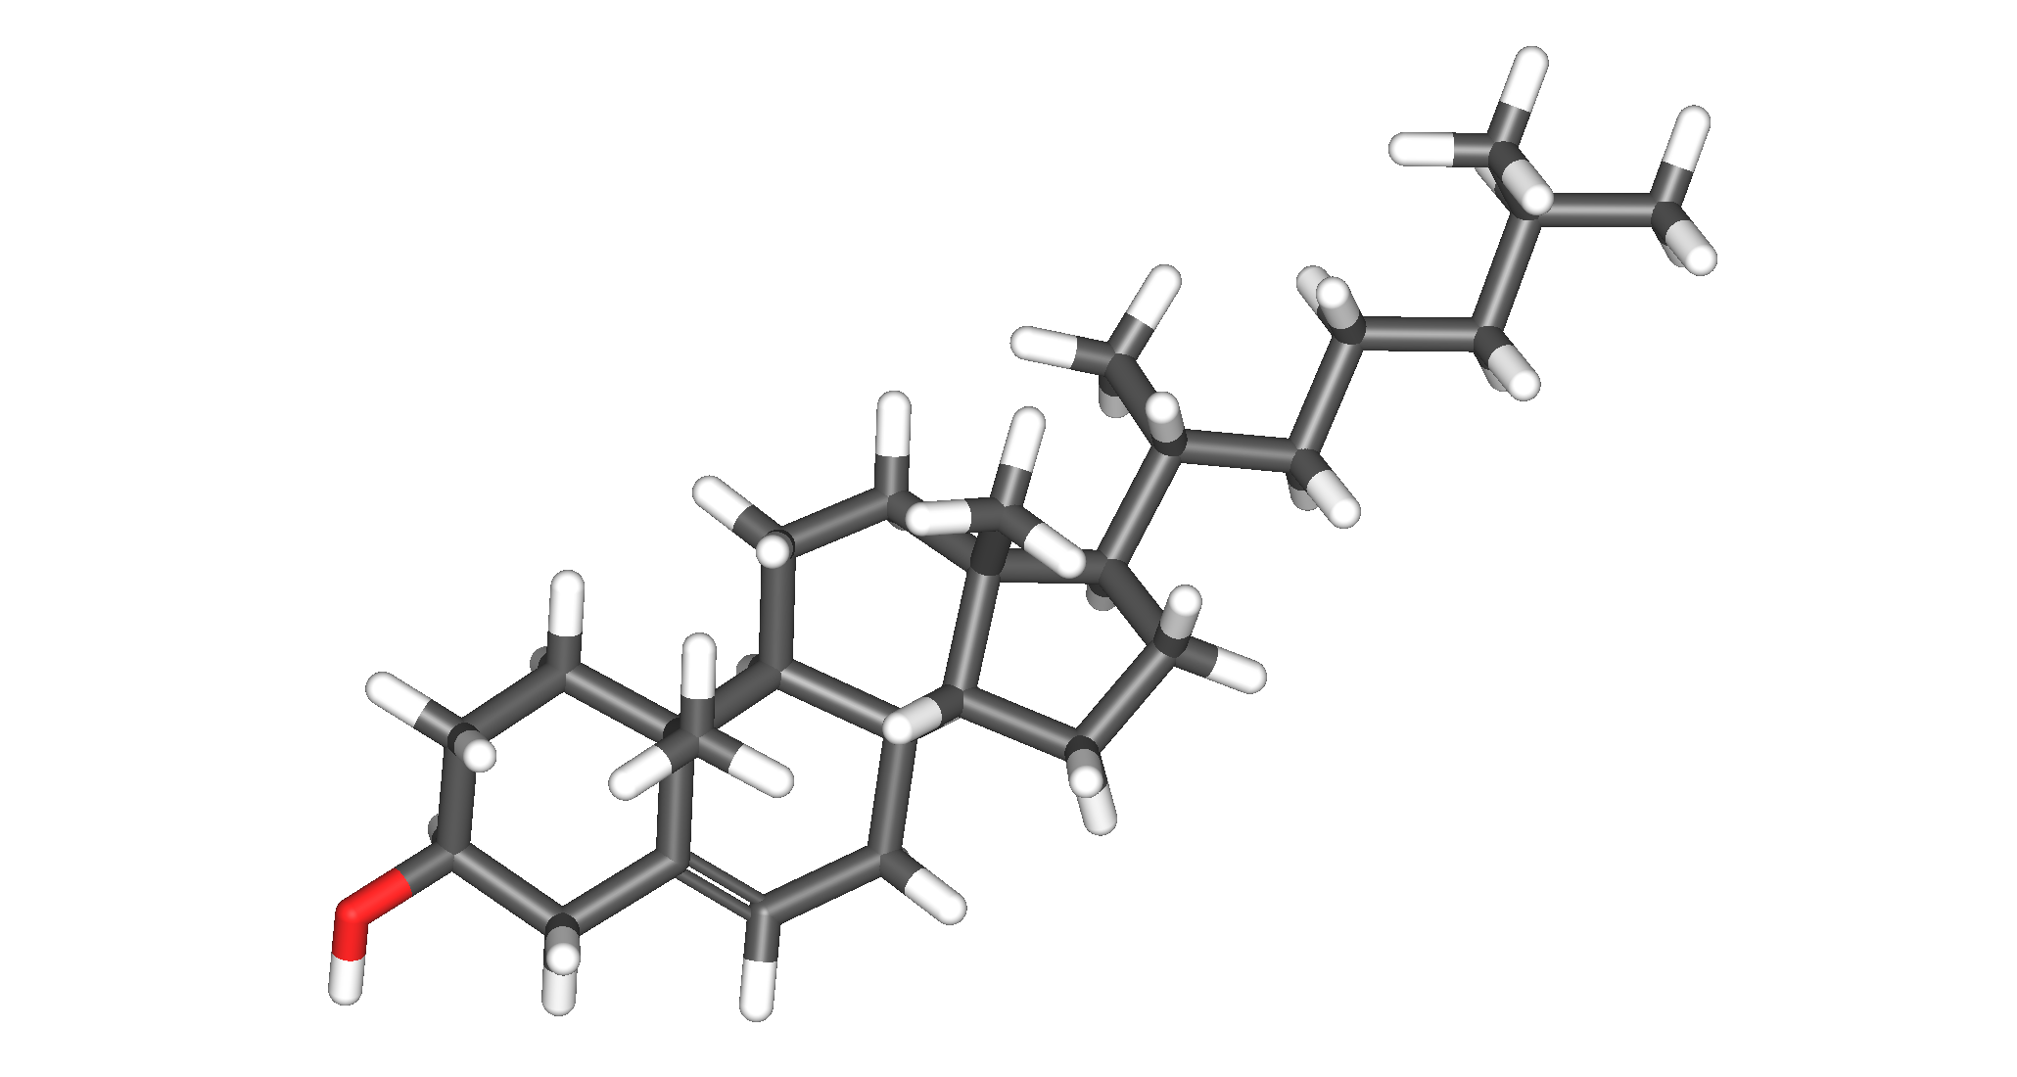
(A) triglyceride
(B) fatty acid
(C) cholesterol
(D) glycerol
The four-ring structure is a tell-tale sign of cholesterol

24. When lipids are being digested, the cell uses up one water molecule.
(A) True
(B) False

25. Lipids and carbohydrates have virtually the same composition.
(A) True
(B) False
Just C, H, and O.

Section B: Structured Questions
1.Estrodiol is a female sex hormone that is responsible for the development of secondary sexual characteristics found in females. The following is the structural formula of estradiol.
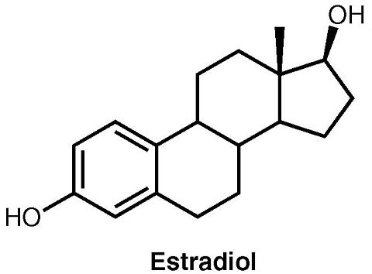
A) Identify the Steriod that acts as a precursor to its synthesis. (1 mark)
(b) Label using A,B,C AND D the hydrophobic regions on this molecule (1 mark)
(c) Name the functional group present.(1 mark)

2. Tristearin is a triglyceride used in the manufacture of soaps, candles, adhesives, textiles and
water proofing products. Draw the structure of tristearin if the fatty acid used is stearic acid
having ∆ designation of 18:0. (4 marks)

3. The table below shows four fatty acids.
Fatty Acid Name | Fatty Acid Type | Notation
Butyric |  | C4:0
Oleic |  | C18:1Δ⁹
Linoelic |  | C18:3
Palmitic |  | C16:0
Elaidic |  | C18:1

(a) Complete the table by writing the fatty acid type for each fatty acid. (5 Marks)
(b) Draw a possible structure for butyric acid. (2 Marks)
(c) Oleic acid is cis fatty acid whereas elaidic acid is a trans fatty acid.
(i) Draw a possible structure for oleic acid. (2 Marks)
(ii) Will oleic acid have a lower melting point than elaidic acid? Give a reason for your answer.
(2 Marks)

