CHEM210 – Analytical Chemistry
Mass Spectrometry Worksheet
1. (a) Draw a simple diagram of a mass spectrometer. State briefly how its use could show the
existence of isotopes in a gaseous sample of an element. (6 Marks)

__________________________________________________________________________________________________________________________________________________________________________________________________________________________________________

(b) Chlorine exists as a mixture of two stable isotopes ³⁵Cl and ³⁷Cl , present in the approximate
ratio 3:1.
(i) Calculate the relative atomic mass of chlorine. (2 Marks)
________________________________________________________________________________________________________________________________________________________________________________________________________________________________________________________________________________________________________________________
(ii) Sketch and label a diagram of the mass spectrum of molecular chlorine. (3 Marks)

2. The diagram below represents the spectrum of chlorine, consisting of five peaks, labelled I, II, III, IV and V respectively. Peak I is due to the ³⁵Cl⁺ ion.
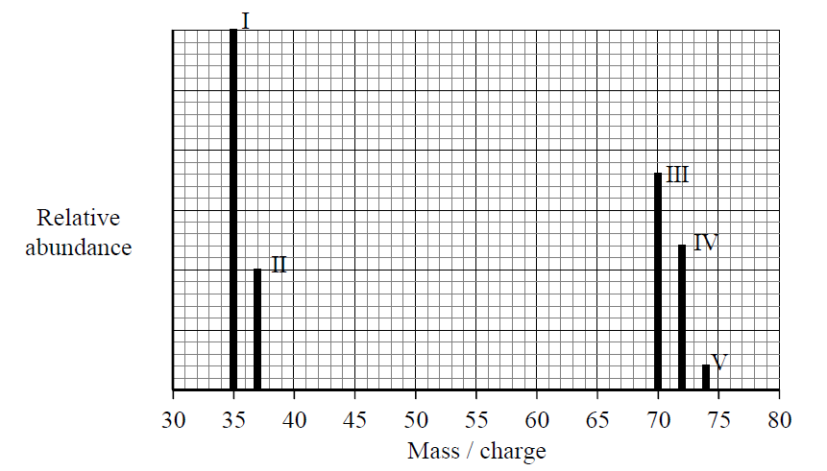
(a) What analytical technique would give a spectrum like that shown above? (1 Mark)
______________________________________________________________________________ (b) State why the spectrum of chlorine consists of more than two peaks. (1 Mark)
______________________________________________________________________________ (c) Suggest what peaks II and IV might be due to. (2 Marks)
____________________________________________________________________________________________________________________________________________________________
(d) Using the spectrum above, find the isotopic composition of chlorine and justify your answer.
(2 Marks)
______________________________________________________________________________
____________________________________________________________________________________________________________________________________________________________

(e) (i) How is a molecular ion formed? (1 Mark)
______________________________________________________________________________
(ii) What information could be obtained from the mass/charge value of the molecular ion?
(1 Mark)
______________________________________________________________________________

3. Mass spectrometry is a powerful analytical technique used in the identification of
organic compounds. The mass spectrum of a compound with empirical formula CH₂O displays
peaks at m/z 15, 45 and 60.
(a) Determine the molecular formula of the compound. (2 Marks)

____________________________________________________________________________________________________________________________________________________________
(b) Identify the fragments responsible for the peaks at the m/z values below. (2 Marks)
m/z = 15 ______________________________________________________________________ m/z = 45 ______________________________________________________________________
(c) Identify a compound that could produce this spectrum. (1 Mark)

______________________________________________________________________________

4. An organic compound A was found by analysis to have the empirical formula C₉H₁₀ O
(a) The mass spectrum of compound A is given below:
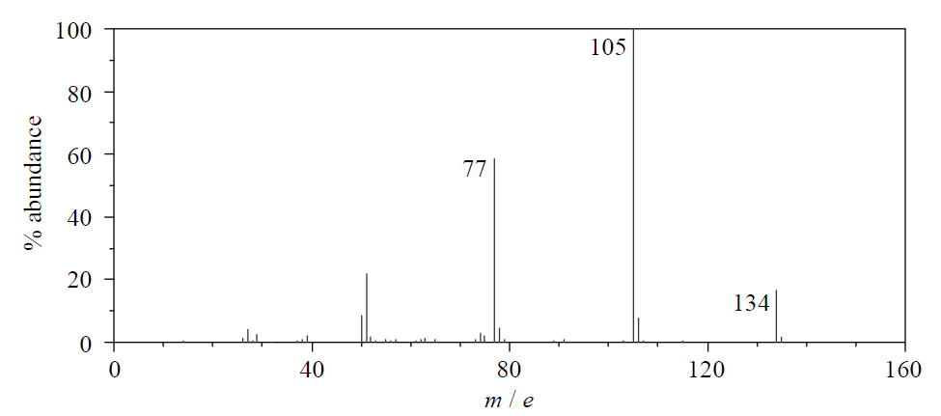
(i) What does the peak at 134 represent and what information about compound A can be
deduced from it? (2 Marks)

____________________________________________________________________________________________________________________________________________________________
(ii) There is a small peak at 135. Explain what causes this peak. (1 Mark)

______________________________________________________________________________
(iii) Suggest which fragments are responsible for the peaks at 105 and 77. (2 Marks)

105___________________________________

77____________________________________

