MASS SPECTROMETRY

1.How a mass spectrometer works
(i) The basic principle
If something is moving and you subject it to a sideways force, instead of moving in a straight line, it will move in a curve - deflected out of its original path by the sideways force.
Suppose you had a cannonball travelling past you and you wanted to deflect it as it went by you. All you've got is a jet of water from a hose-pipe that you can squirt at it. Frankly, its not going to make a lot of difference! Because the cannonball is so heavy, it will hardly be deflected at all from its original course.
But suppose instead, you tried to deflect a table tennis ball travelling at the same speed as the cannonball using the same jet of water. Because this ball is so light, you will get a huge deflection.
The amount of deflection you will get for a given sideways force depends on the mass of the ball. If you knew the speed of the ball and the size of the force, you could calculate the mass of the ball if you knew what sort of curved path it was deflected through. The less the deflection, the heavier the ball.

(ii) An outline of what happens in a mass spectrometer
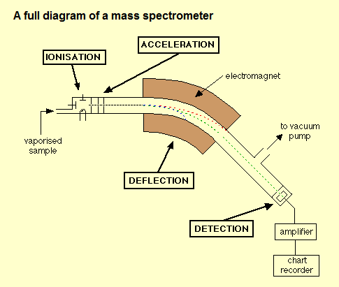
Atoms can be deflected by magnetic fields - provided the atom is first turned into an ion. Electrically charged particles are affected by a magnetic field although electrically neutral ones are not.
The sequence is:
Stage 1: Ionisation
The atom is ionised by knocking one or more electrons off to give a positive ion. This is true even for things which you would normally expect to form negative ions (chlorine, for example) or never form ions at all (argon, for example). Mass spectrometers always work with positive ions.
Stage 2: Acceleration
The ions are accelerated so that they all have the same kinetic energy.
Stage 3: Deflection
The ions are then deflected by a magnetic field according to their masses. The lighter they are, the more they are deflected.
The amount of deflection also depends on the number of positive charges on the ion - in other words, on how many electrons were knocked off in the first stage. The more the ion is charged, the more it gets deflected.
Stage 4: Detection
The beam of ions passing through the machine is detected electrically.

(iii) What the mass spectrometer output looks like
The output from the chart recorder is usually simplified into a "stick diagram". This shows the relative current produced by ions of varying mass/charge ratio.
The stick diagram for molybdenum looks like this:
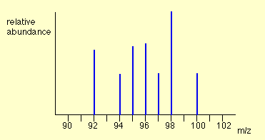
You may find diagrams in which the vertical axis is labelled as either "relative abundance" or "relative intensity". Whichever is used, it means the same thing. The vertical scale is related to the current received by the chart recorder - and so to the number of ions arriving at the detector: the greater the current, the more abundant the ion.
As you will see from the diagram, the commonest ion has a mass/charge ratio of 98. Other ions have mass/charge ratios of 92, 94, 95, 96, 97 and 100.
That means that molybdenum consists of 7 different isotopes. Assuming that the ions all have a charge of 1+, that means that the masses of the 7 isotopes on the carbon-12 scale are 92, 94, 95, 96, 97, 98 and 100.

2. THE MASS SPECTRA OF ELEMENTS
(i) The mass spectrum of monatomic elements
Monatomic elements include all those except for things like chlorine, Cl₂, with molecules containing more than one atom.
Example 1: The mass spectrum for boron
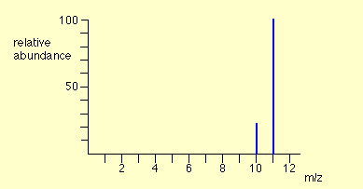
The number of isotopes
The two peaks in the mass spectrum shows that there are 2 isotopes of boron - with relative isotopic masses of 10 and 11 on the ¹²C scale.
The abundance of the isotopes
The relative sizes of the peaks gives you a direct measure of the relative abundances of the isotopes. The tallest peak is often given an arbitrary height of 100 - but you may find all sorts of other scales used. It doesn't matter in the least.
You can find the relative abundances by measuring the lines on the stick diagram.
In this case, the two isotopes (with their relative abundances) are:
boron-10 |  | 23
boron-11 |  | 100
Example 2: The mass spectrum for zirconium
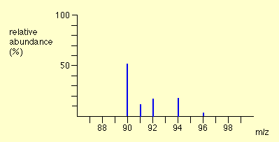
The number of isotopes
The 5 peaks in the mass spectrum shows that there are 5 isotopes of zirconium - with relative isotopic masses of 90, 91, 92, 94 and 96 on the ¹²C scale.
The abundance of the isotopes
This time, the relative abundances are given as percentages. Again you can find these relative abundances by measuring the lines on the stick diagram.
In this case, the 5 isotopes (with their relative percentage abundances) are:
zirconium-90 |  | 51.5
zirconium-91 |  | 11.2
zirconium-92 |  | 17.1
zirconium-94 |  | 17.4
zirconium-96 |  | 2.8
Example 3: The mass spectrum of chlorine
Chlorine is taken as typical of elements with more than one atom per molecule. We'll look at its mass spectrum to show the sort of problems involved.
Chlorine has two isotopes, ³⁵Cl and ³⁷Cl, in the approximate ratio of 3 atoms of ³⁵Cl to 1 atom of ³⁷Cl. You might suppose that the mass spectrum would look like this:
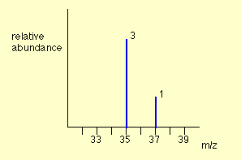
You would be wrong!
The problem is that chlorine consists of molecules, not individual atoms. When chlorine is passed into the ionisation chamber, an electron is knocked off the molecule to give a molecular ion, Cl₂⁺. These ions won't be particularly stable, and some will fall apart to give a chlorine atom and a Cl⁺ ion. The term for this is fragmentation.
If the Cl atom formed isn't then ionised in the ionisation chamber, it simply gets lost in the machine - neither accelerated nor deflected.
The Cl⁺ ions will pass through the machine and will give lines at 35 and 37, depending on the isotope and you would get exactly the pattern in the last diagram. The problem is that you will also record lines for the unfragmented Cl₂⁺ ions.
Think about the possible combinations of chlorine-35 and chlorine-37 atoms in a Cl₂⁺ ion.
Both atoms could be ³⁵Cl, both atoms could be ³⁷Cl, or you could have one of each sort. That would give you total masses of the Cl₂⁺ ion of:
35 + 35 = 70 35 + 37 = 72 37 + 37 = 74
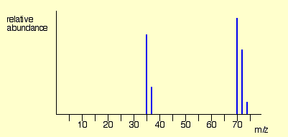

3. FRAGMENTATION PATTERNS IN THE MASS SPECTRA OF ORGANIC COMPOUNDS
(i) The origin of fragmentation patterns
The formation of molecular ions
When the vaporised organic sample passes into the ionisation chamber of a mass spectrometer, it is bombarded by a stream of electrons. These electrons have a high enough energy to knock an electron off an organic molecule to form a positive ion. This ion is called the molecular ion - or sometimes the parent ion.
The molecular ion is often given the symbol M⁺ or - the dot in this second version represents the fact that somewhere in the ion there will be a single unpaired electron. That's one half of what was originally a pair of electrons - the other half is the electron which was removed in the ionisation process.
Fragmentation
The molecular ions are energetically unstable, and some of them will break up into smaller pieces. The simplest case is that a molecular ion breaks into two parts - one of which is another positive ion, and the other is an uncharged free radical.
The uncharged free radical won't produce a line on the mass spectrum. Only charged particles will be accelerated, deflected and detected by the mass spectrometer. These uncharged particles will simply get lost in the machine - eventually, they get removed by the vacuum pump.
The ion, X⁺, will travel through the mass spectrometer just like any other positive ion - and will produce a line on the stick diagram.
All sorts of fragmentations of the original molecular ion are possible - and that means that you will get a whole host of lines in the mass spectrum. For example, the mass spectrum of pentane looks like this:
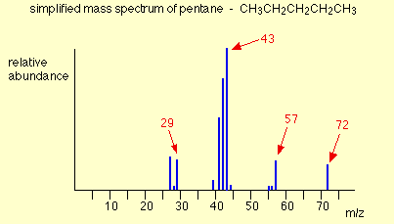
It's important to realise that the pattern of lines in the mass spectrum of an organic compound tells you something quite different from the pattern of lines in the mass spectrum of an element. With an element, each line represents a different isotope of that element. With a compound, each line represents a different fragment produced when the molecular ion breaks up.

The molecular ion peak and the base peak
In the stick diagram showing the mass spectrum of pentane, the line produced by the heaviest ion passing through the machine (at m/z = 72) is due to the molecular ion.
The tallest line in the stick diagram (in this case at m/z = 43) is called the base peak. This is usually given an arbitrary height of 100, and the height of everything else is measured relative to this. The base peak is the tallest peak because it represents the commonest fragment ion to be formed - either because there are several ways in which it could be produced during fragmentation of the parent ion, or because it is a particularly stable ion.
Using fragmentation patterns
This section will ignore the information you can get from the molecular ion (or ions). That is covered in three other pages which you can get at via the mass spectrometry menu. You will find a link at the bottom of the page.
Working out which ion produces which line
This is generally the simplest thing you can be asked to do.
Example 1: The mass spectrum of pentane
Let's have another look at the mass spectrum for pentane:
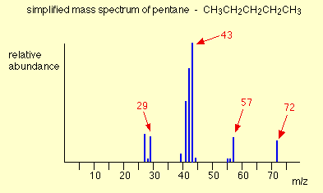
What causes the line at m/z = 57?
How many carbon atoms are there in this ion? There can't be 5 because 5 x 12 = 60. What about 4? 4 x 12 = 48. That leaves 9 to make up a total of 57. How about C₄H₉⁺ then?
C₄H₉⁺ would be [CH₃CH₂CH₂CH₂]⁺, and this would be produced by the following fragmentation:
The methyl radical produced will simply get lost in the machine.
The line at m/z = 43 can be worked out similarly. If you play around with the numbers, you will find that this corresponds to a break producing a 3-carbon ion:
The line at m/z = 29 is typical of an ethyl ion, [CH₃CH₂]⁺:
The other lines in the mass spectrum are more difficult to explain. For example, lines with m/z values 1 or 2 less than one of the easy lines are often due to loss of one or more hydrogen atoms during the fragmentation process.

Example 2: The mass spectrum of pentan-3-one
This time the base peak (the tallest peak - and so the commonest fragment ion) is at m/z = 57. But this isn't produced by the same ion as the same m/z value peak in pentane.
If you remember, the m/z = 57 peak in pentane was produced by [CH₃CH₂CH₂CH₂]⁺. If you look at the structure of pentan-3-one, it's impossible to get that particular fragment from it.
Work along the molecule mentally chopping bits off until you come up with something that adds up to 57. With a small amount of patience, you'll eventually find [CH₃CH₂CO]⁺ - which is produced by this fragmentation:
You would get exactly the same products whichever side of the CO group you split the molecular ion.
The m/z = 29 peak is produced by the ethyl ion - which once again could be formed by splitting the molecular ion either side of the CO group.

Peak heights and the stability of ions
The more stable an ion is, the more likely it is to form. The more of a particular sort of ion that's formed, the higher its peak height will be. We'll look at two common examples of this.
Examples involving carbocations (carbonium ions)
Applying the logic of this to fragmentation patterns, it means that a split which produces a secondary carbocation is going to be more successful than one producing a primary one. A split producing a tertiary carbocation will be more successful still.
Let's look at the mass spectrum of 2-methylbutane. 2-methylbutane is an isomer of pentane - isomers are molecules with the same molecular formula, but a different spatial arrangement of the atoms.
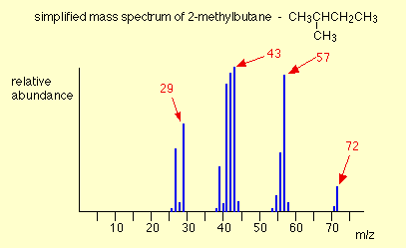
Look first at the very strong peak at m/z = 43. This is caused by a different ion than the corresponding peak in the pentane mass spectrum. This peak in 2-methylbutane is caused by:
The ion formed is a secondary carbocation - it has two alkyl groups attached to the carbon with the positive charge. As such, it is relatively stable.
The peak at m/z = 57 is much taller than the corresponding line in pentane. Again a secondary carbocation is formed - this time, by:
You would get the same ion, of course, if the left-hand CH₃ group broke off instead of the bottom one as we've drawn it.
In these two spectra, this is probably the most dramatic example of the extra stability of a secondary carbocation.
Examples involving acylium ions, [RCO]⁺
Ions with the positive charge on the carbon of a carbonyl group, C=O, are also relatively stable. This is fairly clearly seen in the mass spectra of ketones like pentan-3-one.
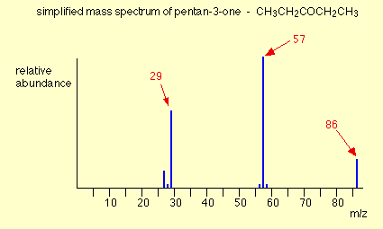
The base peak, at m/z=57, is due to the [CH₃CH₂CO]⁺ ion. We've already discussed the fragmentation that produces this.
Using mass spectra to distinguish between compounds
Suppose you had to suggest a way of distinguishing between pentan-2-one and pentan-3-one using their mass spectra.
pentan-2-one |  | CH₃COCH₂CH₂CH₃
pentan-3-one |  | CH₃CH₂COCH₂CH₃
Each of these is likely to split to produce ions with a positive charge on the CO group.
In the pentan-2-one case, there are two different ions like this:
- [CH₃CO]⁺
- [COCH₂CH₂CH₃]⁺
That would give you strong lines at m/z = 43 and 71.
With pentan-3-one, you would only get one ion of this kind:
- [CH₃CH₂CO]⁺
In that case, you would get a strong line at 57.
You don't need to worry about the other lines in the spectra - the 43, 57 and 71 lines give you plenty of difference between the two. The 43 and 71 lines are missing from the pentan-3-one spectrum, and the 57 line is missing from the pentan-2-one one.
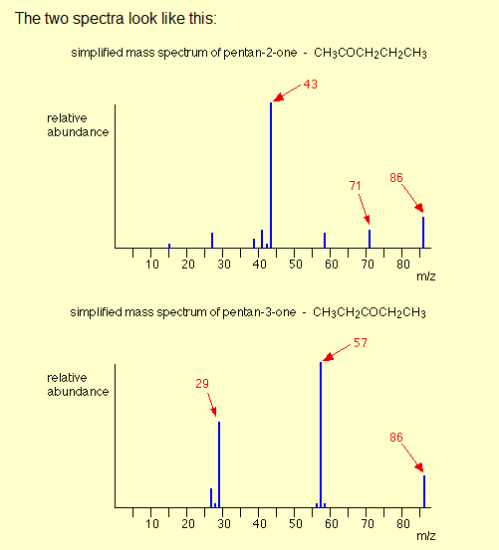
Computer matching of mass spectra
As you've seen, the mass spectrum of even very similar organic compounds will be quite different because of the different fragmentations that can occur. Provided you have a computer data base of mass spectra, any unkown spectrum can be computer analysed and simply matched against the data base.

4. MASS SPECTRA - THE MOLECULAR ION (M⁺) PEAK
Using a mass spectrum to find relative formula mass
The formation of molecular ions
When the vaporised organic sample passes into the ionisation chamber of a mass spectrometer, it is bombarded by a stream of electrons. These electrons have a high enough energy to knock an electron off an organic molecule to form a positive ion. This ion is called the molecular ion.
The molecular ion is often given the symbol M⁺ or - the dot in this second version represents the fact that somewhere in the ion there will be a single unpaired electron. That's one half of what was originally a pair of electrons - the other half is the electron which was removed in the ionisation process.
The molecular ions tend to be unstable and some of them break into smaller fragments. These fragments produce the familiar stick diagram. Fragmentation is irrelevant to what we are talking about on this page - all we're interested in is the molecular ion.
Using the molecular ion to find the relative formula mass
In the mass spectrum, the heaviest ion (the one with the greatest m/z value) is likely to be the molecular ion. A few compounds have mass spectra which don't contain a molecular ion peak, because all the molecular ions break into fragments. That isn't a problem you are likely to meet at A'level.
For example, in the mass spectrum of pentane, the heaviest ion has an m/z value of 72.
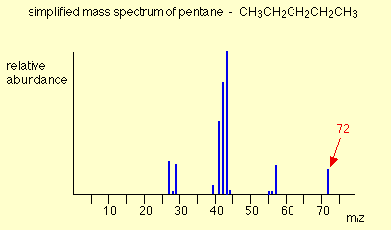
Because the largest m/z value is 72, that represents the largest ion going through the mass spectrometer - and you can reasonably assume that this is the molecular ion. The relative formula mass of the compound is therefore 72.
Finding the relative formula mass (relative molecular mass) from a mass spectrum is therefore trivial. Look for the peak with the highest value for m/z, and that value is the relative formula mass of the compound.
There are, however, complications which arise because of the possibility of different isotopes (either of carbon or of chlorine or bromine) in the molecular ion. These cases are dealt with on separate pages.
Using a mass spectrum to find a molecular formula
So far we've been looking at m/z values in a mass spectrum as whole numbers, but it's possible to get far more accurate results using a high resolution mass spectrometer. You can use that more accurate information about the mass of the molecular ion to work out the molecular formula of the compound.
Accurate isotopic masses
For normal calculation purposes, you tend to use rounded-off relative isotopic masses. For example, you are familiar with the numbers:
¹H |  | 1
¹²C |  | 12
¹⁴N |  | 14
¹⁶O |  | 16
To 4 decimal places, however, these are the relative isotopic masses:
¹H |  | 1.0078
¹²C |  | 12.0000
¹⁴N |  | 14.0031
¹⁶O |  | 15.9949
The carbon value is 12.0000, of course, because all the other masses are measured on the carbon-12 scale which is based on the carbon-12 isotope having a mass of exactly 12.

Using these accurate values to find a molecular formula
Two simple organic compounds have a relative formula mass of 44 - propane, C₃H₈, and ethanal, CH₃CHO. Using a high resolution mass spectrometer, you could easily decide which of these you had.
On a high resolution mass spectrometer, the molecular ion peaks for the two compounds give the following m/z values:
C₃H₈ |  | 44.0624
CH₃CHO |  | 44.0261
You can easily check that by adding up numbers from the table of accurate relative isotopic masses above.
A possible exam question
A gas was known to contain only elements from the following list:
¹H |  | 1.0078
¹²C |  | 12.0000
¹⁴N |  | 14.0031
¹⁶O |  | 15.9949
The gas had a molecular ion peak at m/z = 28.0312 in a high resolution mass spectrometer. What was the gas?
After a bit of playing around, you might reasonably come up with 3 gases which had relative formula masses of approximately 28 and which contained the elements from the list. They are N₂, CO and C₂H₄.
Working out their accurate relative formula masses gives:
N₂ |  | 28.0062
CO |  | 27.9949
C₂H₄ |  | 28.0312
The gas is obviously C₂H₄.
In an exam, you would hope that - apart from the most simple cases - you would be given the possible formulae to work from. Trying to work out all the possible things which might add up to the value you want is quite time-consuming - and it's easy to miss an important possibility!

5. MASS SPECTRA - THE M+1 PEAK
What causes the M+1 peak?
What is an M+1 peak?
If you had a complete (rather than a simplified) mass spectrum, you will find a small line 1 m/z unit to the right of the main molecular ion peak. This small peak is called the M+1 peak.
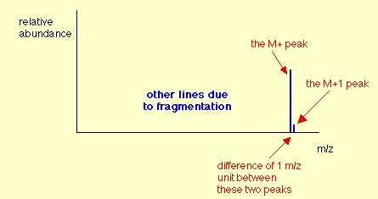
In questions at this level (UK A level or its equivalent), the M+1 peak is often left out to avoid confusion - particularly if you were being asked to find the relative formula mass of the compound from the molecular ion peak.
The carbon-13 isotope
The M+1 peak is caused by the presence of the ¹³C isotope in the molecule. ¹³C is a stable isotope of carbon - don't confuse it with the ¹⁴C isotope which is radioactive. Carbon-13 makes up 1.11% of all carbon atoms.
If you had a simple compound like methane, CH₄, approximately 1 in every 100 of these molecules will contain carbon-13 rather than the more common carbon-12. That means that 1 in every 100 of the molecules will have a mass of 17 (13 + 4) rather than 16 (12 + 4).
The mass spectrum will therefore have a line corresponding to the molecular ion [¹³CH₄]⁺ as well as [¹²CH₄]⁺.
The line at m/z = 17 will be much smaller than the line at m/z = 16 because the carbon-13 isotope is much less common. Statistically you will have a ratio of approximately 1 of the heavier ions to every 99 of the lighter ones. That's why the M+1 peak is much smaller than the M+ peak.

Using the M+1 peak
What happens when there is more than 1 carbon atom in the compound?
Imagine a compound containing 2 carbon atoms. Either of them has an approximately 1 in 100 chance of being ¹³C.
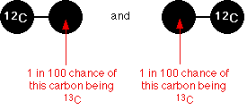
There's therefore a 2 in 100 chance of the molecule as a whole containing one ¹³C atom rather than a ¹²C atom - which leaves a 98 in 100 chance of both atoms being ¹²C.
That means that the ratio of the height of the M+1 peak to the M+ peak will be approximately 2 : 98. That's pretty close to having an M+1 peak approximately 2% of the height of the M+ peak.
Using the relative peak heights to predict the number of carbon atoms
If there are small numbers of carbon atoms
If you measure the peak height of the M+1 peak as a percentage of the peak height of the M+ peak, that gives you the number of carbon atoms in the compound.
We've just seen that a compound with 2 carbons will have an M+1 peak approximately 2% of the height of the M+ peak.
Similarly, you could show that a compound with 3 carbons will have the M+1 peak at about 3% of the height of the M+ peak.
With larger numbers of carbon atoms
The approximations we are making won't hold with more than 2 or 3 carbons. The proportion of carbon atoms which are ¹³C isn't 1% - it's 1.11%. And the appoximation that a ratio of 2 : 98 is about 2% doesn't hold as the small number increases.
Consider a molecule with 5 carbons in it. You could work out that 5.55 (5 x 1.11) molecules will contain 1 ¹³C to every 94.45 (100 - 5.55) which contain only ¹²C atoms. If you convert that to how tall the M+1 peak is as a percentage of the M+ peak, you get an answer of 5.9% (5.55/94.45 x 100). That's close enough to 6% that you might assume wrongly that there are 6 carbon atoms.
Above 3 carbon atoms, then, you shouldn't really be making the approximation that the height of the M+1 peak as a percentage of the height of the M+ peak tells you the number of carbons - you will need to do some fiddly sums!

6. MASS SPECTRA - THE M+2 PEAK
The effect of chlorine or bromine atoms on the mass spectrum of an organic compound
Compounds containing chlorine atoms
One chlorine atom in a compound
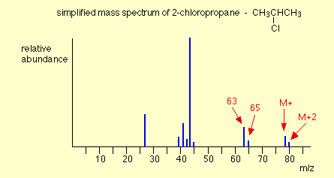
The molecular ion peaks (M+ and M+2) each contain one chlorine atom - but the chlorine can be either of the two chlorine isotopes, ³⁵Cl and ³⁷Cl.
The molecular ion containing the ³⁵Cl isotope has a relative formula mass of 78. The one containing ³⁷Cl has a relative formula mass of 80 - hence the two lines at m/z = 78 and m/z = 80.
Notice that the peak heights are in the ratio of 3 : 1. That reflects the fact that chlorine contains 3 times as much of the ³⁵Cl isotope as the ³⁷Cl one. That means that there will be 3 times more molecules containing the lighter isotope than the heavier one.
So . . . if you look at the molecular ion region, and find two peaks separated by 2 m/z units and with a ratio of 3 : 1 in the peak heights, that tells you that the molecule contains 1 chlorine atom.
You might also have noticed the same pattern at m/z = 63 and m/z = 65 in the mass spectrum above. That pattern is due to fragment ions also containing one chlorine atom - which could either be ³⁵Cl or ³⁷Cl. The fragmentation that produced those ions was:
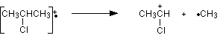
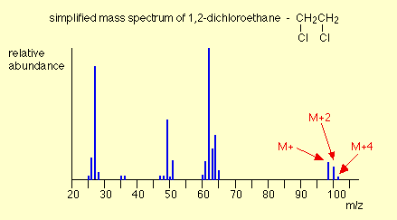
Two chlorine atoms in a compound
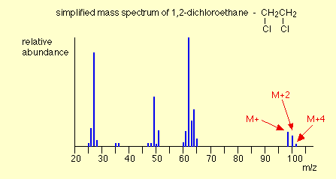
The lines in the molecular ion region (at m/z values of 98, 100 ands 102) arise because of the various combinations of chlorine isotopes that are possible. The carbons and hydrogens add up to 28 - so the various possible molecular ions could be:
28 + 35 + 35 = 98
28 + 35 + 37 = 100
28 + 37 + 37 = 102
If you have the necessary maths, you could show that the chances of these arrangements occurring are in the ratio of 9:6:1 - and this is the ratio of the peak heights. If you don't know the right bit of maths, just learn this ratio!
So . . . if you have 3 lines in the molecular ion region (M+, M+2 and M+4) with gaps of 2 m/z units between them, and with peak heights in the ratio of 9:6:1, the compound contains 2 chlorine atoms.

Compounds containing bromine atoms
Bromine has two isotopes, ⁷⁹Br and ⁸¹Br in an approximately 1:1 ratio (50.5 : 49.5 if you want to be fussy!). That means that a compound containing 1 bromine atom will have two peaks in the molecular ion region, depending on which bromine isotope the molecular ion contains.
Unlike compounds containing chlorine, though, the two peaks will be very similar in height.
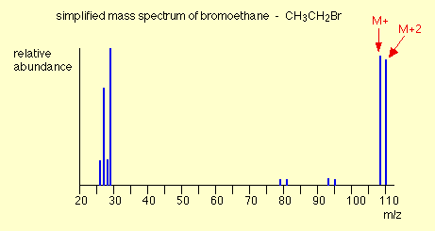
The carbons and hydrogens add up to 29. The M+ and M+2 peaks are therefore at m/z values given by:
29 + 79 = 108
29 + 81 = 110
So . . . if you have two lines in the molecular ion region with a gap of 2 m/z units between them and with almost equal heights, this shows the presence of a bromine atom in the molecule.

