COSTAATT
CHEM092 – Introduction to Concepts in Chemistry II
Lesson 9 – Homework

1. The diagram below shows the apparatus used for the electrolysis of lead bromide. Draw labels to show the following:
cathode anode electrolyte
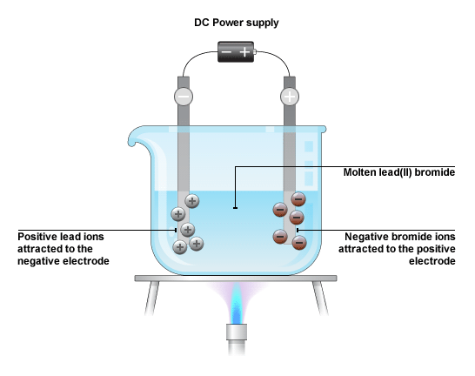
2. Say what is formed at the cathode and at the anode during the electrolysis of the following substances. Assume that carbon electrodes were used each time. You don’t need to write electrode equations.
(a) molten zinc chloride
at the anode:____________________ at the cathode:____________________

(b) molten sodium iodide
at the anode:____________________ at the cathode:____________________

