COSTAATT
CHEM 090
Lesson 7 – Worksheet

Bonding Basics
Section A: Complete the chart using a periodic table to help you.
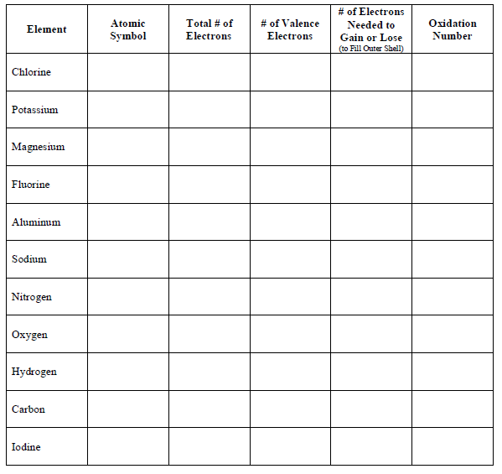

Answer these questions:
▪ An atom that gains one or more electrons will have a ____________________ charge.
▪ An atom that loses one or more electrons will have a ____________________ charge.
▪ An atom that gains or loses one or more electrons is called an ____________.
▪ A positive ion is called a ______________ and a negative ion is called an _______________.
Section B: Ionic Bonds
What is an ionic bond?
▪ Atoms will transfer one or more ___________________ to another to form the bond.
▪ Each atom is left with a ___________________ outer shell.
▪ An ionic bond forms between a ___________________ ion with a positive charge and a ___________________ ion with a negative charge.

Example B1: Sodium + Chlorine Example B2: Magnesium + Iodine

Example B3: Potassium + Iodine Example B4: Sodium + Oxygen

Example B5: Calcium + Chlorine Example B6: Aluminum + Chlorine

Challenge: What are some other ionic bonds that can be formed by the elements you see? Remember that you need a metal and a nonmetal to make an ionic bond. Write the chemical formula for the compound and its name.
Section C: Covalent Bonds
What is a covalent bond?
▪ Atoms ___________________ one or more electrons with each other to form the bond.
▪ Each atom is left with a ___________________ outer shell.
▪ A covalent bond forms between two ___________________.

Example C1: Hydrogen + Chlorine Example C2: 2 Hydrogen + Oxygen

Example C3: Chlorine + Chlorine Example C4: Oxygen + Oxygen

Example C5: Carbon + 2 Oxygen Example C6: Carbon + 4 Hydrogen

Challenge: What are some other covalent bonds that can be formed by the elements you see? Remember that you need two or more nonmetals to make a covalent bond. Write the chemical formula for the compound and its name if you know it.

