COSTAATT
CHEM 090
Lesson 6 – Worksheet

Instructions

The following table shows some common ions and the charges that they carry.

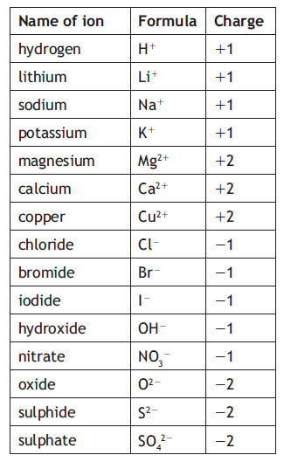
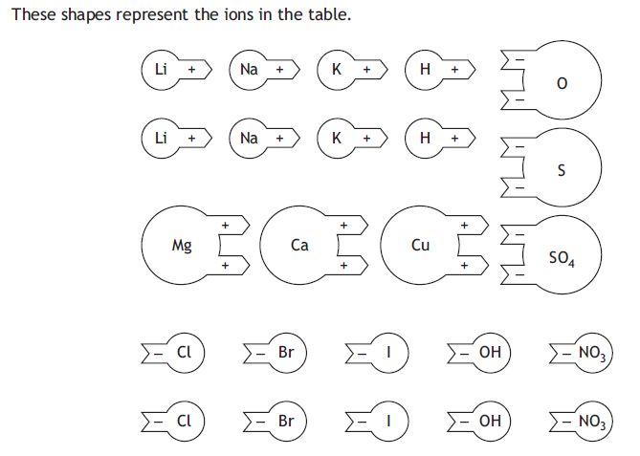
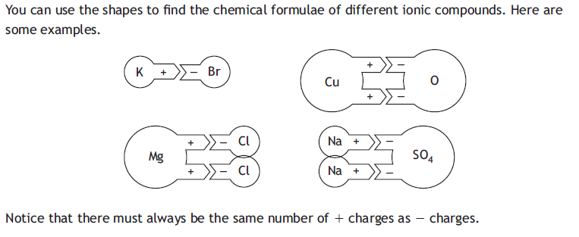
The chemical formulae of the compounds above are written as:
1. KBr 2. CuO 3. MgCl₂ 4. Na₂SO₄

Questions
1. Cut the shapes out and use them to find the chemical formulae of each of the following ionic compounds.
(a) Lithium bromide (b) Calcium oxide
(c) Copper iodide (d) Potassium sulphate

2. Now make three more compounds. For each one write its name and formula.

