COSTAATT
CHEM 090
Lesson 3 – Worksheet

1. Which particle(s) in the atom is/are responsible for the:
(a) mass of the atom;
(b) volume of the atom?

2. Define the following terms:
atomic number, mass number.

3. For each of the following nuclear notations, give the number of protons, electrons and neutrons.
(a) ¹¹₅ B (b) ²³₁₁ Na (c) ⁴⁰₂₀ Ca

4. Define the term isotope.

5. Give the formula used to determine the maximum number of electrons allowed in an electron shell.

6. (a) Represent the electronic configuration of the following atoms using both a shell diagram and writing:
(i) magnesium which has 12 electrons (ii) chlorine which has 17 electrons
(iii) neon which has 10 electons

(b) For each of the elements in question 6 (a) give the number of valence electrons.
7. Represent the electronic diagram of the following atoms of carbon using both a shell diagram and writing:
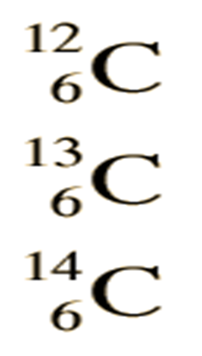

8. Represent the electronic diagram of the following atoms of chlorine using both a shell diagram and writing:

9. Use your knowledge of atomic calculations to complete the chart below.
Element | Atomic Number | Mass Number | Number of  Protons | Number of Neutrons | Number of Electrons
Li | 3 | 7
P | 15 | 31
Cl |  | 35 | 17
Ni | 28 |  |  | 31
K |  | 39 |  |  | 19
Ag | 47 |  |  | 61
H |  | 1 | 1
Si |  |  |  | 14 | 14
Ne |  |  |  | 10 | 10

