COSTAATT
CHEM 090
Lesson 9 – Worksheet

1. In the boxes provided, name the method of separating mixtures you would use to
solve each of the problems below.
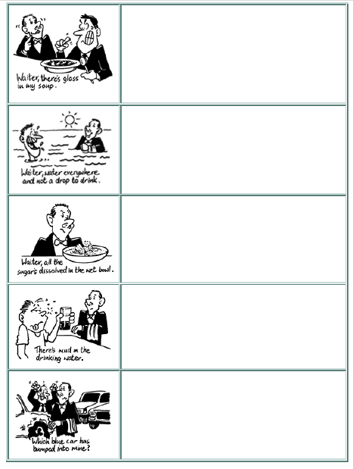
2. Which properties of the components of a mixture are considered when deciding on a separation technique?
__________________________________________________________________________________________________________________________________________________________________________________________________________________
3. What is the main difference between using distillation and evaporation as a separation technique?
____________________________________________________________________________________________________________________________________________
4. For each of the following mixtures, explain how you would separate them into their component parts:
(a) a mixture of salt, pepper and water
__________________________________________________________________________________________________________________________________________________________________________________________________________________
(b) a mixture of oil, sugar and water
__________________________________________________________________________________________________________________________________________________________________________________________________________________

