COSTAATT
CHEM 111
Lesson 2 – Worksheet

1. Which particle(s) in the atom is/are responsible for the:
(a) mass of the atom;
(b) volume of the atom?

2. Define the following terms:
atomic number, mass number.

3. For each of the following nuclear notations, give the number of protons, electrons and neutrons.
(a) ¹¹₅ B (b) ²³₁₁ Na (c) ⁴⁰₂₀ Ca

4. Define the term isotope.

5. Give the formula used to determine the maximum number of electrons allowed in an electron shell.

6. (a) Represent the electronic configuration of the following atoms using both a shell diagram and writing:
(i) magnesium which has 12 electrons (ii) chlorine which has 17 electrons
(iii) neon which has 10 electons

(b) For each of the elements in question 6 (a) give the number of valence electrons.
7. Represent the electronic diagram of the following atoms of carbon using both a shell diagram and writing:
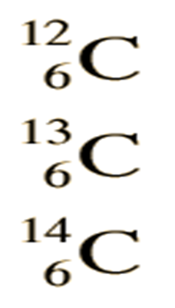

8. Represent the electronic diagram of the following atoms of chlorine using both a shell diagram and writing:

9. Use your knowledge of atomic calculations to complete the chart below.
Element | Atomic Number | Mass Number | Number of  Protons | Number of Neutrons | Number of Electrons
Li | 3 | 7
P | 15 | 31
Cl |  | 35 | 17
Ni | 28 |  |  | 31
K |  | 39 |  |  | 19
Ag | 47 |  |  | 61
H |  | 1 | 1
Si |  |  |  | 14 | 14
Ne |  |  |  | 10 | 10
10. Bonding Basics
Section A: Complete the chart using a periodic table to help you.
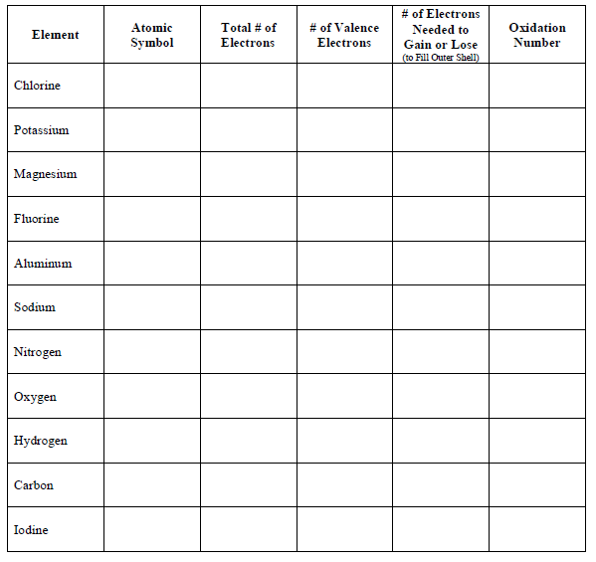

Answer these questions:
▪ An atom that gains one or more electrons will have a ____________________ charge.
▪ An atom that loses one or more electrons will have a ____________________ charge.
▪ An atom that gains or loses one or more electrons is called an ____________.
▪ A positive ion is called a ______________ and a negative ion is called an _______________.
Section B: Ionic Bonds
What is an ionic bond?
▪ Atoms will transfer one or more ___________________ to another to form the bond.
▪ Each atom is left with a ___________________ outer shell.
▪ An ionic bond forms between a ___________________ ion with a positive charge and a ___________________ ion with a negative charge.

Example B1: Sodium + Chlorine Example B2: Magnesium + Iodine

Example B3: Potassium + Iodine Example B4: Sodium + Oxygen

Example B5: Calcium + Chlorine Example B6: Aluminum + Chlorine

Challenge: What are some other ionic bonds that can be formed by the elements you see? Remember that you need a metal and a nonmetal to make an ionic bond. Write the chemical formula for the compound and its name.
Section C: Covalent Bonds
What is a covalent bond?
▪ Atoms ___________________ one or more electrons with each other to form the bond.
▪ Each atom is left with a ___________________ outer shell.
▪ A covalent bond forms between two ___________________.

Example C1: Hydrogen + Chlorine Example C2: 2 Hydrogen + Oxygen

Example C3: Chlorine + Chlorine Example C4: Oxygen + Oxygen

Example C5: Carbon + 2 Oxygen Example C6: Carbon + 4 Hydrogen

Challenge: What are some other covalent bonds that can be formed by the elements you see? Remember that you need two or more nonmetals to make a covalent bond. Write the chemical formula for the compound and its name if you know it.

