COSTAATT
CHEM 111
Lesson 2 – Homework

1. What is the charge of a proton?
(A) +1 (B) -1 (C) 0 (D) 1/1800

2. Which of the following statements about the numbers of protons and neutrons in an atom is true?
(A) They must be the same (B) They are never the same
(C) They are in the ratio 1:2 (D) They can be the same

3. Which of the following statements about the numbers of protons and electrons in an atom is true?
(A) They are always different (B) They are the same
(C) They are sometimes different (D) They can change

4. What does the atomic number represent? No. of protons or electrons

5. What does the mass number represent? No. of protons and neutrons

6. How would you figure out the number of protons or electrons in an atom? It would be the same as the atomic number.

7. How would you figure out the number of neutrons in an atom? Mass number minus atomic number.

8. What term is used for the electrons in the outermost shell or energy level? Valence electrons

9. Explain why atoms bond with one another. To attain a full outer shell and so become more stable.

10. Define ionic bonding.
Ionic bonding is a transfer of valence electrons between metal and non-metal atoms.
Usually the transfer is from the metal atom to the non-metal atom.

11. Use shell diagrams to represent the ionic bonding between sodium and oxygen to form sodium oxide, Na₂O.

12. Calcium forms an ionic bond with fluorine to form a compound.
(a) Give the name of the compound. Calcium fluoride
(b) Give the formula unit of the compound. CaF₂
(c) Use shell diagrams to represent the ionic bonding between calcium and fluorine to form the compound.

13. What happens to the electrons when covalent bonds are formed?

(a) They are lost (b) They are gained

(c) They are shared (d) They are not involved

14. Use shell diagrams to represent the covalent bonding in the following elements/compounds:

(a) H₂

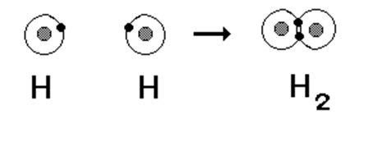

(b) N₂

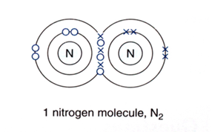

(c) HBr

15. Draw the shell diagram of the covalent bonding between carbon and chlorine and give the formula of the compound.
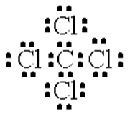
CCl₄

16. (i) Draw ring diagrams to show all the electrons in:
(a) a hydrogen chloride molecule
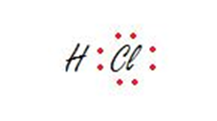
(b) a fluorine molecule
(c) a carbon dioxide molecule
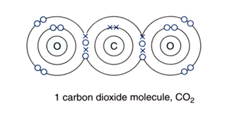
(ii) Are all the electrons in an atom used in bonding? Explain your answer.
No, not all of the atoms are used in bonding. Only the amount needed to complete the valence shell is used.

Homework Project – Due date: next class
