COSTAATT
CHEM 111
Lesson 1 – Homework

1. In which of the following are particles closest together?
(A) solids (B) gases (C) solutions (D) liquids

2. What is the opposite of evaporation?
(A) freezing (B) melting (C) boiling (D) condensation

3. Which of the following statements is/are true?
(I) in diffusion particles move
(II) gases diffuse faster than liquids
(III) the spread of cooking smells is an example of diffusion
(IV) evaporation and diffusion are really the same thing

(A) I and II (B) I, II and IV (C) I, II and III (D) II and IV

4. (a) State the four main ideas in the particle theory of matter.
(b) Explain why scientists find the particle theory of matter useful.

5. What is the relationship between the temperature of a particle and movement of the particle?

6. What are the three states of matter?
7. (a) Explain what is meant by diffusion. Include a diagram in your answer.
(b) Describe what happens to the perfume particles from an aerosol can when it is used in a closed room.

8. (a) What is meant by osmosis?
(b) Describe an experiment to investigate osmosis using plant material.

9. Copy the diagram below, and label each arrow to show the change in state.
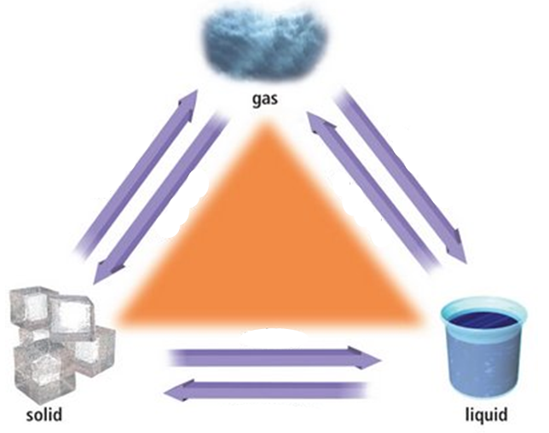

10. Complete the table below. The first one is completed as an example of what is required.
Change of State | Name given to change of state | Energy added or removed to change state
Solid to liquid | Melting | Added
Liquid to gas
Gas to liquid
Liquid to solid
Solid to gas

