COSTAATT
CHEM 090
Lesson 12 – Worksheet

1. What does the diagram below show?
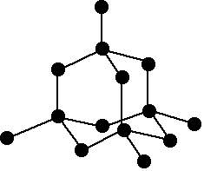
(A) The structure of graphite (B) The structure of diamond
(C) The structure of sodium chloride (D) The structure of copper

2. Graphite can be described as
(A) hard and crystalline (B) soft and slippery
(C) a dark liquid (D) made of hydrogen atoms

3. Diamond is
(A) made only of carbon and hydrogen atoms
(B) the hardest substance known to man
(C) soft and slippery
(D) clear and brittle

4. What makes diamond so hard?
(A) diamond has a crystal structure similar to ice
(B) diamond is made up of only carbon atoms
(C) the C-C bonds all have different bond lengths
(D) a rigid network of atoms that cannot move

5. Which statement best describes why graphite is soft?
(A) graphite is made up of only carbon atoms
(B) graphite is layered
(C) graphite has a low melting point
(D) graphite is made up only of hydrogen atoms
6. Which of the following statements is not correct
(A) both carbon and diamond are made of only carbon atoms
(B) graphite has only weak forces between its layers
(C) graphite and diamond have the same density
(D) in diamond each carbon is the same distance to each of its neighbouring carbon atoms

