COSTAATT
CHEM 090
Final Revision Worksheet

1. (a) Explain why atoms bond with one another.
____________________________________________________________________________________________________________________________________________________________
(1 Mark)
(b) Define ionic bonding.
____________________________________________________________________________________________________________________________________________________________
(1 Mark)
(c) Use shell diagrams to represent the ionic bonding between sodium and oxygen.

(4 Marks)
(d) What is the name of the compound?
______________________________________________________________________________
(1 Mark)
(e) What is the formula unit of the compound?
______________________________________________________________________________
(1 Mark)
2. Aluminium bonds with oxygen to form a compound.
(a) What type of bonding will take place between aluminium and oxygen? Give a reason for your answer.
Type of Bonding:_______________________________________________________________
Reason:_____________________________________________________________________________________________________________________________________________________
(2 Marks)
(b) Use shell diagrams to represent the bonding between aluminium and oxygen to form the compound.

(4 Marks)
(c) Give the formula unit of the compound.
______________________________________________________________________________
(1 Mark)
(d) What is the name of the compound?
______________________________________________________________________________
(1 Mark)
3. Carbon bonds with chlorine to form a certain compound.
(a) What type of bonding will take place between carbon and chlorine? Give a reason for your answer.
Type of Bonding:_______________________________________________________________
Reason:_____________________________________________________________________________________________________________________________________________________
(2 Marks)
(b) Draw the shell diagrams to show the bonding between carbon and chlorine.

(4 Marks)
(c) Give the formula unit of the compound.
______________________________________________________________________________
(1 Mark)
(d) What is the name of the compound?
______________________________________________________________________________
(1 Mark)
4. For each of the following mixtures, explain how you would separate them into their component parts:
(a) a mixture of salt, pepper and water
__________________________________________________________________________________________________________________________________________________________________________________________________________________________________________
(3 Marks)
(b) a mixture of oil, sugar and water
__________________________________________________________________________________________________________________________________________________________________________________________________________________________________________
(3 Marks)
5. The two allotropes of carbon are shown below.
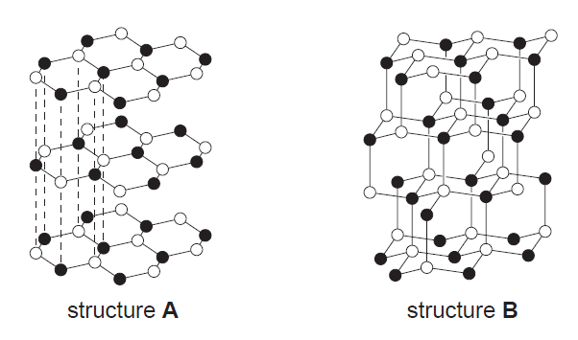
(a) What are allotropes?
____________________________________________________________________________________________________________________________________________________________
(2 Marks)
(b) (i) Which allotrope of carbon does structure A represent?
______________________________________________________________________________
(1 Mark)
(ii) Which allotrope of carbon does structure B represent?
______________________________________________________________________________
(1 Mark)
(c) (i) Which structure can be used as a lubricant?
______________________________________________________________________________
(1 Mark)
(ii) Explain why the structure named in (c) (i) can be used as a lubricant. __________________________________________________________________________________________________________________________________________________________________________________________________________________________________________
(2 Marks)
(d) (i) Which structure can conduct electricity?
______________________________________________________________________________
(1 Mark)
(ii) Explain why the structure named in (d) (i) can conduct electricity. __________________________________________________________________________________________________________________________________________________________________________________________________________________________________________
(2 Marks)
END OF REVISION PAPER
Total = _______/40 = _________%

