

**COLLEGE OF SCIENCE, TECHNOLOGY & APPLIED ARTS**

**OF**

**TRINIDAD & TOBAGO**

***Department of Natural & Life Sciences***

**CHEM 131 – General chemistry 1**

**for students**

Academic Yr 201410-201430

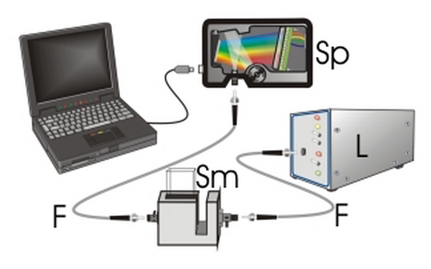

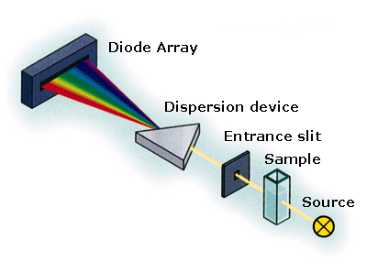**TABLE OF CONTENTS**

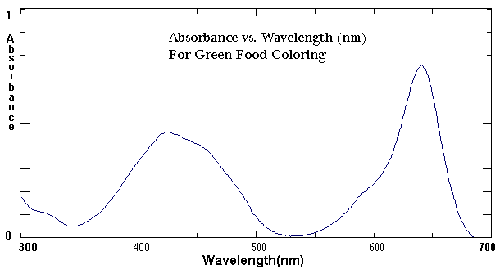

[*A Word of Welcome* 3](#_Toc272321883)

[*WASTE DISPOSAL* 4](#_Toc272321884)

[*MANAGING YOUR TIME DURING THE PRACTICAL* 7](#_Toc272321885)

[*SAFETY IN THE CHEMISTRY LABORATORY* 8](#_Toc272321886)

[*GETTING STARTED* 13](#_Toc272321887)

[EXPERIMENT 2 14](#_Toc272321888)

[Flame Tests - Emission Spectroscopy 14](#_Toc272321889)

[EXPERIMENT 3 18](#_Toc272321890)

[The Electromagnetic Spectrum 18](#_Toc272321891)

[EXPERIMENT 4 24](#_Toc272321892)

[UV-Visible Spectrophotometry & Beer-Lambert’s Law 24](#_Toc272321893)

[Experiment 5 28](#_Toc272321894)

[How effective is your Sunscreen? 28](#_Toc272321895)

[Experiment 6 34](#_Toc272321896)

[Planning and Design Lab 34](#_Toc272321897)

[EXPERIMENT 7 35](#_Toc272321898)

[Chemical Bonding 35](#_Toc272321899)

[EXPERIMENT 8 – Option 1 38](#_Toc272321900)

[Models of Molecular Shapes 38](#_Toc272321901)

[EXPERIMENT 9 – Option 2 39](#_Toc272321902)

[Molecular Models 39](#_Toc272321903)

[Experiment 10 43](#_Toc272321904)

[MOLECULAR SHAPE AND POLARITY. 43](#_Toc272321905)

[Experiment 11 45](#_Toc272321906)

[KINETIC THEORY- Investigation of Charles’s Law 45](#_Toc272321907)

# *A Word of Welcome*

The Department of Natural & Life Sciences welcomes you to the practical component of the course. The experiments that form part of this course have been selected to:

* reinforce your knowledge and understanding of the theoretical content of your first year Chemistry course,
* develop skills such as observing, recording, measuring and reporting of results, and
* teach you special techniques, such as weighing, pipetting, titrating, filtration etc, so that you will become familiar with the basics of laboratory work.

bd06220_

# *WASTE DISPOSAL*

We all have a responsibility towards a clean and safe environment. The Chemistry Department’s policy dealing with the disposal of laboratory waste is in accordance with the Occupational Health and Safety Act, which is a law of our country. We do not expect you to understand every aspect of this law, but as responsible citizen and laboratory user you must be aware of the correct procedures for disposal of the different classes of laboratory waste. You will be given specific instructions on how to dispose of your chemical wastes during each pre-lab briefing. Here are also some general rules that you must take note of:

1. Place broken glass into the specially marked bins.
2. Drain all harmless chemicals in solution into the sink followed by plenty of running water.
3. Pour toxic inorganic waste solutions into the specially labeled container in the fume cupboard.
4. Discard paper and any other solid waste into the bin.
5. Ensure that matches are extinguished before disposing of them in this way.
6. Shut off all gas and water lines when not in use.

Figure 1: Apparatus that you will be using in the laboratory

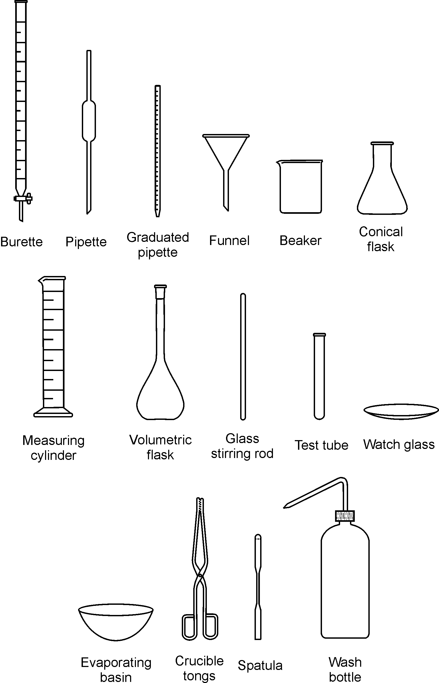

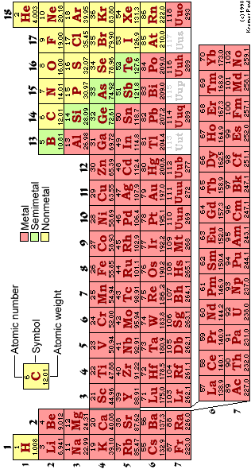

# *MANAGING YOUR TIME DURING THE PRACTICAL*

1. It is recommended that you arrange your workbench according to the diagram below. Keeping your workspace organized and free of clutter will save you time and frustration, and contributes greatly to laboratory safety.

BENCH SOLUTIONS

⊗ WATER TAP ⊗ GAS TAP ⊗ WATER TAP

|  |  |  |
| --- | --- | --- |
| USED APPARATUS AND DIRTY GLASSWARE |  | SOLUTIONS AND DRY CHEMICALS |
| PAPERWORK (PRAC MANUAL, REPORT SHEET AND FLOW DIAGRAM) | EXPERIMENTAL SET-UP | CLEAN GLASSWARE |

1. When collecting chemicals:
   * Choose the size of your container according to the volume of chemical that you will be collecting, for instance: for 100 cm3 of solution, use a 250 cm3 beaker and for 10 cm3 use a test tube.
   * Before collecting chemicals and/or solutions from the dispensary, mark each container with the name or formula of the chemical to be collected. This will prevent any mix-ups later on.
2. Use a small notebook for jotting down masses, measurements and observations. Writing these bits of information on slips of scrap paper that can easily be lost is not only unprofessional, but also risky because it means that your whole afternoon’s practical work can be wasted because of lost data.

# *SAFETY IN THE CHEMISTRY LABORATORY*

The chemistry laboratory is a dangerous environment in which to work. The dangers are often unavoidable since chemists regularly have to use hazardous materials. However, with sensible precautions the laboratory is probably no more dangerous than your home, is it house or apartment. You MUST AT ALL TIMES OBSERVE THE ENTIRE RULE stated in this manual.

**Essential Rules for Laboratory Safety**

The essential rules for laboratory safety can be expressed under two simple headings:

**ALWAYS AND NEVER**

**ALWAYS**

* Familiarize yourself with the laboratory safety procedures.
* Dress appropriately.
* Wash your hands before leaving the laboratory.
* Read the instructions for the laboratory protocol **carefully** before starting any experiment.
* Handle all chemicals with great care.
* Keep your working area tidy.
* Immediately inform your instructor about spills.

**NEVER**

* Eat or drink in the laboratory. CHEWING OF GUM IS STRICTLY PROHIBITED!
* Smoke in the laboratory
* Inhale, taste or sniff chemicals.
* Fool around or distract neighbours.
* Carry out unauthorized experiments.

**Laboratory Safety Procedures**

Your laboratory will have certain procedures, which you must be familiar with. Make sure you know where all the exits from the laboratory are, in the event of an evacuation because of fire or other incident. Locate the SHOWERS and eyewash stations and know the type the fire extinguishers that are in the laboratory and how to operate them.

**Dress Code**

* Wear a Lab coat.
* Wear approved safety goggles or safety glasses when in the lab.
* Avoid floppy garments; avoid things that dangle. These get tangled up in equipment or glassware and cause accidents.
* Avoid long, loose hair styles for the same reason. When Bunsen burners are in use, long hair sometimes catches on fire.
* Avoid open footwear & high heels. So sandals & thongs are unacceptable.

**Laboratory Techniques**

**Handling of Acids or Bases**

* In addition to the dress code above, personal protective equipment, such as Vinyl" gloves or "nitrile" GLOVES SHOULD be worn.
* For even more dangerous liquids, thick "nitrile" gloves should be used. These are very safe.

**Become acquainted with handling laboratory safety equipment e.g.**

* Fire Extinguishers
* Fire Blanket
* Eye-wash Fountain
* First-Aid Kit

**Become acquainted with using of the FUME HOOD**

* Use the HOOD for reactions that give off vapours, especially smelly vapours.
* The draft of the HOOD will sweep away vapours so that the lab itself maintains reasonable air quality.

**Locate the Safety Shower and understand how it works**

* Shower should be used for ***dire EMERGENCY***only!
* If you are ***ON FIRE***, or suffer a ***massive spill*** of a **dangerous chemical**, and need to get it off rapidly.

**Position yourself under the safety shower and pull the handle—a deluge of water will result.**

**Immediately clean up Broken Glass**

* Sweep it up right away
* Place the broken glass in a "SHARP’S CONTAINER.
* This is a thick walled carton that will be sealed and discarded as such.

**Student Use of the Laboratory**

* No UNAUTHORIZED experiments! These are terrible dangers in unskilled hands
* No EATING or DRINKING in the LAB. A good practice is to assume everything in the lab is toxic.
* DO NOT drink from lab equipment. NOT EVEN distilled water.
* When using pipettes, **DO NOT** suck the liquid into the pipette directly by mouth.
* Frequent mistakes, even by skilled lab workers, lead to the liquid reaching the mouth.
* Do NOT smell the flask directly.

**Housekeeping:**

* **STUDENTS MUST CLEAN UP AFTER THEMSELVES**.
* Paper and trash must not be left in the room, thrown into drawers, sinks, on the floor, etc.
* When the equipment boxes are on carts, students who take a box form the cart to do an experiment must put everything back into the box neatly and put the box back on the cart.

**If you absolutely must test the odour, carefully waft the vapour from the flask toward your nose with your hand, keeping the flask quite distant from your face.**

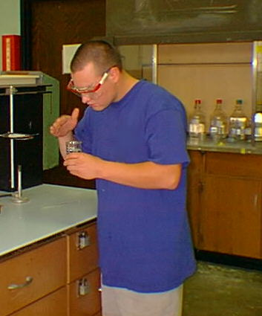

**Make sure that reaction tubes, e.g. test tubes, are not directed toward yourself or other persons. The chemicals may splatter out the tube.**

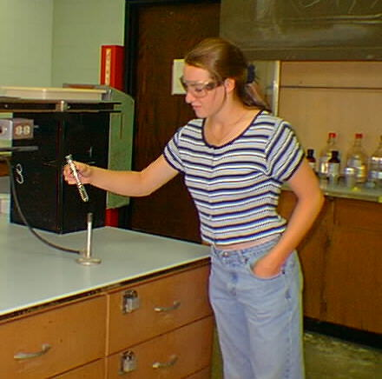

**DO NOT add *WATER* to *CONCENTRATED ACID****.* The heat generated will cause splattering. If necessary to prepare certain solutions, **DO** add ACID to WATER (instead of the reverse order of addition). The heat generated will be less, but splattering still may occur. A good practice in all lab operations is to keep things at arm’s length.

# *GETTING STARTED*

For each laboratory period, including the first, you will be required to:

* + Study the entire experimental outline in the **Laboratory Manual**. It includes specific directions concerning laboratory philosophy and protocols.
  + Prepare your **Laboratory Notebook**. Include a summary and a procedural outline for your experiment (see "Rules for Keeping Your Laboratory Notebook" and Instruction in the experiment outline).
  + Bring your safety goggles or use the safety goggles provided. These offer adequate protection against accidental splashing of corrosive chemicals.
  + Come to lab dressed appropriately

**A GOOD PRACTICE:**

Read the experimental procedure ahead of lab.

Avoid horseplay. In a laboratory setting, horseplay, even if good-natured, is absolutely unacceptable.

* + - **No pushing!**
    - **No shoving!**

At the end of the lab period: Exit the lab in an orderly manner. Again: no running, no pushing, AND NO shoving.

# EXPERIMENT 2

## Flame Tests - Emission Spectroscopy

**AIM:** To investigate and predict the identity of metal ions with flame tests.

**INTRODUCTION:**

A number of common metal ions (Li+, Na+, K+, Ca2+, Ba2+, Sr+, and Cu2+) give a distinct colour in the presence of a flame. Therefore, a flame test is often used as a confirmatory test in identifying an unknown metal.

Compounds of these ions provide the beautiful colours in a fireworks display. When glass is melted in a Bunsen burner flame, sodium ions colour the flame bright yellow. A copper wire inserted into the flame often results in a striking deep blue or green colour.

In this experiment you will observe and record the flame colours of several metals of Group 1 and 2. Review the section in the text dealing with alkali and alkaline metals.

**SAFETY:**

* + - **Wear safety goggles and gloves**.
    - The **HCl** being used is **7 M. It is caustic and corrosive**; **avoid contact with skin and eyes.**  **When rinsing out the solution from your test tube** **DO** **NOT** **add WATER to ACID,** as this will result in an **EXPLOSION**. Pour out the concentrated solution before rinsing the test tube.
    - **If any should spill on you, immediately flush the area with water and then notify your teacher.**

**APPARATUS & MATERIALS:**

* Bunsen Burner
* 11 beakers
* 10 test tubes
* Forceps
* Nichrome Wire [2]
* 0.5 M NaCl (aq)
* NaCl (s)
* 0.5 M Ca(NO3)2 (aq)
* 0.5 M ZnSO4 (aq)
* Na and K mixture
* Unknown Metal 1 & 2
* 0.5 M KNO3 (aq)
* 0.5 M Cu(NO3)2 (aq)
* 0.5 M Ba(NO3)2 (aq)
* 0.5 M SrNO3 (aq)
* 0.5 M LiNO3 (aq)
* Test tube with 7.0 M HCl

**PROCEDURE**:

**PART A: Known Cations**

1. Fill each test tube [not the test tube containing 7.0 M HCl] to a depth of 1cm with the respective stock solutions.
2. Ignite your Bunsen burner and adjust the flam to produce a non-luminous (smokeless blue flame with pale blue inner core) flame.
3. To ensure that the nichrome wire is clean, dip it first into the 7.0 MHCl in a test tube and then hold it in the hottest part of the flame. Repeat until the wire imparts no colour to the flame.
4. Dip the loop of the clean nichrome wire into the test tube containing solution and then hold it in the hottest part of the flame.
5. Observe the colour of the flame just above the wire.
6. Clean the wire as instructed before and repeat the flame test for each solution. Record the colour of the flame for each cation in the Data Table.
7. Repeat the flame test for Na+ ions using a little dry sodium chloride. Describe what you observe.
8. In the cases of the solutions containing Li+ and Sr+ ions, observe which flame is more persistent and takes longer to burn off the wire. Also note the difference in the shades of colour produced.

**PART B: Unknown Cations**

1. Ensure that the wire is clean. If you are not sure of the identity after testing the unknown, retest the known solution of the metal you predict.
2. Place your answer in the Data Table.

**PART C: Solutions containing >1 Cation**

*If two metals are present in the same solution, the colour of one flame may obscure that of the other.*

1. Ensure that the nichrome wire is clean.
2. Carry out the flame test on the solution containing the mixture of KNO3 and NaNO3. Record the colours of the flames in the Data Table.
3. Observe the colour the mixture imparts to the flame when viewed through the cobalt glasses. Record the colours of the flames in the Data Table.

**RESULTS:**

**Table 1: Colours Emitted from the Various Cations in the Presence of a Flame**

|  |  |
| --- | --- |
| **Metallic Ion** | **Colour of Flame** |
| Sodium [from aqueous NaCl] |  |
| Sodium [from solid NaCl] |  |
| Lithium |  |
| Strontium |  |
| Calcium |  |
| Barium |  |
| Potassium |  |
| Copper |  |
| Magnesium |  |
| Sodium and Potassium mixture |  |
| Unknown Metal 1 |  |
| Unknown Metal 2 |  |

**POST LAB QUESTIONS:**

1. Is flame colouration a test for the metallic ion or for the nitrate ion? Explain your deductions.
2. Dry sodium chloride and the solutions of sodium nitrate and sodium chloride all impart the same colour to the flame; explain this observation.
3. .Describe the test for sodium ions and potassium ions when both are present.
4. .How would you characterize the flame test with respect to its sensitivity?
5. What difficulties may be encountered in the use of the flame test for identification?
6. List the flame colour of three Group 1, three Group 2, and one Transition Group metals.
7. a) A student recorded the following results when testing three unknowns. Identify the unknowns by referring to your Data Table:

|  |  |  |
| --- | --- | --- |
| **Metallic Ion** | **Observation** | **Cation** |
| Unknown #1 | yellowish green |  |
| Unknown #2 | scarlet |  |
| Unknown #3 | orange-red |  |

* 1. Several of the flame tests were shades of red. What should be done in the laboratory to correctly identify one of these ions?

1. During a flood, the labels from three bottles of chemicals floated away. The unlabeled bottles of white solids were known to contain the following: SrNO3, (NH4)2CO3, and K2SO4. **Explain** how you could easily re-label these three bottles.

**CONCLUSION**:

Describe the activity of electrons when a substance is vapourized in a flame. What is viewed through a spectroscope and how does this instrument serve in identifying substances?

# EXPERIMENT 3

## The Electromagnetic Spectrum

**Objective:** To study the spectra of the light from various sources as well as to examine the relationship between the observed emission spectra of hydrogen gas and atomic structure.

**Introduction:** Electromagnetic radiation is a form of energy which travels through space. The **electromagnetic radiation spectrum** (range of types of radiation) extends from gamma rays to radio waves with visible light being one small segment of the spectrum. The visible region of the electromagnetic spectrum corresponds to wavelengths in the range of 400 to 700 nm. Note, **1 m = 109nm**.

**Electromagnetic Spectrum**

Cosmic Rays X-rays ultra violet Visible microwave radio waves

**High Energy Low Energy**

violet blue green yellow red

The light sources whose emission spectra you will be examining today fall into two categories, **continuous** and **discrete**. A light source’s emission spectrum can be viewed by using the phenomenon of **diffraction**. Diffraction is a property of waves and the fact that light demonstrates this property indicates that it is wave-like. Diffraction is the flaring out of light waves as they emerge from a narrow slit. It is observed that the more narrow a slit through which the light travels, the more the light flares out. Also, longer wavelengths of light will flare out more than shorter wavelengths. This provides a mechanism for separating the different wavelengths of light (breaking the light up into its component colours, its spectrum). You will use diffraction grating slides and diffraction grating spectroscopes to observe the emission spectra of the different light sources.

**PART A** of this experiment will demonstrate the wave properties of light and show how the color of light emitted by a substance changes as it is heated. For example, a substance at about 1000 oC will begin to glow red. This is due to the substance emitting red photons (radiation of about 650 nm wavelength). Whereas the same substance heated at about 1500 oC will glow white. This is due to the fact that a whole range of colors from red to blue are being emitted. In experiment A, you will see that the higher the temperature of an incandescent bulb filament the shorter wavelength radiation it will emit. Bottom line: as temperature increases shorter wavelengths of radiation are emitted. It was in trying to explain this type of behavior that Max Planck initiated the quantum revolution by proposing that energy was quantized. That is, he proposed that energy came in discrete packages (quanta). The size of the energy packets are given by (hν).

ΔE = hν (1)

ν = c/λ (2)

Where, h = 6.6 x 10-34 J s

And c = 3.0 x 108 m/s

Note: ΔE = the energy change of a body, h = Planck’s constant, ν = frequency of the radiated energy, λ = the wavelength of the emitted radiation and c = the speed of light.

It is important to note that the spectrum of radiation emitted by the incandescent bulb is continuous. That is, there was no distinct demarcation between the different colors of light emitted.

Experiment B: Discrete Spectra: Whereas the incandescent bulb produces a continuous spectrum, the hydrogen discharge tube produces a discrete spectrum (a **line spectrum**). A set of very sharp, distinct lines of different color (wavelength) are emitted by the hydrogen gas lamp. Using Einstein’s equation for the energy of a photon of light (Ephoton = hν) you will be able to calculate the amount of energy carried by one photon of each of the three different wavelength lines you will observe in the hydrogen spectrum. By using a diffraction spectroscope to view the spectrum of the hydrogen lamp you will once again demonstrate the wave-like behavior of light. However, by calculating the energy per photon you will be expressing the particle-like behavior of light. That is, Einstein’s equation implies that the photon is a particle of light that carries a specific amount of energy determined by its frequency (ν). Thus, this experiment illustrates the wave-particle duality of light.

There is another very important implication associated with the discrete line spectra of the hydrogen lamp. That is, it implies that only certain energies are allowed for the hydrogen atom. The hydrogen atom has an atomic number of 1, which means it has one proton and one electron. The line spectra implies that the electron in the hydrogen atom can only exist in certain energy levels. Like a book on a bookshelf can rest at specific levels above the floor (at whatever level a shelf exists) but cannot rest at levels between shelves. That is, a book can be in a high potential energy state (on a top shelf far from the floor) or a lower energy state (on a low shelf near the floor) but cannot rest at energy states between shelves. The line spectrum suggests that the electron can only exist at specific energy levels, distances from the nucleus. Conclusion: The energy of atoms is quantized.

A book on a high shelf is in a higher potential energy state.

A book on a low shelf is in a lower potential energy state.

The Bohr Model of the Atom:

Based upon the same kind of observations you will make today, Neils Bohr, a Danish physicist proposed a model of the hydrogen atom that explained the quantization of the energy of the atom. Using classical physics along with quantum ideas proposed by Planck and Einstein, Bohr suggested that the electron in the hydrogen atom can travel in circular orbits only at set distances from the nucleus. The closer orbits were low energy orbits (like shelves close to the floor are low potential energy positions for a book). The orbits further from the nucleus were higher energy orbits.

e-

***The Bohr Model of the Hydrogen atom****. Each orbit around the nucleus represents an allowed position for an electron in the atom. The orbits are designated as n = 1 for the orbit nearest the nucleus, n = 2 for the next furthest orbit and so forth.* ***Note:*** *an electron in a given orbit will have a specific energy associated with it.*

Bohr proposed that the light emitted by a hydrogen lamp is due to an electron falling from an orbit far from the nucleus to one closer to the nucleus. The energy of the electron decreases and the excess energy is emitted as a photon of light. The energy of the photon is equal to the energy difference between the two orbits. Bohr derived the following equation to describe the energy change of the electron.

ΔEe = R[(1/ni)2 - (1/nf)2] (3)

where ni is the initial orbit, nf is the final orbit and R is a constant with a value of 2.18 x 10-18 J and ΔEe is the energy change of the electron.

In this diagram we show the electron dropping from the n =3 level to the n = 2 level. Since the electron drops from a higher to a lower energy level it must give up energy to the surroundings. That energy is released as a photon of light with an energy exactly equal to the difference in energy between the two orbits.

Since the energy of the photon is equal to the energy difference between the two orbits we can state that

Ephoton  = ΔEe (4)

hν = R[(1/ni)2 - (1/nf)2] (5)

Thus, the energy of all atoms is **quantized**. For the hydrogen atom only the energies given by equation 1 are allowed. Measuring the wavelength of an atom’s emission can be used to calculate the energy of the photon which is equal to the magnitude of energy change experienced by an electron as it drops from one position to another within an atom.

**Apparatus and Materials:** Incandescent light bulb, Hydrogen gas discharge tubes, “neon lights”, fluorescent room lights, power supplies, diffraction grating slides and diffraction grating spectroscopes.

**Procedure:**

Part A: Continuous Spectra:

1. Using the supplied diffraction grating slides view the light from an incandescent light bulb. Begin with the voltage set very low so that the filament just glows red. While observing the lamp gradually turn up the voltage. Record your observations.
2. Repeat the observations using a spectroscope and record the approximate wavelength for the red, green and blue light.

Part B: Line Spectra:

1. Using a spectroscope view the emission spectrum of **hydrogen** gas from the hydrogen gas discharge tube. Record the color and wavelength of each line observed.
2. Insert a **helium** gas discharge tube into the spectral tube power supply. Using the spectroscope, observe the emission lines for helium gas. Record the colour and wavelength of the six most intense lines.
3. Repeat step 2 using the **other gas** discharge tubes provided. Record observations for only the most intense lines.
4. View the emission spectrum of the **fluorescent** room lights. Record your observations and state whether the spectrum is continuous or discrete.

**Calculations and Questions:**

1. Use equations 1& 2 to calculate the energy of the photons for each line in the hydrogen spectrum.
2. Use equation 3 and calculate the energy of a photon emitted as an electron in the hydrogen atom falls from:
3. n = 5 to n = 2
4. n = 4 to n = 2
5. n = 3 to n = 2
6. Compare the energy values from Question (1) to those calculated from the line spectra of hydrogen Question (2). Comment on what these values mean.
7. Explain why the incandescent light produced a continuous spectrum whereas the fluorescent room lights produced a line spectrum.
8. Advertising lights are commonly referred to as “neon lights.” If advertising lights are large gas discharge tubes, do all “neon lights” contain neon gas? YES/NO
9. Based on your observations of gas discharge tubes, suggest a gas suitable for:
   1. A reddish-orange advertising light –
   2. A purple advertising light –
   3. A blue advertising light –

**PRE-LABORATORY QUESTIONS**

1. In your own words, define the following terms:
   1. Continuous spectrum –
   2. Frequency –
   3. Light –
   4. Line spectrum-
   5. Photon –
   6. Visible spectrum –
   7. Wavelength –
2. Arrange the six primary colours (R, O, Y, G, B, V) in the visible spectrum in order of :
   1. Decreasing wavelength –
   2. Decreasing frequency –
   3. Decreasing energy –
3. A hydrogen gas discharge tubes emits a faint line when electrons drop from the 10th to the 2nd energy level. Calculate the wavelength for this spectral line.
4. How many photons are emitted when 1 electron drops form the 10th to the 2nd energy level?

# EXPERIMENT 4

## UV-Visible Spectrophotometry & Beer-Lambert’s Law

**AIM:** To become acquainted with UV-Visible Spectrophotometry and to determine the concentration of a solution of colbalt (II) chloride using Beer-Lambert’s Law.

**INTRODUCTION:** The visible and ultraviolet regions are only a small portion of the electromagnetic radiation spectrum but they encompass the region of energy necessary to promote electrons from ground state orbitals to higher energy orbitals.

Many molecules absorb ultraviolet or visible light. Absorbance is directly proportional to the *path length*, ***b*** and the *concentration*, ***c***, of the absorbing species.

**Beer's Law** states that:

**A = εbc**,

where ***ε*** is a constant of proportionality, called *the extinction coefficient.*

Different molecules absorb radiation of different wavelengths. A spectrophotometer is employed to measure the amount of light that a sample absorbs. The instrument operates by passing a beam of light through a sample and measuring the intensity of light reaching a detector.

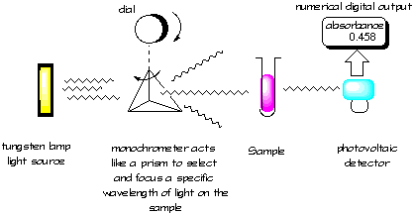

**A spectrophotometer has four essential parts as shown the figure above**

An absorption spectrum will show a number of absorption bands corresponding to structural groups within the molecule. For example the reduced spectrum for **cytochrome c** is shown below:

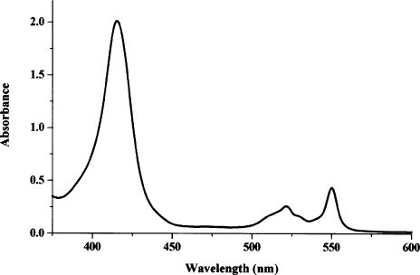

Cytochrome c absorbs light maximally at this wavelength (418 nm)

**Reduced spectrum: Cytochrome c**

Upon completion of this experiment you should be able to prepare a standard solution, perform serial dilutions and use a spectrophotometer to determine an absorption spectrum and a Beer’s law plot.

**APPARATUS**:

|  |  |
| --- | --- |
| * 50mL volumetric flask [1] * 50 ml beaker [1] * Test tubes [6] * Stirring Rod * Cuvette[1] | * Distilled Water * Cobalt (II) chloride, CoCl2 salt * Parafilm paper (or vortex mixer) * Kim wipes |

**PROCEDURE:**

Preparation of aqueous cobalt (II) chloride solution

1. As part of your pre-laboratory questions you should have calculated the mass of CoCl2 **.** 6H2O needed to prepare 50 ml of a 0.3M CoCl2 solution. Confirm with your lab lecturer that you have calculated the correct mass before starting.
2. Dissolve the appropriate amount of cobalt (II) chloride in about 25 ml of distilled water in a small beaker. Transfer the solution to a 50-ml volumetric flask. Be sure to rinse the beaker and add the washings to the flask. Dilute to the 50-ml mark and **mix thoroughly**.

Preparation of diluted solutions

1. Make 4 serial, 1 in 2 dilutions of at least 6 ml each of your stock solution. Consult with your lecturer. These solutions could be prepared in test tubes. Be sure to **mix thoroughly** by inversion or use the vortex mixer before preparing each new dilution.

Absorption Spectrum

1. Before you can perform the concentration study, it is first necessary to determine the absorption spectrum of cobalt chloride. First, blank with water and then using tubes 1 and 3, determine the wavelength at which maximum absorption occurs. Your lab lecturer or lab technician would demonstrate the use of the spectrophotometer.
2. Draw a sketch of the curves.

Beer’s law plot

1. Set the wavelength to the optimum wavelength as determined above.
2. With water in your cuvette, adjust spectrophotometer to zero absorbance. (This is referred to as blanking)
3. Rinse your cuvette with a small amount of test sample at least 2 times, and then fill to approximately 3/4 up with the same fresh solution.
4. Wipe fingerprints from the cell with *Kim wipes* and then measure the absorbance. Record your results for each dilution in the data table below.
5. Obtain the cobalt chloride solution of **unknown concentration** from the lab technician and measure the absorbance.

**NOTE:** It is important to wash the cuvette with distilled water in between readings, however, if you read from low to high concentration you can simply blot any excess solution on tissue and forego the washings.

1. Plot a graph of absorbance vs. concentration (calibration curve).
2. Determine the concentration of the unknown from your curve.

**DATA TABLES**

Table 1: Serial Dilutions

|  |  |  |  |
| --- | --- | --- | --- |
| Tube Number | Volume of Water (ml) | Volume of CoCl2 **.** 6H2O (ml) | Concentration of CoCl2 **.** 6H2O (M) |
| Blank | 6.0 | 0.0 |  |
| 1 | 0 | 6.0 | 0.3 |
| 2 | 3.0 | 3.0 of Tube 1 |  |
| 3 |  |  |  |
| 4 |  |  |  |
| 5 |  |  |  |

Table 2: Absorbance of cobalt chloride at \_\_\_\_\_\_\_\_\_ nm.

|  |  |  |
| --- | --- | --- |
| Tube Number | Concentration of CoCl2 . 6H2O (M) | Absorbance |
| Blank | 0 | 0.0 |
| 1 | 0.3 |  |
| 2 |  |  |
| 3 |  |  |
| 4 |  |  |
| 5 |  |  |
| Unknown | From graph |  |

**PRE-LABORAOTORY PROBLEMS**

1. How many grams of CoCl2 . 6H2O are needed to prepare 50.0 ml of a 0.30M CoCl2 solution?
2. If 2.00 ml of the 0.3M CoCl2 solution is diluted to 5.00 ml with water, what is the resulting CoCl2 concentration?
3. At a wavelength of 270 nm, a 0.040M solution of acetone in water has an absorbption of 0.64 in a 1.00 cm cell. The absorption of a solution of unknown concentration of acetone in water was 0.48 at the same wavelength and in the same cell. What is the concentration of acetone in the unknown? (Assume that there is zero absorption of light by water at 270 nm.)

# Experiment 5

## How effective is your Sunscreen?[[1]](#footnote-1)

**Objective:** To determine the effectiveness of a sunscreen product by measuring the extinction coefficient of its active ingredients.

**Introduction:**

***Electrons, Orbitals and Light***

Atoms and molecules have a variety of orbitals to house electrons.  To move between orbitals, an electron must attain the energy of the new orbital.  Electrons can go from high- to low-energy orbitals, in which case they *emit* the excess energy, or they can go from low- to high-energy orbitals, in which case they *absorb* the energy they need. The energy absorbed by electrons can come from light waves — but not just any wavelength will do.  Since all orbitals have a specific energy, the energy difference, E, between orbitals is exactly fixed.   Thus, even though there may be plenty of light around, most of it is useless for electronic transitions.  Electrons can only use the wavelengths of light whose energy *exactly matches* the energy difference between their orbitals.  The condition for *electronic transitions* between orbitals can be summed up in an equation:

|  |  |
| --- | --- |
|  | image003 |

So atoms and molecules are very selective when they absorb light.  You could say they act like ‘light-filters’. You are familiar with how a water filter can remove certain particles from a stream of water without interrupting the flow.  In a similar way, atoms absorb light of a specific wavelength that is removed from the beam of light.  The rest of the wavelengths pass right through.  In this lab, you will observe molecules acting like filters in what we call an absorption experiment.  You will place a molecular solution in a beam of light and record which wavelengths the molecules absorb (filter out).

***Energy vs. Intensity***

It’s important to note the difference between the energy (wavelength) of a wave and the *intensity* (brightness) of the beam.  We have seen that the energy and wavelength are related by the equation E = hc/, which means a given wavelength of light has fixed energy.  We cannot change it.  The *intensity* of a beam of light, however, *can* be altered because the intensity refers to the number of *copies* of a given wavelength in the beam; the more copies, the more intense, or bright a beam will be.  Each time an electronic transition takes place*, it removes one copy* of that wavelength from the beam.  Each copy of a wavelength in a beam is called a *photon*.  Since a photon is just single copy of a particular wavelength of light, the amount of energy a photon contains is just the energy of the wave (determined by E = hc/).  You may also see the energy written as E = h, where  is the frequency of the light wave.  It really doesn’t matter which expression is used because frequency and wavelength of light are related.  Their product is always ‘c’, the speed of light, that is,  = c.

***Absorbance and Concentration***

An atom or molecule absorbs a single photon when an electron makes a transition to a

higher energy orbital.  Thus the number of photons a sample of material absorbs is directly related to the number of atoms in the path of the beam of light.  This is a very important concept.  It means that by measuring the change in intensity, or number of photons (I) of a light beam before (Io) and after (It) it passes through a solution of molecules, we can measure the number of molecules in the solution!  The intensity change should be related to the number of molecules the beam encounters.  More technically, the log of the ratio of It to Io is called the absorbance (A).  The relationship between absorbance and the concentration of the sample is called **Beer’s Law**:

|  |  |
| --- | --- |
|  | **image005** |

The fundamentals we guessed are here in Beer’s law; A, the absorbance is proportional to C, the concentration (the number of molecules per liter).  The more concentrated a sample is, the higher its absorbance.  The other two symbols are constants. ‘l’ is length of the sample container, and ‘’ is a fudge factor to account for efficiency of absorption and other details.  We have to measure , the extinction coefficient, since every compound has a different value.  The units of  vary.   The absorbance is dimensionless (has no units), so the extinction coefficient carries the units that cancel whatever concentration and length units are used.  In the experiment, you will use grams/mL (which is the same as g/cm3).  In both cases the sample length is 1.0 cm.

When you lather on sunscreen, you’re spreading a chemical on your skin that absorbs in the ultraviolet (UV) region of the electromagnetic spectrum.  Ultraviolet radiation can damage genetic material near the skin’s surface and lead to skin cancer.  Because molecules can act as filters, the right molecules can filter out the harmful radiation from the sun.  That is basically how sunscreen works.  It contains molecules that absorb strongly in the UV region.  Your body’s natural defence to UV light is also to produce filter molecules.  The compound melanin is produced in skin cells and absorbs strongly in the UV region.  The sunscreen industry markets its products with SPF (Sun Protection Factor) ratings.  We can test the various SPF ratings by measuring their absorbance.

Since sunscreens are mixtures of many compounds, you will measure the absorbance of the whole mixture rather than separate the components.  First you will dissolve the sunscreens in ethanol.  Then make a series of the ethanol solutions with different concentrations by diluting your original solution.  You can then measure the absorbance of the different dilutions and plot the absorbance of the sunscreen vs. concentration to calculate the extinction coefficient.  **We’ll compare extinction coefficients of various SPF factors to determine their relative effectiveness at absorbing UV light.**

|  |  |  |
| --- | --- | --- |
| **Apparatus & Materials:**   |  |  | | --- | --- | | * 50.00 mL volumetric flask * 50 mL beaker * 250 mL beaker * 1.00 mL graduated pipet * small test tubes [6] * Stirring rod * Cuvette [1] | * Kim-Wipes * Hot plate * Top loading balance * Spectrophotometer * Sunscreen * 95% ethanol |   **Procedure:**  **Prepare a stock solution of your sunscreen:** |
| 1. Your lab instructor will provide a sunscreen product to analyze. Record the SPF factor in your notebook. |
| 1. Obtain a 50.00 mL volumetric flask Rinse the flask twice using a few milliliters of 95% ethanol and dispose of waste in the flammable waste jug. |
| 1. Clean and dry a 50 mL beaker and tare it on a digital balance.  Carefully add between 0.10 and 0.20 grams of your sunscreen product (a tiny blob) to the beaker and record the mass. |
| 1. Add about 30 mL of 95% ethanol to this beaker and stir the mixture until all of the sunscreen dissolves. |
| 1. If you are unable to completely dissolve the sunscreen after several minutes of stirring you may want to heat the solution gently on one of the hot plates in the room.  Keep stirring as you heat the solution—you will not need to heat it very much to finish dissolving the sunscreen.  Be careful, not to overheat the sample.  **Ethanol is flammable**. |
| 1. Once all of the sunscreen is dissolved transfer the solution to the 50.00 mL volumetric flask.  Bring the volume of ethanol in the flask to **exactly** the 50.00 mL line and *then* mix the solution.  Your lab instructor will demonstrate good volumetric technique. |
| 1. Use your mass from step 3 to calculate the mass of sunscreen per mL ethanol.  Record your result, keeping careful track of units. |
| 1. Clean a 250 mL beaker by rinsing it twice with a few milliliters of 95% ethanol followed by a few milliliters of the sunscreen solution in your volumetric flask.  Discard the rinses.  Pour the remainder of the sunscreen solution into the beaker.  **Label this “original sunscreen solution”**. |
| 1. You need to use the 50.00 mL volumetric again, so clean it by rinsing twice using a few milliliters of 95% ethanol.  Discard the rinses.  Using a 1.00 mL graduated pipet, transfer **exactly** 1.00 mL of the *original sunscreen solution* you just made back into the flask.  Again bring the volume of ethanol in the flask to **exactly** the 50.00 mL line and mix the solution.  You have diluted the *original sunscreen solution* by a factor of 50.  **This is your “stock solution”** |
| 1. Calculate and record the mass of sunscreen per mL in this stock solution. |
| **Record the absorbance of your stock solution:** |
| 1. Blank or zero the spectrophotometer with ethanol. Make a sketch of the absorption spectrum of the stock solution between 250 and 410 nm using a UV-Visible Spectrophotometer.  Record the wavelength of maximum absorption. |
| 1. Before continuing ensure that the is between 0.6 and 1.0 absorbance units at the peak wavelength of 310nm. If it is significantly out of this range, repeat step 9 above and make a new stock solution.  This time, adjusting the volume of original solution you use as follows:  If your absorbance reading at 310 nm is too high, use less, if too low use more.   Remember absorbance and concentration are linearly proportional.  You should be able to guess what volume to use to bring the absorbance into the right range.  Recalculate the sunscreen concentration in the new *stock solution*. |
| **Make accurate dilutions of your *stock solution*:** |
| 1. Clean six small test tubes by rinsing each of them with a few milliliters of 95% ethanol and drying them with a Kim-Wipe.  Label these tubes 1-6.  Make a table like the one below in your lab book.  Fill each of the tubes, using graduated pipettes, according to the table below and complete the missing entries. |

**Table 1: Dilution of Stock Solution**

|  |  |  |  |  |
| --- | --- | --- | --- | --- |
| **Tube** | **mL stock solution** | **mL 95% Ethanol** | **dilution factor** | **g sunscreen/mL** |
| 1 | 3.00 | 0.00 | 1:1   (x1.00) |  |
| 2 | 2.50 | 0.50 | 1:1.2   (x 0.833) |  |
| 3 | 2.00 | 1.00 |  |  |
| 4 | 1.50 | 1.50 |  |  |
| 5 | 1.00 | 2.00 |  |  |
| 6 | 0.50 | 2.50 | 1:6  (x0.167) |  |
| **Record the absorbance and make a Beer’s Law plot:** | | | | | | |
| 1. Run a new blank with ethanol and then measure the absorption of each of these six samples at 310nm. Use **one cuvette** for all the readings. | | | | | | |
| 1. Make a Beer's law plot of your absorption data at 310nm vs. the concentration in grams per milliliter of your six solutions.  You may use the origin (0,0) as a data point.  This is equivalent to ‘blanking’ the spectrometer. | | | | | | |
| 1. Determine the slope of the line.  Be careful with **units.**  Record your value for  (the slope) 2. **Before leaving the lab today**, copy the results from another group that used a different sunscreen.    1. Be sure to record the mass of sunscreen they used and **ALL** their absorbance readings. Include as well Table 1 data.    2. Be sure to take note of the volume of original solution used in step 9 to make up their stock solution. This will affect the calculation in step 10. | | | | | | |

**Questions:**

Was there a difference in the value of  (the slope) in the sunscreens with different SPFs? If so, explain this difference?

Based on your results, what can you say about the effectiveness of your sunscreen in absorbing UV light?

How do the two sunscreens compare?

**DATA SHEET**

**Table 2: Dilution table**

|  |  |  |  |
| --- | --- | --- | --- |
| SPF of sunscreen used =  Mass of sunscreen used = \_\_\_\_\_\_\_g | | SPF of sunscreen used =  Mass of sunscreen used = \_\_\_\_\_\_\_g | |
| **Tube** | **Absorbance at 310nm** | **Tube** | **Absorbance at 310nm** |
| 1 |  | 1 |  |
| 2 |  | 2 |  |
| 3 |  | 3 |  |
| 4 |  | 4 |  |
| 5 |  | 5 |  |
| 6 |  | 6 |  |

# Experiment 6

## Planning and Design Lab

You are provided with three unlabelled samples of salts, which are the oxides of sodium, aluminium and phosphorus. Design an experiment, based on a series of **at least three tests** which can help you to determine the identity of each of the salts.

Points to note:

1. Your method should be written in present tense (like a recipe).
2. Combine your method, expected results and conclusions in a suitable table.
3. Use equations where necessary to explain your expected results.

# EXPERIMENT 7

## Chemical Bonding

**AIM**: To distinguish between Ionic and Covalent Compounds

**APPARATUS & MATERIALS**:

|  |  |
| --- | --- |
| * 100mL Measuring Cylinders [1] * 100mL beakers [3] * Conductivity Circuit * Stopwatch * Retort Stand * Spatula | * Boiling Tubes * Tripod Stand/ Gauze * Compound A * Compound B * Compound C * Bunsen Burners |

*You are provided with three compounds* ***A****,* ***B*** *and* ***C****, the bonding in one of which is* ***ionic****, another is* ***covalent*** *and the other is a* ***polar covalent****. You are to distinguish between these compounds on the basis of the tests identified below*

**PROCEDURE**

|  |  |  |  |
| --- | --- | --- | --- |
| **TEST** | **OBSERVATION** | | |
| **COMPOUND A** | **COMPOUND B** | **COMPOUND C** |
| **1**. Add three spatulas full of each compound to 30mL of water. |  |  |  |

|  |  |  |  |
| --- | --- | --- | --- |
| **TEST** | **OBSERVATION** | | |
| **COMPOUND A** | **COMPOUND B** | **COMPOUND C** |
| **2** Use any solution obtained from **Test 1** to test for electrical conductivity using the circuit provided |  |  |  |
| **3**.   * Place one spatula full of compound A in a clean dry test tube. * Using a retort stand, clamp the test tube into position above the Bunsen burner. * Observe how long it takes for the solid to melt. * Repeat with compounds **B** and **C**, ensuring that the test tubes are clamped at the same level above the Bunsen each time. |  |  |  |

* 1. Which compounds dissolved in water?

* 1. Which compounds conducted electricity in aqueous solution?
  2. On the basis of your answers to the questions above, identify the bonding in each of the compounds, giving reasons for your answers.

Ionic:

Polar Covalent:

Covalent:

# EXPERIMENT 8 – Option 1

## Models of Molecular Shapes

**AIM**: To observe the molecular structure and covalent bonding in six compounds.

*Work in Pairs*

**PROCEDURE**:

You are provided with either Molecular Modeling Kits or plasticene and straws. You are expected to construct models of the molecular shape of six compounds according to the VSEPR theory using the following guidelines:

* Differently coloured plasticene/ plastic spheres represent different types of atoms within a molecule
* Pieces of straw of roughly three inches long represent one covalent bond
* Lone pairs on atoms must be represented by small plasticene spheres stuck on to the larger sphere

**N.B** At the end of the lab, you must present your ***labeled*** models for assessment.

Compounds to be made:

1. H2S
2. CO2
3. PH3
4. [Cu(H2O)6]2+
5. SO3
6. NH4+

**WRITE-UP:**

Include in your write-up diagrams of your models. Ensure that you use stereodescriptors in the drawing of the various bonds. Discuss the VSEPR principles in your theory.

**DISCUSSION:** In your discussion, explain in terms of the number of lone and bonding pairs why you chose the particular shape for each molecule.

# EXPERIMENT 9 – Option 2

## Molecular Models

**AIM:** Topredict shapes, make models and draw Lewis Structures of several compounds using the VSEPR **(valence shell electron pair repulsion)** theory and thus predict molecular polarity for each compound.

**INTRODUCTION:**

*Make sure to carefully read the appropriate chapters prior to doing this lab. It probably will be beneficial for you to also at least attempt to do the corresponding chapter-end problems.*

**VSEPR Theory:** VSEPR theory allows one to predict the electronic and molecular geometries of a molecule from its Lewis structure. These predictions are primarily based on the number of regions of electron density (REDs or VSEPs) around the central atom(s). In order to get correct answers from VSEPR theory, you must first have a correct Lewis structure. Therefore, the procedures for drawing Lewis structures presented in the textbook and lectures need to be mastered. Remember that you must account for all valence electrons and you must show all of these electrons in the Lewis structure.

**Electronic Geometry:** VSEPR theory merely proposes that the REDs will be arranged around the center atom in such a manner that places them as far apart as possible. (This arrangement may be referred to as the “electronic geometry”.) Each of the following is considered to be a single region of electron density:

* A non-bonding pair of electrons or lone pair
* A covalent bond
* A multiple covalent bond (i.e., a double bond or a triple bond)

The most commonly encountered cases for numbers of REDs and electronic geometries are summarized in the following table:

|  |  |
| --- | --- |
| **Number of Regions of Electron Density (RED)** | **Electronic Geometry and Angles** |
| 2 | Linear, 180o |
| 3 | Trigonal Planar, 120o |
| 4 | Tetrahedral, 109.5o |

**Molecular Geometry:** The molecular geometry describes the arrangement of the atomsin a molecule. The non-bonding pairs do not figure into this description. Hence, if there are non-bonding pairs present in the molecule they are ignored when describing the molecular geometry. For example, the electronic geometry of H2O is tetrahedral but two of the REDs are lone pairs, which are ignored. Therefore the molecular geometry of water (the arrangement of the H, O, and H atoms) is best described as “bent”. (If there are no non-bonding pairs then the molecular geometry is just the same as the electronic geometry.)

**Molecular Polarity:** Both the polarity of the bonds present and the molecular geometry must be considered in determining whether a molecule is polar or not. The molecule is not polar if:

* there are no polar bonds.
* there are polar bonds but the molecular geometry makes it so they cancel each other out

The molecule is polar if:

* there are polar bonds present and they do not cancel each other out.

**PRE-LABORATORY QUESTIONS:**

1. Draw Lewis structures for each of the following.
   1. BeH2
   2. PCl3
   3. BF3
   4. SO2

**APPARATUS & MATERIALS:**

* Molecular model kit with tetrahedral, trigonal planar, and linear central atom pieces

**PROCEDURE**:

You will be provided with three molecular models:

* A model with a linear central atom and two other atoms attached.
* A model with a trigonal planar central atom and three other atoms attached.
* A model with a tetrahedral central atom and four other atoms attached.

*For each compound in the observations/data/report table follow the following steps.*

1. Name the compound and draw its Lewis structure. You may want to work on the Lewis structure on a sheet of scratch paper first before filling in the table.
2. Count up the number of REDs in your Lewis structure and predict the electronic geometry.
3. Choose the model that has the correct electronic geometry and remove one attached atom for every non-bonding pair that is present on the central atom of your Lewis structure. (The non-bonding pairs do not count when describing molecular shape – they are “invisible”.) You now have a model that shows the shape of the molecule (the molecular geometry).
4. Make a structural drawing that shows the molecular geometry using wedges and dashes as necessary to show bonds that are not in the plane of the paper. (Tetrahedral molecules are not flat and require using the wedged or dashed bond symbolism to properly show their three-dimensional shape.)
5. Decide which of the three categories of molecular polarity the molecule fits into.

**PREDICTING SHAPES OF MOLECULES USING VSEPR THEORY**

|  |  |  |  |  |  |  |
| --- | --- | --- | --- | --- | --- | --- |
| **Formula** | **Lewis Structure/**  **Name** | **# of REDs** | **Electronic Geometry** | **Draw shape of the structure** | **Molecular Geometry and Bond Angle** | **Molecular Polarity** |
| BeH2 |  |  |  |  |  |  |
| BF3 |  |  |  |  |  |  |
| CF4 |  |  |  |  |  |  |
| PCL3 |  |  |  |  |  |  |
| SO2 |  |  |  |  |  |  |
| NH3 |  |  |  |  |  |  |
| HCN |  |  |  |  |  |  |
| CS2 |  |  |  |  |  |  |
| H3O+ |  |  |  |  |  |  |
| NO2- |  |  |  |  |  |  |

# Experiment 10

## MOLECULAR SHAPE AND POLARITY.

The table below describes the properties of 5 covalent compounds. You are expected to work in groups to suggest suitable molecular formulae for the compounds which match their properties, and models of their molecular shape.

The lecturer will mark the completed table below as well as your models.

Complete the following table:

|  |  |  |  |  |
| --- | --- | --- | --- | --- |
| Description of **covalent** molecule | | Molecular formula suggested | Name of molecular geometry | Diagram of molecular geometry |
| 1 | The molecule is insoluble in water. All atoms surrounding the central atom are not identical. Each RED around the central atom is of the same type. |  |  |  |
| 2 | The molecule is soluble in water. There are different types of REDs around the central atom, but all surrounding atoms are the same. |  |  |  |
| 3 | The molecule is insoluble in water. All REDs and surrounding atoms are the same type. |  |  |  |
| 4 | The molecule is soluble in water. All REDs are of the same type, but the surrounding atoms are different. |  |  |  |
| 5 | The molecule is insoluble in water. There are different types of REDs around the central atom, but all surrounding atoms are the same. |  |  |  |

# Experiment 11

## KINETIC THEORY- Investigation of Charles’s Law

TASK:

You are given an incomplete Plan and Design lab report. You are expected to determine from the Method given the Aim, Apparatus, Theory, Expected Results, Conclusions and Sources of Error for this lab. You should **sketch** a suitable graph based on the expected results. Work in groups of two. Each group hand in **one** script at the end of the Lab Session.

AIM:

APPARATUS:

THEORY: (this is a general background to the principles being explored in the lab, **not an explanation of your results, Include an expression for and explanation of Charles’s Law**)

|  |  |  |
| --- | --- | --- |
|  |  |  |
|  |  |  |
|  |  |  |
|  |  |  |
|  |  |  |
|  |  |  |
|  |  |  |

METHOD:

1. Inflate a balloon. Make sure that it is not so large that it will break easily. Make a knot in the end of the balloon so that the air cannot escape.
2. Measure and record the circumference of the balloon.
3. Place the balloon in an oven for set at a low temperature – not more than 65oC. Leave the balloon in the oven for 5 minutes.
4. Remove the balloon and quickly use the piece of string to measure its circumference. Record this measurement.
5. Now place the balloon in a refrigerator (-5oC) for 15 minutes.
6. Remove the balloon and immediately measure and record its circumference.

EXPECTED RESULTS: (what do you expect to happen to the balloon? Include sketch of graph)

|  |  |  |
| --- | --- | --- |
|  |  |  |
|  |  |  |
|  |  |  |

CONCLUSION: (this is where you explain your results based on the theoretical discussions made before.)

|  |  |
| --- | --- |
|  |  |
|  | |
|  | |
|  | |
|  | |
|  | |
|  | |
|  | |
|  | |
|  | |
|  | |
|  | |
|  | |
|  | |
|  | |

SOURCES OF ERROR: (what could have affected your results?)

1. This is a modification of a lab found at: <http://ist-socrates.berkeley.edu/~chem1a/labmanual/expt4_2.htm> [↑](#footnote-ref-1)