

COLLEGE OF SCIENCE, TECHNOLOGY & APPLIED ARTS OF

TRINIDAD & TOBAGO

Department of Natural & Life Sciences

CHEM 092 – INTRODUCTION TO

CONCEPTS IN CHEMISTRY II

C:\Documents and Settings\klopez\Local Settings\Temporary Internet Files\Content.IE5\V6SKV1CF\MC900290699[1].wmf

## A Word of Welcome

The Department of Natural & Life Sciences welcomes you to the practical component of the course. The experiments that form part of this course were selected to:

* reinforce your knowledge and understanding of the theoretical content of your Chemistry course,
* develop skills such as observing, recording, measuring and reporting of results, and
* Teach you special techniques, such as weighing, pipetting, titrating, filtration etc, so that you will become familiar with the basics of laboratory work.

bd06220_

## WASTE DISPOSAL

We all have a responsibility towards a clean and safe environment. The Chemistry Department’s policy dealing with the disposal of laboratory waste is in accordance with the Occupational Health and Safety Act, which is a law of our country. We do not expect you to understand every aspect of this law, but as responsible citizen and laboratory user, you must be aware of the correct procedures for disposal of the different classes of laboratory waste. You will be given specific instructions on how to dispose of your chemical wastes during each pre-lab briefing. Here are also some general rules that you must be taken:

1. Place broken glass into the specially marked bins.
2. Drain all harmless chemicals in solution into the sink followed by plenty of running water.
3. Pour organic waste solutions into the specially labelled container in the fume cupboard.
4. Pour toxic inorganic waste solutions into the specially labelled container in the fume cupboard.
5. Discard paper and any other solid waste into the bin
6. Ensure that matches are extinguished before disposing of them in this way.
7. Shut off all gas and water lines when not in use.

**FIGURE 1**: APPARATUS THAT YOU WILL BE USING IN THE LABORATORY

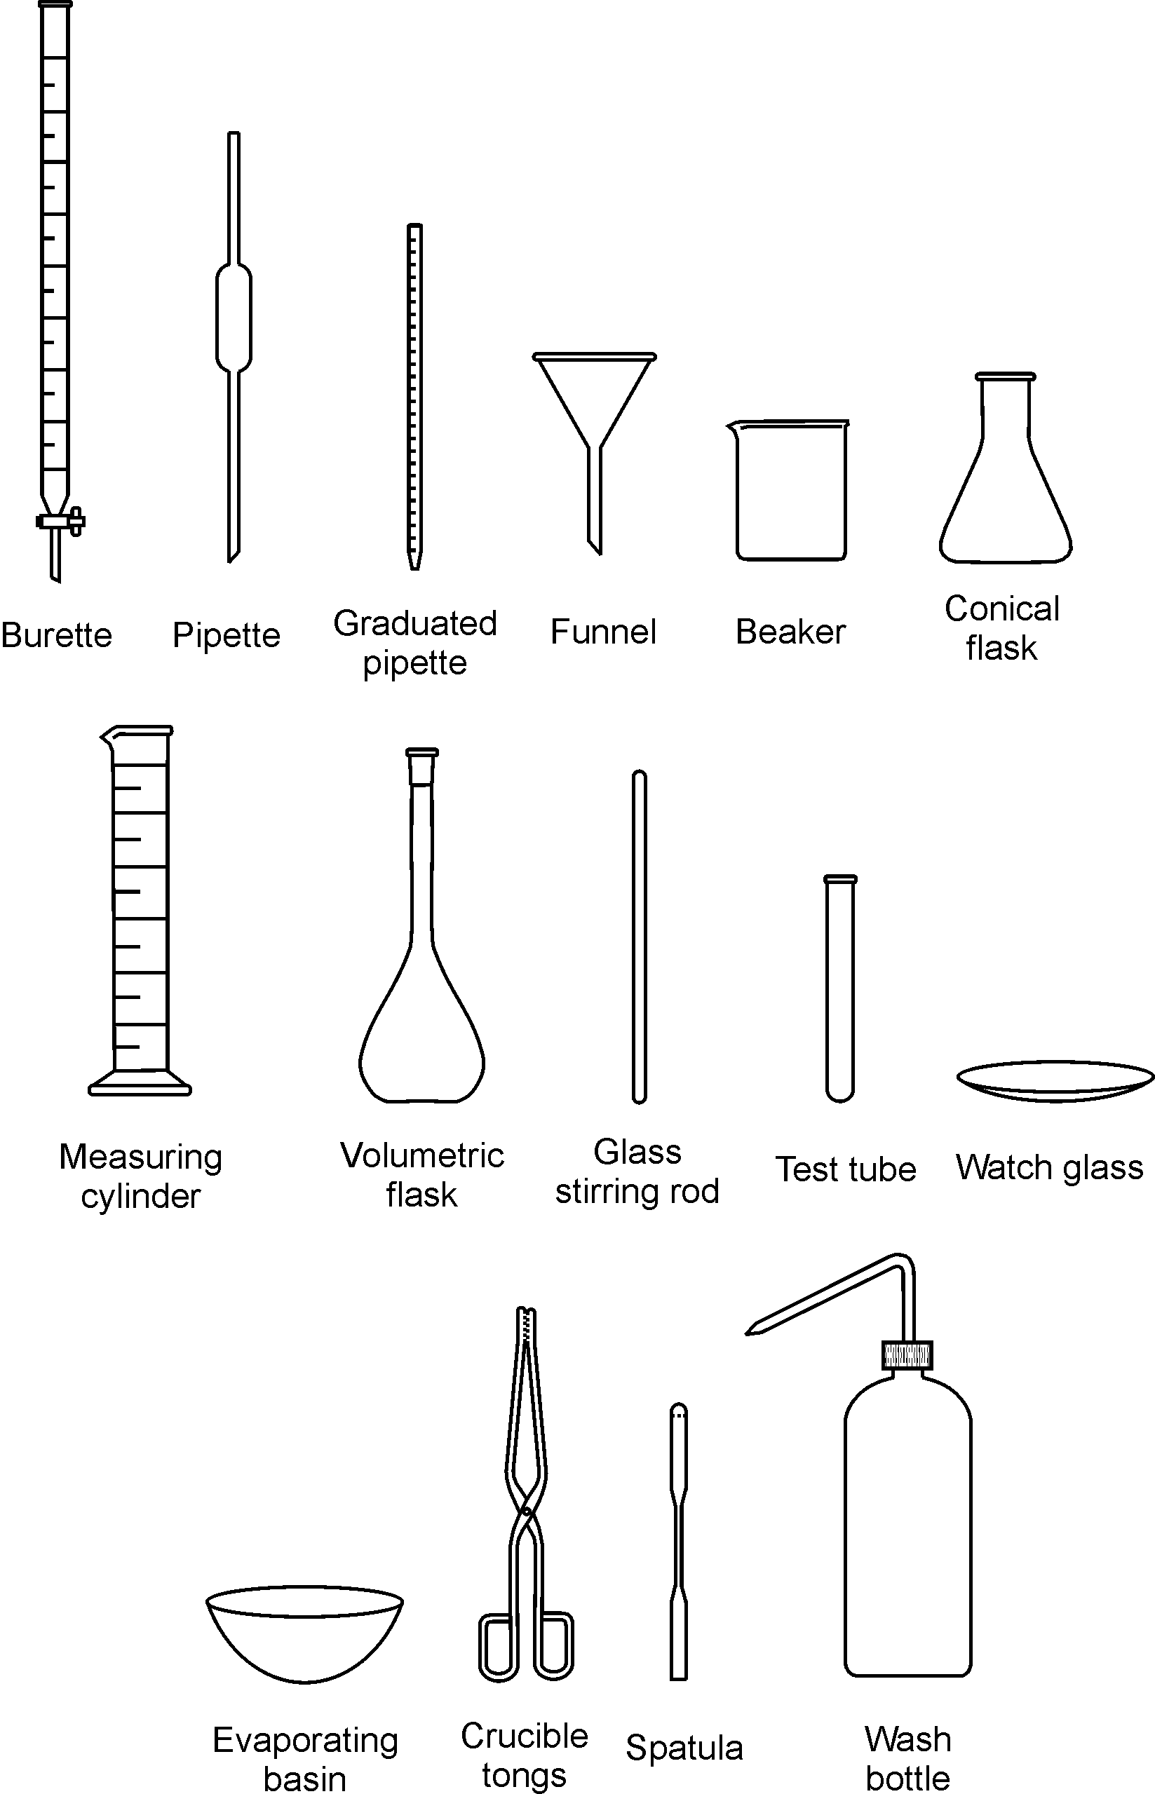

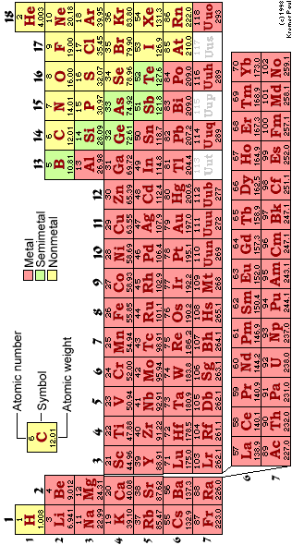

## MANAGING YOUR TIME DURING THE PRACTICAL

1. It is recommended that you arrange your workbench according to the diagram below. Keeping your workspace organised and free of clutter will save you time and frustration, and contributes greatly to laboratory safety.

**BENCH SOLUTIONS**

**⊗ WATER TAP ⊗ GAS TAP ⊗ WATER TAP**

|  |  |  |
| --- | --- | --- |
| USED APPARATUS AND DIRTY GLASSWARE |  | SOLUTIONS AND DRY CHEMICALS |
| PAPERWORK (PRAC MANUAL, REPORT SHEET AND FLOW DIAGRAM) | EXPERIMENTAL SET-UP | CLEAN GLASSWARE |

1. When collecting chemicals:

* Choose the size of your container according to the volume of chemical that you will be collecting, for instance: for 100 cm3 of solution, use a 250 cm3 beaker and for 10 cm3 use a test tube.
* Before collecting chemicals and/or solutions from the dispensary, mark each container with the name or formula of the chemical to be collected. This will prevent any mix-ups later on.

1. Use a small notebook for jotting down masses, measurements and observations. Writing these bits of information on slips of scrap paper that can easily be lost is not only unprofessional, but also risky because it means that your whole afternoon’s practical work can be wasted because of lost data.

# *SAFETY IN THE CHEMISTRY LABORATORY*

The chemistry laboratory is a dangerous environment in which to work. The dangers are often unavoidable since chemists regularly have to use hazardous materials. However, with sensible precautions the laboratory is probably no more dangerous than your home, is it house or apartment. You MUST AT ALL TIMES OBSERVE THE ENTIRE RULE stated in this manual.

**Essential Rules for Laboratory Safety**

The essential rules for laboratory safety can be expressed under two simple headings:

**ALWAYS AND NEVER**

**ALWAYS**

* Familiarize yourself with the laboratory safety procedures.
* Dress appropriately.
* Wash your hands before leaving the laboratory.
* Read the instructions for the laboratory protocol **carefully** before starting any experiment.
* Handle all chemicals with great care.
* Keep your working area tidy.
* Immediately inform your instructor about spills.

**NEVER**

* Eat or drink in the laboratory
* Smoke in the laboratory
* Inhale, taste or sniff chemicals.
* Fool around or distract neighbours.
* Carry out unauthorized experiments.

**Laboratory Safety Procedures**

Your laboratory will have certain procedures, which you must be familiar with. Make sure you know where all the exits from the laboratory are, in the event of an evacuation because of fire or other incident. Locate the SHOWERS and eyewash stations and know the type the fire extinguishers that are in the laboratory and how to operate them.

**Dress Code**

* Wear a Lab coat.
* Wear approved safety goggles or safety glasses when in the lab.
* Avoid floppy garments; avoid things that dangle. These get tangled up in equipment or glassware and cause accidents.
* Avoid long, loose hair styles for the same reason. When Bunsen burners are in use, long hair sometimes catches on fire.
* Avoid open footwear & high heels. Therefore, sandals & thongs are unacceptable.

**LABORATORY TECHNIQUES**

**Handling of Acids or Bases**

* In addition to the dress code above, personal protective equipment, such as Vinyl" gloves or "nitrile" GLOVES SHOULD be worn.
* For even more dangerous liquids, thick "nitrile" gloves should be used. These are very safe.

**Become acquainted with handling laboratory safety equipment e.g.**

* Fire Extinguishers
* Fire Blanket
* Eye-wash Fountain
* First-Aid Kit

**Become acquainted with using of the FUME HOOD**

* Use the HOOD for reactions that give off vapours, especially smelly vapours.
* The draft of the HOOD will sweep away vapours so that the lab itself maintains reasonable air quality.

**Locate the Safety Shower and understand how it works**

* Shower should be used for ***dire EMERGENCY***only!
* If you are ***ON FIRE***, or suffer a ***massive spill*** of a **dangerous chemical**, and need to get it off rapidly.

**Position yourself under the safety shower and pull the handle—a deluge of water will result.**

**Immediately clean up Broken Glass**

* Sweep it up right away
* Place the broken glass in a "SHARP’S CONTAINER.
* This is a thick walled carton that will be sealed and discarded as such.

**Student Use of the Laboratory**

* No UNAUTHORIZED experiments! These are terrible dangers in unskilled hands
* No EATING or DRINKING in the LAB. A good practice is to assume everything in the lab is toxic.
* DO NOT drink from lab equipment. NOT EVEN distilled water.
* When using pipettes, **DO NOT** suck the liquid into the pipette directly by mouth.
* Frequent mistakes, even by skilled lab workers, lead to the liquid reaching the mouth.
* Do NOT smell the flask directly.

**Housekeeping:**

* **STUDENTS MUST CLEAN UP AFTER THEMSELVES.**
* Paper and trash must not be left in the room, thrown into drawers, sinks, on the floor, etc.
* When the equipment boxes are on carts, students who take a box form the cart to do an experiment must put everything back into the box neatly and put the box back on the cart.
* If you absolutely must test the odour, carefully waft the vapour from the flask toward your nose with your hand, keeping the flask quite distant from your face.

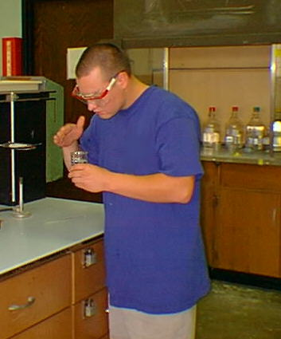

* Make sure that reaction tubes, e.g. test tubes, are not directed toward yourself or other persons. The chemicals may splatter out the tube.

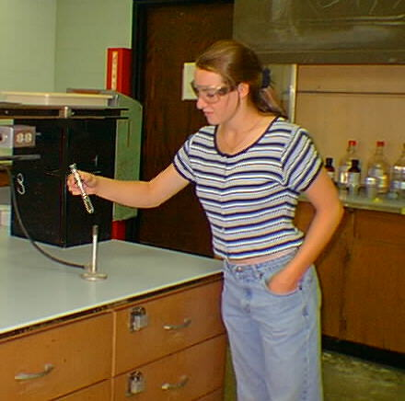

DO NOT add *WATER* to *CONCENTRATED ACID.* The heat generated may cause splattering. If necessary to prepare certain solutions, **DO** add ACID to WATER (instead of the reverse order of addition). The heat generated will be less, but splattering still may occur. A good practice in all lab operations is to keep things at arm’s length.

## GETTING STARTED

For each laboratory period, including the first, you will be required to:

* Study the entire experimental outline in the **Laboratory Manual**. It includes specific directions concerning laboratory philosophy and protocols.
* Prepare your **Laboratory Notebook**. Include a summary and a procedural outline for your experiment (see "Rules for Keeping Your Laboratory Notebook" and Instruction in the experiment outline).
* Bring your safety goggles. These provide adequate protection against accidental splashing of corrosive chemicals.
* Come to lab dressed appropriately

**A GOOD PRACTICE:**

Read the experimental procedure ahead of lab.

Avoid horseplay. In a laboratory setting, horseplay, even if good-natured, is unacceptable.

* No pushing!
* No shoving!

At the end of the lab period: Exit the lab in an orderly manner. Again: no running, no pushing, AND NO shoving

Lab 1: PREPARATION OF A SOLUBLE SALT BY A TITRATION METHOD

AIM:

To Prepare Sodium Chloride crystals by Titration of Sodium Hydroxide with Hydrochloric acid

APPARATUS:

Burette (50cm3), pipette (25cm3), two conical flasks (250cm3), two beakers (250cm3), funnel, wash bottle, retort stand, boss and clamp, evaporating dish,

Bunsen, tripod and gauze, glass rod, pipette filler.

MATERIALS:

Approximately 2.0 mol dm-3 hydrochloric acid, 1.0 mol dm-3 sodium hydroxide, phenolphthalein indicator

PROCEDURE:

1. Rinse the burette twice with a little hydrochloric acid and fill up to just above the zero mark.
2. Run out acid to remove any air trapped in the jet and refill to above the zero mark.
3. Open the tap of the burette and allow acid to run out until the bottom of the meniscus is just on the zero mark when viewed at eye level.
4. Remove any hanging drop from the jet by touching against the inside of the beaker containing the acid.
5. Draw up sodium hydroxide solution using the pipette to above the graduation mark and allow the solution to run into the sink. This is the rinsing of the pipette.
6. Draw up sodium hydroxide solution using the pipette to above the graduation mark and allow the meniscus to fall until the bottom of the meniscus is resting on the graduation mark when viewed at eye level.
7. Run the sodium hydroxide solution from the pipette into a conical flask. After all the liquid has run out from the pipette touch the tip of the pipette against the bottom of the flask and withdraw after 15 sec.
8. Repeat steps 6 and 7 using the other conical flask.
9. Place two drops of phenolphthalein indicator into each flask.
10. Perform titrations on the contents of each flask against the acid from the burette.
11. Record your results in a table and use this to find the end-point of the titration.

*Burette Readings*

|  |  |  |  |  |
| --- | --- | --- | --- | --- |
|  | Rough | Accurate  1 2 3 | | |
| Final burette reading /cm3 |  |  |  |  |
| Initial burette reading/cm3 |  |  |  |  |
| Volume used/cm3 |  |  |  |  |

1. Pipette 25.0 cm3 of the sodium hydroxide solution into the evaporating dish.
2. Refill the burette with acid and add the accurate volume of acid obtained in your titration to the sodium hydroxide in the evaporating dish.
3. Place the evaporating dish on the tripod with gauze and heat to evaporate and concentrate  
   the solution.
4. Continue heating until crystals of sodium chloride form.
5. Turn off the burner and leave the dish to cool. The sodium chloride would appear as white crystals.
6. Calculate the mass of sodium chloride crystals formed.

SAMPLE CALCULATION:

The concentration of the sodium hydroxide solution was 1.0 mol dm-3. This means that:

1000 cm3 of solution contains 1 mole of sodium hydroxide

Hence 1 cm3 of solution contains 1/1000 moles of sodium hydroxide

Hence 25.0 cm3 solution contains 1/1000 x 25.0 moles of sodium hydroxide i.e. .025 mol

The sodium hydroxide solution is exactly neutralized by the hydrochloric acid according to the equation:

NaOH (aq) + HCI (aq) NaCl (aq) + H2O (I)

From the equation we see that:

1 mol of NaOH reacts with 1 mol of HCl to give 1 mol of NaCl

Hence .025 mol of NaOH will react with .025 mol of HC1 to give .025 mol of NaCl.

The mass in grams of .025 mol of NaCl is given by: Mass in grams = mol x molar mass

Lab 2: Redox Titration

Aim

To Determine the Number of Molecules of Water of Crystallization in ammonium iron (II) sulphate crystals

Apparatus

Burette (50cm3), pipette (25cm3), two conical flasks (250cm3), three Beakers (250cm3), measuring cylinder (25cm3), funnel, wash bottle, retort stand, boss and clamp, pipette filler.

Material

0.020 mol dm-3 potassium manganate(VII) solution, 39.2 g dm-3 ammonium iron(II) sulphate, 1 mol dm-3 sulphuric acid.

Theory

Ammonium iron (II) sulphate is a double salt with the formula (NH4)2Fe (SO4)2.nH2O, where n is the number of molecules of water of crystallization. Hence the properties of its solution will be those of its component ions. One of these ions is Fe2+ and this is the actual reducing agent. The potassium manganate (VII) is the oxidizing agent. The reaction between the MnO4- ion of potassium manganate (VII) and Fe2+ of the ammonium iron (II) sulphate is given by the redox equation:

MnO4-(aq) + 5Fe2+ (aq) + 8H+(aq) Mn2+(aq) + 5Fe3+(aq) + 4H2O(l)

From this equation it can be seen that 1 mol of MnO4- reacts with 5 mol of Fe2+. Using this equation and the results of the titration, the concentration of the Fe2+ ions can be determined. From this result, and the information provided, the number of molecules of water of crystallization in the double salt can also be calculated.

PROCEDURE:

1. Rinse the burette twice with a little potassium manganate (VII) solution and fill above the zero mark.
2. Run out potassium manganate (VII) to remove any air trapped in the jet and refill to above the zero mark.
3. Open the tap of the burette and allow potassium manganate (VII) to run out until the top of the meniscus is just on the zero mark when viewed at eye level.- with manganate(VII) titrations you read the top of the meniscus since the bottom of the meniscus is not clearly visible.
4. Remove any hanging drop from the jet by touching against the inside of the beaker containing the potassium manganate (VII).
5. Draw up the ammonium iron (II) sulphate solution using the pipette to above the graduation mark and allow the solution to run into the waste beaker. This is the rinsing of the pipette.
6. Draw up the ammonium iron (II) sulphate solution using the pipette to above the graduation mark and allow the meniscus to fall until the bottom of the meniscus is resting on the graduation mark when viewed at eye level.
7. Run the ammonium iron (II) sulphate solution from the pipette into a conical flask. After all the liquid has run out from the pipette touch the tip of the pipette against the bottom of the flask and withdraw after 15 sec.
8. Using the measuring cylinder, add 25 cm3 of dilute sulphuric acid to the conical flask.
9. Repeat steps 6, 7 and 8 using the other conical flask.
10. Perform titrations on the contents of each flask against the potassium manganate (VII) from the burette until the first permanent trace of pink is obtained.
11. Record your results in a table and repeat the titration until you obtain consistent results.

RESULTS: Burette

|  |  |  |  |  |
| --- | --- | --- | --- | --- |
|  | Rough | Accurate  1 2 3 | | |
| Final burette reading /cm3 |  |  |  |  |
| Initial burette reading/cm3 |  |  |  |  |
| Volume used/cm3 |  |  |  |  |

TREATMENT OF RESULTS:

1. Calculate the number of moles of MnO4- in the volume used in the titration using your mean titre volume.
2. Using your answer to 1 and the mole ratio of the equation, calculate the number of moles of Fe2+ in the 25.0 cm3 pipette.
3. Use your answer to 2 to calculate the concentration of Fe2+ in mol dm-3.
4. Divide 39.2 g dm-3 by your answer to 3 to get the relative molecular mass of the double salt.
5. 284 + 18n = answer from 4. Use this to calculate n.
6. Your answer for n to the nearest whole number is the number of molecules of water of  
   crystallization in ammonium iron (II) sulphate.

Lab 3: Determination of Concentration of an Unknown Solution by Titration Method

AIM:

To determine the concentration of an unknown solution of sodium hydroxide

APPARATUS:

Burette (50cm3), pipette (25cm3), three conical flasks (250cm3), three beakers (250cm3), funnel, wash bottle, retort stand, boss and clamp, evaporating dish, Bunsen, tripod and gauze, glass rod, pipette filler.

MATERIALS:

Approximately 1.0 mol dm-3 hydrochloric acid, unknown sodium hydroxide solution, phenolphthalein indicator

PROCEDURE:

1. Rinse the burette twice with a little hydrochloric acid and fill up to just above the zero mark.
2. Run out acid to remove any air trapped in the jet and refill to above the zero mark.
3. Open the tap of the burette and allow acid to run out until the bottom of the meniscus is just on the zero mark when viewed at eye level.
4. Remove any hanging drop from the jet by touching against the inside of the beaker containing the acid.
5. Draw up sodium hydroxide solution using the pipette to above the graduation mark and allow the solution to run into the waste beaker. This is the rinsing of the pipette.
6. Draw up sodium hydroxide solution using the pipette to above the graduation mark and allow the meniscus to fall until the bottom of the meniscus is resting on the graduation mark when viewed at eye level.
7. Run the sodium hydroxide solution from the pipette into a conical flask. After all the liquid has run out from the pipette touch the tip of the pipette against the bottom of the flask and withdraw after 15 sec.
8. Repeat steps 6 and 7 using the other conical flask.
9. Place two drops of phenolphthalein indicator into each flask.
10. Perform titrations on each flask against the acid from the burette.
11. Record your results in a table and use this to find the end-point of the titration.

*Burette Readings*

|  |  |  |  |  |
| --- | --- | --- | --- | --- |
|  | Rough | Accurate  1 2 3 | | |
| Final burette reading /cm3 |  |  |  |  |
| Initial burette reading/cm3 |  |  |  |  |
| Volume used/cm3 |  |  |  |  |

TREATMENT OF RESULTS:

1. Write a balanced equation for the reaction in this experiment
2. Calculate the mean titre volume
3. Calculate the number of moles of HCl in the volume used in the titration using your mean titre volume.
4. Using your answer to 3 and the mole ratio of the equation, calculate the number of moles of NaOH in the 25.0 cm3 pipette.
5. Calculate the number of moles of NaOH present in 1dm3 of solution (concentration in moldm-3)
6. Calculate the concentration of NaOH in gdm-3

**APPENDIX A**

LAB REPORT SHEET FORMAT

**NAME:**

**PARTNER(S) NAME:**

**DATE:**

**TITLE:**

**AIM:** brief description of the purpose of the lab.

**APPARATUS:** list of all the equipment and chemicals that were used in the exercise.

**METHOD:** written in past perfect tense, this is a numbered sequence of the steps that were followed to carry out the exercise.

E.g. The addition of iodine to a test tube would be described in the following way:

“The iodine **was added** to the test tube…”

NOT

“They added iodine to the test tube…”

**PRECAUTIONS FOR ACCURATE RESULTS AND SAFETY:**

* List of two important precautions which must be followed when using the equipment for the lab exercise.
* For the procedure followed in the virtual lab, suggest two safety measures which must have been observed.

**RESULTS:** present the results of the experiment (the things you saw or heard). Draw a table wherever possible (title should be written in caps and underlined **above** the table).

**CONCLUSION:** in relation to the aim of the experiment, the deductions made based on the results obtained.

**ANSWERS TO QUESTIONS**: answer any post lab questions.

**APPENDIX B**

EXAMPLE OF A COMPLETED LAB REPORT SHEET

**NAME:** Jane Joelly

**PARTNER’S NAME**: Richard Rally

**DATE:** 20.05.2016

**TITLE**: Osmosis

**AIM:** To observe the process of osmosis.

APPARATUS: 3 cups, vinegar, corn syrup, water, egg, stop-clock.

**METHOD:**

* 1. The egg was soaked in vinegar for two days.
  2. The egg shell was then removed leaving the soft membrane still holding the yolk and albumen.
  3. The egg was then placed in a cup containing enough corn syrup to cover most of it and left for an hour.
  4. Any difference in size and appearance was recorded.
  5. The egg was then placed in another cup containing just enough fresh water to cover most of it for another two hours.
  6. Any difference in size and appearance was recorded.

**PRECAUTIONS FOR ACCURATE RESULTS AND SAFETY:**

Accuracy:

* The stop clock was tested before use to ensure that it was working properly.
* The batteries in the stopclock were changed to ensure that they did not run out during the experiment.

Safety:

* Gloves should have been worn to protect the hands from vinegar.
* Protective glasses were worn to protect the eyes form the vinegar.

**RESULTS:**

After I hour in the corn syrup, the egg was smaller than it was at first. There were also wrinkles on the surface.

After 10 minutes in the fresh water, the wrinkles disappeared. The longer the egg stayed in the fresh water, the larger it swelled.

**CONCLUSION:**

In this experiment, osmosis was observed. Osmosis is the movement of water particles from a dilute solution to a more concentrated solution across a semi-permeable membrane. When the egg shell was removed, the membrane left behind was semi-permeable. The albumen was more dilute than the corn syrup, so water moved from the albumen across the semi-permeable membrane and into the syrup. This caused the egg to reduce in size and wrinkle. The albumen was more concentrated than the fresh water however, so water particles moved across the semi-permeable membrane into the egg, making it swell.

**ANSWERS TO QUESTIONS:**

1. Would the same observations be made with an egg with the shell intact?

No, because the egg shell is not semi-permeable.

1. If the experiment is carried out using the same method but replacing the corn syrup with salt water what observations would be made?

The same observations would be made once the concentration of the salt solution was higher than that of the albumen.

**APPENDIX C**

**LAB RUBRIC**

**This is the Mark Scheme which will be used to score your Lab Reports**

|  |  |  |  |  |  |
| --- | --- | --- | --- | --- | --- |
| **SECTION** | **COMPETENCY** | **PERFORMANCE RATING** | | | |
| **Excellent**  **4** | **Average**  **3** | **Fair**  **2** | **Poor**  **1** |
| **Aim** | Effective Communication | The aim is clearly stated. | The aim is slightly unclear. | The aim is quite vague. | The aim is not stated. |
| **Apparatus** | Knowledge | Apparatus list is complete. Student gives the correct name of all equipment used. | Apparatus list is complete. Student gives the correct name of most equipment used. | Apparatus list is incomplete. Student gives the correct name of most the equipment they listed. | Apparatus list is incomplete. Student gives the correct name of only a few pieces of the equipment they listed. |
| **Method** | Effective  Communication | Method is correct, logical, complete and written in appropriate tense. | Method is incorrect, or illogical, or incomplete or written in inappropriate tense. | Method has two - three deficiencies. | Method is incorrect and illogical and incomplete and written in inappropriate tense. |
| Technical expertise | Students suggest at least two precautions and two safety measures for each lab which are relevant and accurate. | Students suggest at least one precaution and one safety measure for each lab is relevant and accurate. | Students suggest at least one precaution or one safety measure for each lab which is relevant and accurate. | Students do not suggest any precaution or safety measure which is relevant and accurate. |
| **Results** | Effective  Communication | Each observation is accurately and completely included. | Most observations are accurately and completely included. | Few observations are accurately and completely included. | No observations are accurately and completely included. |
| Technological Expertise | All results are recorded in appropriate format. All calculations, tables and graphs are done correctly. | Most results are recorded in appropriate format or most calculations, tables and graphs are done correctly. | Most results are not recorded in appropriate format or most calculations, tables and graphs are not done correctly. | Most results are not recorded in appropriate format and most calculations, tables and graphs are not done correctly. |
| **Conclusion** | Analytical Ability | The chemical principles underlying each observation are fully explained and relevant conclusions are made. | The chemical principles underlying most observations are fully explained and relevant conclusions are made. | The chemical principles underlying few observations are fully explained and relevant conclusions are made. | No observations are fully explained and irrelevant conclusions are made. |
| **Post lab questions/ Post Lab Worksheet** | Analytical Ability | All questions answered correctly. | Most questions answered correctly. | Few questions answered correctly. | No questions answered correctly. |

**APPENDIX D**

**LAB ASSESSMENT SHEET**

The marks for each lab you submit will be recorded on one of these sheets by the Lab Lecturer.

|  |  |  |  |  |  |  |
| --- | --- | --- | --- | --- | --- | --- |
| 1. **Student Name:** | |  | | | | |
| 1. **Course:** | |  | | | | |
| 1. **CRN:** | |  | | | | |
| 1. **Lab #:** | |  | | | | |
| 1. **Date:** | |  | | | | |
| **Section** | **Competency** | **SCORE** | | | | **COMMENTS** |
| **Aim** | Eff. Comm. 1 | **4** | **3** | **2** | **1** |  |
| **TOTAL** |  | | | | |
| **Apparatus** | Knowledge | **4** | **3** | **2** | **1** |  |
| **TOTAL** |  | | | | |
| **Method** | Eff. Comm. | **4** | **3** | **2** | **1** |  |
| Tech. Exp. | **4** | **3** | **2** | **1** |  |
| **TOTAL** |  | | | | |
| **Results** | Tech. Exp. | **4** | **3** | **2** | **1** |  |
| Eff. Comm. | **4** | **3** | **2** | **1** |  |
| **TOTAL** |  | | | | |
| **Conclusion** | Analytical Ability | **4** | **3** | **2** | **1** |  |
| **TOTAL** |  |  |  |  |  |
| **Post Lab questions** | Anal. Ability | **4** | **3** | **2** | **1** |  |
| **TOTAL** |  | | | | |
| **TOTAL LAB MARK /32:** | |  | | | | |
| **TOTAL LAB MARK (%):** | |  | | | | |
| **LAB LECTURER:** | |  | | | | |