

COLLEGE OF SCIENCE, TECHNOLOGY & APPLIED ARTS OF

TRINIDAD & TOBAGO

Department of Natural & Life Sciences

CHEM 090 – INTRODUCTION TO

CONCEPTS IN CHEMISTRY

C:\Documents and Settings\klopez\Local Settings\Temporary Internet Files\Content.IE5\V6SKV1CF\MC900290699[1].wmf

## A Word of Welcome

The Department of Natural & Life Sciences welcomes you to the practical component of the course. The experiments that form part of this course were selected to:

* reinforce your knowledge and understanding of the theoretical content of your Chemistry course,
* develop skills such as observing, recording, measuring and reporting of results, and
* Teach you special techniques, such as weighing, pipetting, titrating, filtration etc, so that you will become familiar with the basics of laboratory work.

bd06220_

## WASTE DISPOSAL

We all have a responsibility towards a clean and safe environment. The Chemistry Department’s policy dealing with the disposal of laboratory waste is in accordance with the Occupational Health and Safety Act, which is a law of our country. We do not expect you to understand every aspect of this law, but as responsible citizen and laboratory user, you must be aware of the correct procedures for disposal of the different classes of laboratory waste. You will be given specific instructions on how to dispose of your chemical wastes during each pre-lab briefing. Here are also some general rules that you must be taken:

1. Place broken glass into the specially marked bins.
2. Drain all harmless chemicals in solution into the sink followed by plenty of running water.
3. Pour organic waste solutions into the specially labelled container in the fume cupboard.
4. Pour toxic inorganic waste solutions into the specially labelled container in the fume cupboard.
5. Discard paper and any other solid waste into the bin
6. Ensure that matches are extinguished before disposing of them in this way.
7. Shut off all gas and water lines when not in use.

**FIGURE 1**: APPARATUS THAT YOU WILL BE USING IN THE LABORATORY

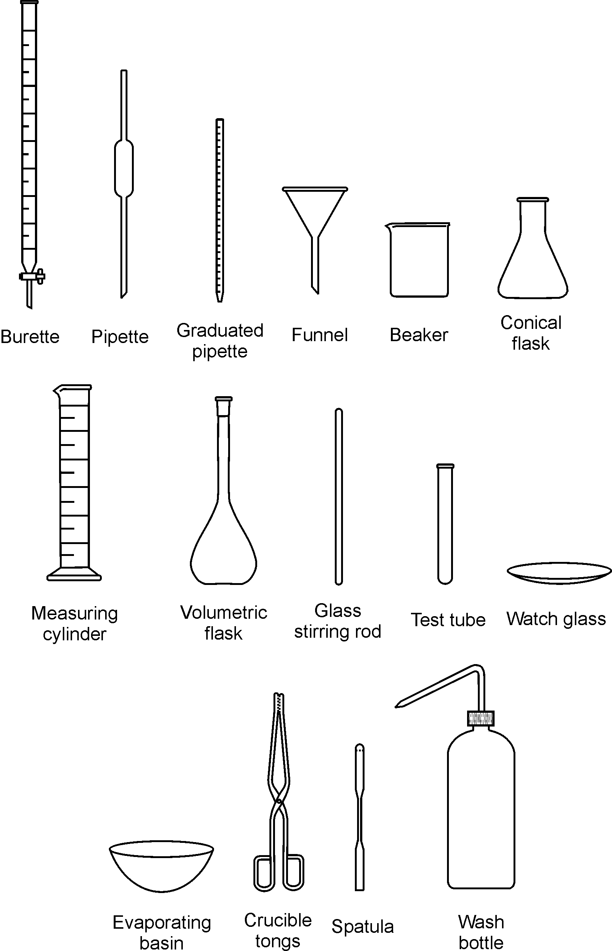

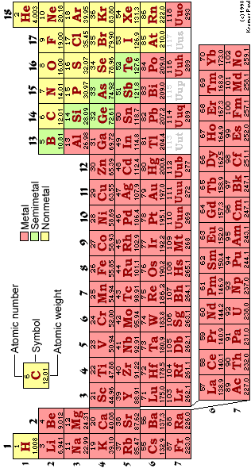

## MANAGING YOUR TIME DURING THE PRACTICAL

1. It is recommended that you arrange your workbench according to the diagram below. Keeping your workspace organised and free of clutter will save you time and frustration, and contributes greatly to laboratory safety.

**BENCH SOLUTIONS**

**⊗ WATER TAP ⊗ GAS TAP ⊗ WATER TAP**

|  |  |  |
| --- | --- | --- |
| USED APPARATUS AND DIRTY GLASSWARE |  | SOLUTIONS AND DRY CHEMICALS |
| PAPERWORK (PRAC MANUAL, REPORT SHEET AND FLOW DIAGRAM) | EXPERIMENTAL SET-UP | CLEAN GLASSWARE |

1. When collecting chemicals:

* Choose the size of your container according to the volume of chemical that you will be collecting, for instance: for 100 cm3 of solution, use a 250 cm3 beaker and for 10 cm3 use a test tube.
* Before collecting chemicals and/or solutions from the dispensary, mark each container with the name or formula of the chemical to be collected. This will prevent any mix-ups later on.

1. Use a small notebook for jotting down masses, measurements and observations. Writing these bits of information on slips of scrap paper that can easily be lost is not only unprofessional, but also risky because it means that your whole afternoon’s practical work can be wasted because of lost data.

# *SAFETY IN THE CHEMISTRY LABORATORY*

The chemistry laboratory is a dangerous environment in which to work. The dangers are often unavoidable since chemists regularly have to use hazardous materials. However, with sensible precautions the laboratory is probably no more dangerous than your home, is it house or apartment. You MUST AT ALL TIMES OBSERVE THE ENTIRE RULE stated in this manual.

**Essential Rules for Laboratory Safety**

The essential rules for laboratory safety can be expressed under two simple headings:

**ALWAYS AND NEVER**

**ALWAYS**

* Wear lab coats in the lab.
* Familiarize yourself with the laboratory safety procedures.
* Dress appropriately.
* Wash your hands before leaving the laboratory.
* Read the instructions for the laboratory protocol **carefully** before starting any experiment.
* Handle all chemicals with great care.
* Keep your working area tidy.
* Immediately inform your instructor about spills.

**NEVER**

* Eat or drink in the laboratory
* Smoke in the laboratory
* Inhale, taste or sniff chemicals.
* Fool around or distract neighbours.
* Carry out unauthorized experiments.

**Laboratory Safety Procedures**

Your laboratory will have certain procedures, which you must be familiar with. Make sure you know where all the exits from the laboratory are, in the event of an evacuation because of fire or other incident. Locate the SHOWERS and eyewash stations and know the type the fire extinguishers that are in the laboratory and how to operate them.

**Dress Code**

* Wear a Lab coat.
* Wear approved safety goggles or safety glasses when in the lab.
* Avoid floppy garments; avoid things that dangle. These get tangled up in equipment or glassware and cause accidents.
* Avoid long, loose hair styles for the same reason. When Bunsen burners are in use, long hair sometimes catches on fire.
* Avoid open footwear & high heels. Therefore, sandals & thongs are unacceptable.

**LABORATORY TECHNIQUES**

**Handling of Acids or Bases**

* In addition to the dress code above, personal protective equipment, such as Vinyl" gloves or "nitrile" GLOVES SHOULD be worn.
* For even more dangerous liquids, thick "nitrile" gloves should be used. These are very safe.

**Become acquainted with handling laboratory safety equipment e.g.**

* Fire Extinguishers
* Fire Blanket
* Eye-wash Fountain
* First-Aid Kit

**Become acquainted with using of the FUME HOOD**

* Use the HOOD for reactions that give off vapours, especially smelly vapours.
* The draft of the HOOD will sweep away vapours so that the lab itself maintains reasonable air quality.

**Locate the Safety Shower and understand how it works**

* Shower should be used for ***dire EMERGENCY***only!
* If you are ***ON FIRE***, or suffer a ***massive spill*** of a **dangerous chemical**, and need to get it off rapidly.

**Position yourself under the safety shower and pull the handle—a deluge of water will result.**

**Immediately clean up Broken Glass**

* Sweep it up right away
* Place the broken glass in a "SHARP’S CONTAINER.
* This is a thick walled carton that will be sealed and discarded as such.

**Student Use of the Laboratory**

* No UNAUTHORIZED experiments! These are terrible dangers in unskilled hands
* No EATING or DRINKING in the LAB. A good practice is to assume everything in the lab is toxic.
* DO NOT drink from lab equipment. NOT EVEN distilled water.
* When using pipettes, **DO NOT** suck the liquid into the pipette directly by mouth.
* Frequent mistakes, even by skilled lab workers, lead to the liquid reaching the mouth.
* Do NOT smell the flask directly.

**Housekeeping:**

* **STUDENTS MUST CLEAN UP AFTER THEMSELVES.**
* Paper and trash must not be left in the room, thrown into drawers, sinks, on the floor, etc.
* When the equipment boxes are on carts, students who take a box form the cart to do an experiment must put everything back into the box neatly and put the box back on the cart.
* If you absolutely must test the odour, carefully waft the vapour from the flask toward your nose with your hand, keeping the flask quite distant from your face.

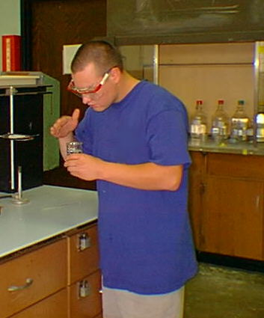

* Make sure that reaction tubes, e.g. test tubes, are not directed toward yourself or other persons. The chemicals may splatter out the tube.

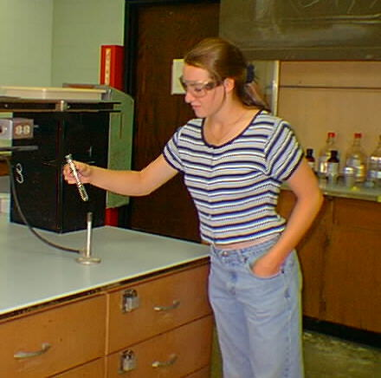

DO NOT add *WATER* to *CONCENTRATED ACID.* The heat generated may cause splattering. If necessary to prepare certain solutions, **DO** add ACID to WATER (instead of the reverse order of addition). The heat generated will be less, but splattering still may occur. A good practice in all lab operations is to keep things at arm’s length.

## GETTING STARTED

For each laboratory period, including the first, you will be required to:

* Study the entire experimental outline in the **Laboratory Manual**. It includes specific directions concerning laboratory philosophy and protocols.
* Prepare your **Laboratory Notebook**. Include a summary and a procedural outline for your experiment (see "Rules for Keeping Your Laboratory Notebook" and Instruction in the experiment outline).
* Bring your safety goggles. These provide adequate protection against accidental splashing of corrosive chemicals.
* Come to lab dressed appropriately with a lab coat on.

**A GOOD PRACTICE:**

Read the experimental procedure ahead of lab.

Avoid horseplay. In a laboratory setting, horseplay, even if good-natured, is unacceptable.

* No pushing!
* No shoving!

At the end of the lab period: Exit the lab in an orderly manner. Again: no running, no pushing, AND NO shoving

LAB 1A: INTRODUCTION TO CHEMISTRY PRACTICALS

AIM:

In this introductory practical you would be asked:

1. To identify and name some of the apparatus used in Chemistry Practicals.
2. To measure the volume of a liquid correctly using a measuring cylinder,
3. To measure temperature correctly using a mercury-in-glass thermometer.

APPARATUS:

burette, graduated pipette, fixed volume pipette, retort stand boss and clamp, conical flask, beaker, funnel, wash bottle, measuring cylinders, volumetric flasks, glass stirring rod, watch glass, evaporating basin, crucible tongs, wash bottle, thermometer, stopwatch, balance, test tubes, boiling tube, test tube rack, test tube holder, spatula, Bunsen burner.

MATERIALS: distilled water

PROCEDURE:

1. You are provided with various apparatus used in chemistry practicals. The names of these  
   apparatus are listed above. You are to identify, name and draw diagrams/sketches of these  
   apparatus.
2. Draw up a list of the names and uses of each apparatus as follows:  
   Example:

Name of apparatus Use

Burette measuring volumes of liquids

1. Take the 100 cm3 measuring cylinder, place it on the bench top and add water from the wash bottle to give a reading of 45 cm3 of water measured. You must view the bottom of the water meniscus at eye level. Check the diagram on the board.
2. Take the thermometer and place it in the water in the measuring cylinder. Record the reading  
   on the thermometer when the mercury level is steady. View the mercury meniscus at eye level.
3. Repeat steps 3 and 4 using the 10 cm3 measuring cylinder (measure 8 cm3 of water).

TREATMENT OF RESULTS:

1. Place in order of accuracy, most accurate first, the accuracy of the following apparatus used for measuring liquid volumes: Burette, Beaker, Measuring cylinder and Volumetric flask.
2. To what decimal position can you measure accurately, using the thermometer you were provided with?
3. Why is accuracy of measurements in the lab so important?
4. Why is lab safety so important?
5. Distinguish between distilled and deionised water.
6. Why do we always view the meniscus at eye level?

Lab 1B: DETERMINATION OF MELTING POINT

AIM:

To Determine the Melting-Point of Stearic Acid from its Cooling Curve.

APPARATUS:

Retort stand, boss and clamp; Bunsen burner, tripod, wire gauze,

Beaker (250 cm3), conical flask (250 cm3), boiling tube, test tube holder,

Thermometer (-10 to +110 °C at 0.5 °C), stop clock

MATERIALS:

Pure powdered stearic acid- about 2.5 cm depth in a boiling tube

PROCEDURE:

1. Set up a water bath by pouring approximately 150 cm3 of water into the
2. 250cm3 beaker and then placing it on the tripod and gauze with Bunsen burner under the tripod.
3. Place the boiling tube containing the pure powdered stearic acid in the  
   water bath so that the level of water is above the level of the stearic acid  
   in the boiling tube-you may need to top up the water in the beaker.
4. Light the Bunsen burner under the water bath and heat until the  
   stearic acid melts.
5. When the stearic acid has melted place a thermometer in the boiling tube-  
   see that the thermometer bulb is well covered by the stearic acid without  
   it touching the bottom or sides of the boiling tube.
6. Continue heating until the liquid stearic acid is at about 80 °C.
7. Turn off the burner.
8. Take the temperature reading and start the stop clock.
9. Take temperature readings every minute until it cools down till you get 3 consecutive readings as the stearic acid cools the thermometer should be GENTLY turned to  
   stir the liquid, but this *must be stopped* as soon as the first crystals of  
   solid appear.
10. Note the temperature when solid stearic acid first appears.
11. Record your results in a table.
12. Plot a graph of Temperature °C (y-axis) against Time in minutes (x-axis).
13. At the end of the experiment leave the thermometer in place- do not attempt to remove the thermometer embedded in the solid stearic acid.

QUESTIONS:

1. At what temperature did the first crystals of stearic acid appear?
2. How can you use your graph to find the freezing point of stearic acid?
3. What is the melting point of pure stearic acid?
4. If the stearic acid were impure, would the freezing point of stearic acid be higher or lower than the value you obtained in this experiment?
5. Explain the shape of your graph.

Lab 2: Separation of Mixtures

**AIM**: To separate mixtures using different separating techniques.

1. **Filtration**

**Apparatus:** 2 Beakers, stirring rod, filter paper, funnel, retort stand and boss clamp

**Materials:** Sand and water.

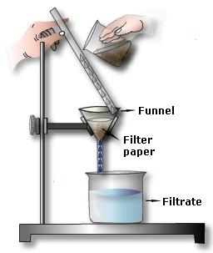 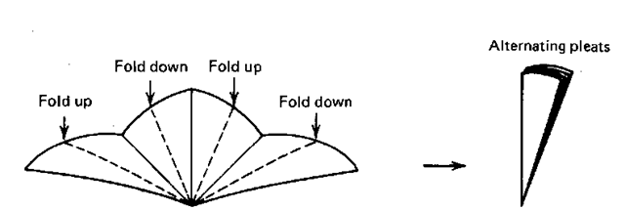

**Procedure:**

1. Set up your apparatus as seen in the diagram above.
2. Your lecturer will show you how to flute your filter paper.
3. Pour your mixture of sand and water into the funnel slowly. Ensure all the mixture gets into the filter paper.
4. Allow the mixture to pass through the filter paper.
5. Record your observations.

**Questions:**

1. Define what a mixture is.
2. Which substance remained in the funnel?
3. What is the term given to the substance which remained in the funnel?
4. Why did the substance remain in the funnel?
5. Is the filtrate pure? Explain.
6. Why do you need to flute your filter paper?
7. **Separating funnel**

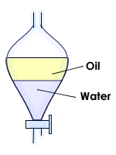

**Apparatus**: Separating funnel and beaker.

**Materials**: Oil and water.

**Procedure**:

1. Pour the mixture into the separating funnel. Ensure the tap is closed off.
2. Close the top of the separating funnel and shake vigorously.
3. Keep shaking and stop at 20 second intervals and release the air pressure inside the separating funnel by holding the funnel upwards and opening the tap.
4. Close the tap and re-do this about 5 times.
5. Allow to rest until you see a distinct line between the 2 solutions.
6. Gently pour off the lower level solution into a beaker by opening the tap. Stop when the low density solution reaches the tap.
7. For accuracy, discard the area between the line of separation of the liquids.

**Questions**:

1. Give definitions of immiscible and miscible liquids.
2. Give another example of 2 immiscible liquids besides water and oil.
3. Why was the water at the bottom of the mixture?
4. Why did you need to open the separating funnel at different intervals?
5. Why do the solutions not mix?

1. **Chromatography**

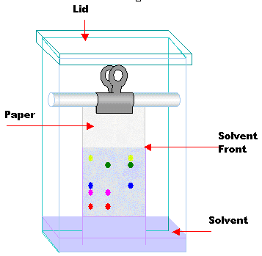 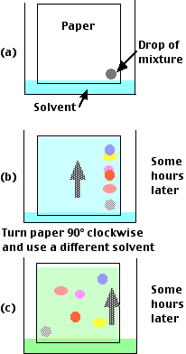

**Apparatus**: 1000mL Beaker, filter paper, tape or clip, stirring rod or pencil, dropper.

**Materials**: dye or coffee, salt and water.

**Procedure**:

1. Cut a piece of filter paper into a 5cm x 10cm rectangle.
2. **Using a pencil**, draw a horizontal line at 1cm from the tip of one end of the filter paper.
3. Place the filter paper into the beaker and allow the bottom of the filter paper to touch the bottom of the beaker and attach the excess outside the top to a stirring rod.
4. Remove the filter paper and pour a 5% salt water solution into the beaker. Fill it to 1cm above the bottom of the beaker.
5. **Using a pencil**, label 2 spots along the horizontal line. Using a dropper, add a drop of each dye onto each spot and wait 5 minutes for it to dry.
6. Place the filter paper into the beaker and ensure that the liquid in the beaker is below the horizontal line. Cover the beaker and leave for 10 minutes or until the solvent reaches about 3 cm from the top of the filter paper.
7. Observe your recordings. Measure the movements and colours seen.

**Questions**:

1. Which is the stationary phase and which is the mobile phase?
2. List the colours which make up each dye.
3. Why did one dye travel further and faster than the other?
4. What is the purpose of the 5% salt water?
5. **Simple Distillation (Demonstration)**

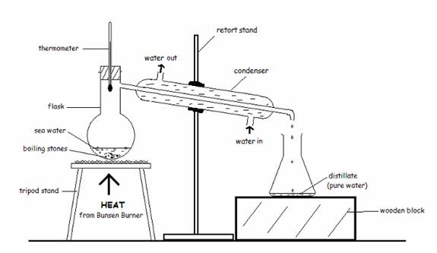**Apparatus**: Bunsen burner, simple distillation apparatus, beaker.

**Procedure**: The lab technician and lab lecturer will demonstrate the separation of salt and water using the apparatus seen above.

**Questions**:

1. Define the terms “solute” and “solvent”?
2. What is the reason for the thermometer in the apparatus set up?
3. How does the condenser work?
4. What is the purpose of the boiling chips?
5. What is the difference between simple distillation and fractional distillations?
6. Give an example of a commercial use for simple distillation.

Lab 3: EFFECT OF TEMPERATURE ON THE SOLUBILITY OF A SALT

AIM:

To investigate how the Solubility of Potassium Nitrate varies with Temperature.

APPARATUS:

Retort stand, boss and clamp; Bunsen burner, tripod, wire gauze,

Beaker (250 cm3), boiling tube, test tube holder, burette and burette stand,

Thermometer (-10 to +110 °C at 0.5 °C)

MATERIALS:

Pure crystals of Potassium Nitrate (8.0 g in a boiling tube), distilled water.

PROCEDURE:

1. Set up a water bath by pouring approximately 150 cm3 of water into the
2. 250 cm3 beaker and then placing it on the tripod and gauze with Bunsen burner under the tripod.
3. Add 5 cm3 of distilled water from a burette to the 8.0 g of potassium  
   Nitrate in the boiling tube.
4. Clamp the boiling tube containing the potassium Nitrate crystals in the  
   water bath so that the level of water is above the level of the potassium  
   Nitrate in the boiling tube- you may need to top up the water in the beaker.
5. Light the Bunsen burner under the water bath and heat until all the  
   potassium Nitrate dissolves.
6. Place the thermometer in the boiling tube and lift the boiling tube out of the  
   water bath.
7. Allow the boiling tube to cool, stir gently with the thermometer and  
   record the temperature at which crystals *first appear.*
8. Add a further 1cm3 of distilled water from the burette to the boiling tube  
   and repeat steps 3.to 6.- If you overshoot the1 cm3 note the precise reading on the burette, you can read the burette to two decimal places, and record the appropriate total volume. E.g. if you added 1.15 cm3 instead of 1 cm3 your total volume would be 6.15 cm3. Hence your second entry in your *Table of Results, under the* Volume of water/cm3 column, *would be 6.15 and not 6.0.*
9. Repeat adding further 1cm3 portions of distilled water to obtain a total of  
   six readings.
10. Record results in a table and calculate the solubility in g per 100 g of water at each temperature.
11. Plot a graph of solubility, *g per 100 g of water* (*y-axis*), against temperature, *°C* (*x-axis*).
12. Draw a smooth curve through the points on the graph.

RESULTS:

The solubility of a substance is normally expressed in grams of solute per 100 g of water. You need to calculate the solubility of potassium Nitrate in these units. Assuming that 1cm3 of water has a mass of 1 g the calculation is performed as follows:

You started the experiment with 8.0 g of potassium Nitrate and 5 cm3 of water. What is the solubility of potassium Nitrate expressed in g per 100 g of water (at the temperature it dissolves)?

5 cm3 i.e. 5 g of water dissolves 8 g of potassium Nitrate

Hence 1 cm3 i.e. 1 g of water will dissolve 8/5 g of potassium Nitrate

Hence 100 cm3 i.e. 100g of water will dissolve 8/5 x 100 g of potassium Nitrate = 160 g of potassium Nitrate

i.e. (mass of potassium Nitrate/ volume of water ) x 100 = solubility of potassium Nitrate.

Hence the solubility of potassium Nitrate at the temperature at which crystals first appear = 160 *g per 100 g of water*

You need to repeat the calculation for each of the other five volumes of water using the actual volume added- see step 8 under PROCEDURE above

Table of Results:

|  |  |  |  |
| --- | --- | --- | --- |
| Volume of water/cm3 | Mass of potassium Nitrate/ g | Solubility/ *g per 100 g of water* | Temperature/ *°C* |
| 5.0 | 8.0 | 160.0 |  |
|  | 8.0 |  |  |
|  | 8.0 |  |  |
|  | 8.0 |  |  |
|  | 8.0 |  |  |
|  | 8.0 |  |  |

QUESTIONS:

1. Does the solubility of potassium Nitrate in water increase or decrease as  
   temperature rises?
2. Which temperature is chosen as standard when comparing the solubility  
   of different substances?
3. Use the graph from the experiment to work out the temperature at which  
   crystals will start to form when a solution of 30 g potassium Nitrate in  
   100 g water is cooled.
4. Use your graph to determine the solubility of potassium Nitrate at 55 oC

**APPENDIX A**

**LAB REPORT SHEET FORMAT**

**NAME:**

**PARTNER(S) NAME:**

**DATE:**

**TITLE:**

**AIM:** brief description of the purpose of the lab.

**APPARATUS:** list of all the equipment and chemicals that were used in the exercise.

**METHOD:** written in past perfect tense, this is a numbered sequence of the steps that were followed to carry out the exercise.

E.g. The addition of iodine to a test tube would be described in the following way:

“The iodine **was added** to the test tube…”

NOT

“They added iodine to the test tube…”

**PRECAUTIONS FOR ACCURATE RESULTS AND SAFETY:**

* List of two important precautions which must be followed when using the equipment for the lab exercise.
* For the procedure followed in the virtual lab, suggest two safety measures which must have been observed.

**RESULTS:** present the results of the experiment (the things you saw or heard). Draw a table wherever possible (title should be written in caps and underlined **above** the table).

**CONCLUSION:** in relation to the aim of the experiment, the deductions made based on the results obtained.

**ANSWERS TO QUESTIONS**: answer any post lab questions.

**APPENDIX B**

**EXAMPLE OF A COMPLETED LAB REPORT SHEET**

**NAME:** Jane Joelly

**PARTNER’S NAME**: Richard Rally

**DATE:** 20.05.2016

**TITLE**: Osmosis

**AIM:** To observe the process of osmosis.

APPARATUS: 3 cups, vinegar, corn syrup, water, egg, stop-clock.

**METHOD:**

* 1. The egg was soaked in vinegar for two days.
  2. The egg shell was then removed leaving the soft membrane still holding the yolk and albumen.
  3. The egg was then placed in a cup containing enough corn syrup to cover most of it and left for an hour.
  4. Any difference in size and appearance was recorded.
  5. The egg was then placed in another cup containing just enough fresh water to cover most of it for another two hours.
  6. Any difference in size and appearance was recorded.

**PRECAUTIONS FOR ACCURATE RESULTS AND SAFETY:**

Accuracy:

* The stop clock was tested before use to ensure that it was working properly.
* The batteries in the stop clock were changed to ensure that they did not run out during the experiment.

Safety:

* Gloves should have been worn to protect the hands from vinegar.
* Protective glasses were worn to protect the eyes form the vinegar.

**RESULTS:**

After I hour in the corn syrup, the egg was smaller than it was at first. There were also wrinkles on the surface.

After 10 minutes in the fresh water, the wrinkles disappeared. The longer the egg stayed in the fresh water, the larger it swelled.

**CONCLUSION:**

In this experiment, osmosis was observed. Osmosis is the movement of water particles from a dilute solution to a more concentrated solution across a semi-permeable membrane. When the egg shell was removed, the membrane left behind was semi-permeable. The albumen was more dilute than the corn syrup, so water moved from the albumen across the semi-permeable membrane and into the syrup. This caused the egg to reduce in size and wrinkle. The albumen was more concentrated than the fresh water however, so water particles moved across the semi-permeable membrane into the egg, making it swell.

**ANSWERS TO QUESTIONS:**

1. Would the same observations be made with an egg with the shell intact?

No, because the egg shell is not semi-permeable.

1. If the experiment is carried out using the same method but replacing the corn syrup with salt water what observations would be made?

The same observations would be made once the concentration of the salt solution was higher than that of the albumen.

**APPENDIX C**

**LAB RUBRIC**

**This is the Mark Scheme which will be used to score your Lab Reports**

|  |  |  |  |  |  |
| --- | --- | --- | --- | --- | --- |
| **SECTION** | **COMPETENCY** | **PERFORMANCE RATING** | | | |
| **Excellent**  **4** | **Average**  **3** | **Fair**  **2** | **Poor**  **1** |
| **Aim** | Effective Communication | The aim is clearly stated. | The aim is slightly unclear. | The aim is quite vague. | The aim is not stated. |
| **Apparatus** | Knowledge | Apparatus list is complete. Student gives the correct name of all equipment used. | Apparatus list is complete. Student gives the correct name of most equipment used. | Apparatus list is incomplete. Student gives the correct name of most the equipment they listed. | Apparatus list is incomplete. Student gives the correct name of only a few pieces of the equipment they listed. |
| **Method** | Effective  Communication | Method is correct, logical, complete and written in appropriate tense. | Method is incorrect, or illogical, or incomplete or written in inappropriate tense. | Method has two - three deficiencies. | Method is incorrect and illogical and incomplete and written in inappropriate tense. |
| Technical expertise | Students suggest at least two precautions and two safety measures for each lab which are relevant and accurate. | Students suggest at least one precaution and one safety measure for each lab is relevant and accurate. | Students suggest at least one precaution or one safety measure for each lab which is relevant and accurate. | Students do not suggest any precaution or safety measure which is relevant and accurate. |
| **Results** | Effective  Communication | Each observation is accurately and completely included. | Most observations are accurately and completely included. | Few observations are accurately and completely included. | No observations are accurately and completely included. |
| Technological Expertise | All results are recorded in appropriate format. All calculations, tables and graphs are done correctly. | Most results are recorded in appropriate format or most calculations, tables and graphs are done correctly. | Most results are not recorded in appropriate format or most calculations, tables and graphs are not done correctly. | Most results are not recorded in appropriate format and most calculations, tables and graphs are not done correctly. |
| **Conclusion** | Analytical Ability | The chemical principles underlying each observation are fully explained and relevant conclusions are made. | The chemical principles underlying most observations are fully explained and relevant conclusions are made. | The chemical principles underlying few observations are fully explained and relevant conclusions are made. | No observations are fully explained and irrelevant conclusions are made. |
| **Post lab questions/ Post Lab Worksheet** | Analytical Ability | All questions answered correctly. | Most questions answered correctly. | Few questions answered correctly. | No questions answered correctly. |

**APPENDIX D**

**LAB ASSESSMENT SHEET**

The marks for each lab you submit will be recorded on one of these sheets by the Lab Lecturer.

|  |  |  |  |  |  |  |
| --- | --- | --- | --- | --- | --- | --- |
| 1. **Student Name:** | |  | | | | |
| 1. **Course:** | |  | | | | |
| 1. **CRN:** | |  | | | | |
| 1. **Lab #:** | |  | | | | |
| 1. **Date:** | |  | | | | |
| **Section** | **Competency** | **SCORE** | | | | **COMMENTS** |
| **Aim** | Eff. Comm. 1 | **4** | **3** | **2** | **1** |  |
| **TOTAL** |  | | | | |
| **Apparatus** | Knowledge | **4** | **3** | **2** | **1** |  |
| **TOTAL** |  | | | | |
| **Method** | Eff. Comm. | **4** | **3** | **2** | **1** |  |
| Tech. Exp. | **4** | **3** | **2** | **1** |  |
| **TOTAL** |  | | | | |
| **Results** | Tech. Exp. | **4** | **3** | **2** | **1** |  |
| Eff. Comm. | **4** | **3** | **2** | **1** |  |
| **TOTAL** |  | | | | |
| **Conclusion** | Anal. Ability | **4** | **3** | **2** | **1** |  |
| **TOTAL** |  |  |  |  |  |
| **Post Lab questions** | Anal. Ability | **4** | **3** | **2** | **1** |  |
| **TOTAL** |  | | | | |
| **TOTAL LAB MARK /32:** | |  | | | | |
| **TOTAL LAB MARK (%):** | |  | | | | |
| **LAB LECTURER:** | |  | | | | |