CHEM121
Unit 3: Lipid Structure & Biochemistry
Lecture 5
At the end of the lecture, students should be able to:
- Discuss the physiological function of lipids

- List the physiological relevant lipids including
- Fatty acids
- Triglycerides
- Phospholipids
- Sphingolipids,
- Steroids (cholesterol & cholesterol esters)
- Lipoproteins

- Draw the structure of fatty acids from various nomenclature applied to fatty acids example carboxyl and omega naming systems
- Discuss how variations in:
- chain length
- degree of unsaturation and
- shape (Cis vs Trans)
of fatty acids affect properties of fatty acids example melting point
- Draw the structure of triglycerides

1. Discuss the physiological function of lipids
- Lipids are long term energy storage in comparison to carbohydrates, which are for short-term usage.
- Lipids are fats.
- Their primary purpose in the body is energy storage- a very small mass of lipids can store a very large amount of energy, which is excellent if you don't happen to have a ready energy supply around.
- In adipose tissue, lipids can also serve as cushioning.
- Structuring cell membranes. The cell membrane constitutes a barrier for the cell and controls the flow of material in and out of the cell.
- Energy storage. Triglycerides are an efficient form of energy storage that can be mobilized when fuel is needed.
- Transmission of information in cells (signal transduction). Lipid hormones, like steroids and eicosanoids, also mediate communication between cells.
- Cellular metabolism. The fat-soluble vitamins A, D, E, and K are required for metabolism, usually as coenzymes.
- In essence, lipids are used for energy storage, cell membrane stabilizers, substrates for other molecules, and provision of adipose tissue for warmth and protection - especially in cold climates.
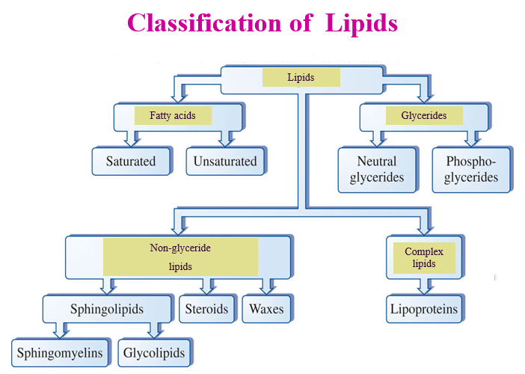

2. List the physiological relevant lipids including:
- Fatty acids
- Triglycerides
- Phospholipids
- Sphingolipids
- Steroids (cholesterol & cholesterol esters)
- Lipoproteins

Fatty Acids
- Fatty acids are acids produced when fats are broken down.
- They are considered “good fats.”
- These acids are not highly soluble in water, and they can be used for energy by most types of cells.
- They may be monounsaturated, polyunsaturated, or saturated.
- They are organic, or in other words, they contain both carbon and hydrogen molecules.
- Fatty acids are found in oils and other fats that make up different foods.
- They are an important part of a healthy diet, because the body needs them for several purposes.
- Fatty acids help move oxygen through the bloodstream to all parts of the body.
- They aid cell membrane development, strength, and function, and they are necessary for strong organs and tissue.
- Fatty acids can also help keep skin healthy, help prevent early aging, and may promote weight loss by helping the body process cholesterol.
- More importantly, they help rid the arteries of cholesterol build up.
- Another purpose of fatty acids is to assist the adrenal and thyroid glands, which may also help regulate weight.
- There are different types of fatty acids. You have most likely heard of certain types, such as Omega-3.
- Omega-3 is considered an “essential” fatty acid, as is Omega-6. There is one other, Omega-9, but this type can be readily produced by the body, while the other two types cannot.

TRIGLYCERIDES
- Triglycerides are the chemical formation of animal and vegetable fats.
- In molecular form, three molecules of fatty acids combine with glycerol to form triglycerides.
- In the human body, these are carried through the blood plasma, and unused molecules are stored in the body as fat.
- Virtually all naturally occurring fats contain triglycerides.
- However, while higher than normal levels of these lipoproteins are considered medically unsafe, a normal intake is encouraged.
- Both carbohydrates and proteins provide energy to the body.
- Triglycerides provide twice that.
- Triglycerides are not only present in the body through the consumption of fats, but also through the consumption of carbohydrates.
- Most carbohydrates are naturally turned into triglycerides by the body.
- Therefore, a diet low in fat, but high in carbohydrates, may serve to increase triglyceride levels.
- A low carbohydrate diet often helps to lower triglyceride levels, although this type of diet is not good for everyone.
- Many nutritionists encourage the consumption of both fats and carbohydrates in moderation.

PHOSPHOLIPIDS

- Phospholipids are just one type of a large group of organic compounds called lipids.
- The main role of phospholipids in living organisms is that they make up the cell membrane.
- Lipids form a large and varied group of compounds that contain carbon (C), oxygen (O) and hydrogen (H) and are insoluble in water, or they do not dissolve in water.
- All lipids fall into one of two groups – fats or oils.
- The only difference between these groups is that fats are solid at room temperature while oils are a liquid.
- The chemical structure of lipids varies between the many different types.
- Most are triglycerides, or they are formed from three fatty acid chains attached to a glycerol molecule.
- All lipids contain the same glycerol molecule, so it is the nature of the fatty acids that determines a lipid’s characteristics.
- All fatty acids are made up of a carboxyl group (-COOH) attached to a hydrocarbon chain, made up of carbon and hydrogen atoms.
- The hydrocarbon chains can vary in length and are hydrophobic, or repel water.

SPHINGOLIPIDS
- A sphingolipid is a fat-soluble molecule that is derived from an amino alcohol with an unsaturated hydrocarbon chain.
- The fat-soluble molecule is a lipid specifically made from the 18-carbon sphingosine and is a major component in cell membranes.
- The amino alcohol itself is considered aliphatic, which means it forms a stable ring shape.
- The sphingolipid is considered to be a ceramide, meaning it is a combination of sphingosine and a fatty acid linked together.
- Various types of sphingolipids can be created within cells, each performing a specific function.
- Sphingomyelin is located in the cell membrane of the myelin sheath on neurons.
- Glycosphingolipids are found in the cell membrane of muscle tissue.
- Gangliosides are a sphingolipid linked with a sugar chain such as sialic acid and found in the plasma membrane of a cell.
- The main function of a sphingolipid is to protect the surface of a cell from various factors that may cause harm.
- They form a stable and resistant outer shell that reacts both mechanically and chemically to exterior materials.
- Depending on the cell, a sphingolipid is paramount to the process of cell recognition and signaling.
- This occurs when other lipids or proteins are present in neighboring cells.

STEROIDS (CHOLESTEROL & CHOLESTEROL ESTERS)

- CHOLESTEROL

- Cholesterol is a substance in the human body that is needed for building and regulating cells.
- Most people are familiar with the term, however, because of the fear of 'high cholesterol' and indeed, too much of the wrong kind of cholesterol is actively bad for you.
- Cholesterol can be ingested in the food we eat, but most of your body's store is made in the liver and other organs and circulates in the bloodstream, where it does its work.

- CHOLESTEROL ESTERS

- Cholesterol esterase — Also referred to as cholesterol ester hydrolase and sterol esterase, this form occurs in the pancreas, the intestinal mucosa, the liver, and the kidney. It even occurs in the muscle.
- Cholesterol esterase is used clinically to locate the presence of cholesterol in most patients.

LIPOPROTEINS

- Simply put, a lipoprotein is a biochemical assembly made up of lipids, which are fats, and protein molecules.
- The fat and protein molecules are bound together in different ways depending on the type of lipoprotein.
- A specific kind of protein, known as an apolipoprotein, bonds to a lipid through a covalent or noncovalent bond at the atomic level.
- Lipoproteins are vital to body functions because they serve to transport different forms of fat and cholesterol to areas in the body where they are needed.
- This transport system is necessary because these types of fats cannot dissolve in the blood.
- While the best-known types of lipoprotein are the different kinds of cholesterol lipoprotein, they are also a vital component in enzymes, antigens and other important elements.
- Because of concerns about high cholesterol and its role in various health problems, many people have heard of high density lipoprotein (HDL) and /or low density lipoprotein (LDL).
- HDLs are commonly known as "good" cholesterol, and LDLs are termed "bad" cholesterol.
- LDL can build up in the arteries, forming plaque and eventual blockages that can lead to heart disease or stroke.
- HDL, by contrast, seems to carry cholesterol through the system to the liver, where it can be properly metabolized.
- Though experts are not entirely certain how it does so, HDL seems to protect the cardiovascular system from disease.

3. Draw the structure of fatty acids from various nomenclature applied to fatty acids example carboxyl and omega naming systems
4. Discuss how variations in:
- chain length
- degree of unsaturation and
- shape (Cis vs Trans)
of fatty acids affect properties of fatty acids example melting point

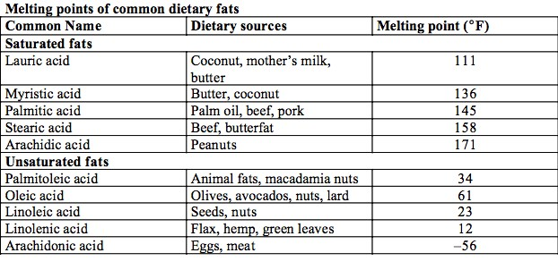
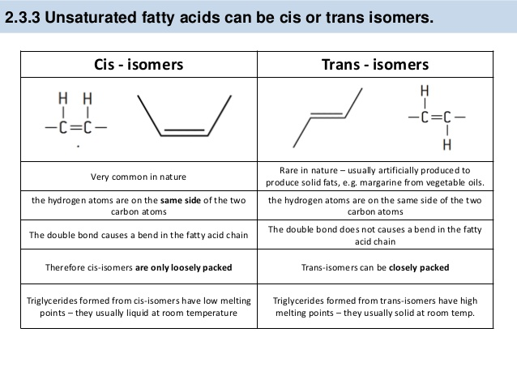

5. Draw the structure of triglycerides

