CHEM121
Unit 2: Carbohydrate Metabolism
Lecture 4
At the end of the lecture, students should be able to:
- Describe gluconeogenesis and its physiological importance
- Describe glycogen synthesis and degradation and its physiological importance
- Discuss the hormonal control of :
  - glycolysis
  - gluconeogenesis
  - glycogen synthesis and degradation
- Discuss clinical condition related to defects in carbohydrates use eg. Diabetes mellitus, lactose intolerance and galactosemia
- Distinguish between clinical conditions that result from defects in metabolism of carbohydrates based on simple laboratory tests and physical signs and symptoms (HOMEWORK ASSIGMENT)
- Give the major products for one turn of the citric acid cycle:
- 2CO₂
- 1 GTP
- 1 FADH₂
- 3NADH
- Discuss the importance of the citric acid cycle as an avenue for the further production of ATP
- Name the site for the Electron Transport Chain(ETC) and the importance of oxidative phosphorylation in generating ATP from NADH and FADH₂

1. Describe gluconeogenesis and its physiological importance

- Gluconeogenesis is the process by which glucose is made, primarily in the liver, from non-carbohydrate sources.
- The body is able to make glucose from:
- amino acids (protein),
- glycerol (the backbone of triglycerides, the primary fat storage molecule), and
- glucose metabolism intermediaries like lactate and pyruvate.
- The process of gluconeogenesis is one of the most important processes within the human body because it is the reverse of glycolysis
- It is the process used by the human body to take two pyruvate molecules and convert them back into a glucose molecule.

Physiological Significance of Gluconeogenesis

- Gluconeogenesis is particularly important in liver control of blood glucose homeostasis (Homeostasis is the tendency towards a relatively stable equilibrium between interdependent elements, especially as maintained by physiological processes. E.g. body temperature, blood pressure).
- In certain cases, the body actually ends up needing more glucose than is present. Whether or not it needs to store glucose or it needs it for any other purpose, there needs to exist a mechanism (i.e. a series of reactions) through which the body can manufacture glucose.
- This is doubly important when you take into consideration the fact that glucose might not always be readily available for intake in the outside environment.
- Gluconeogenesis allows synthesis of glucose for times when liver glycogen reserves are substantially depleted; during fasting (before breakfast) and during starvation.
- Unlike most tissues, glucose can easily diffuse out of hepatocytes into the blood. (A hepatocyte is a cell of the main parenchymal tissue of the liver. Hepatocytes make up 70-85% of the liver's mass. These cells are involved in: Protein synthesis & Protein storage).

Overall Glyconeogenesis

- Gluconeogenesis is the biosynthesis of new glucose (i.e. not glucose from glycogen).
- The production of glucose from other metabolites is necessary for use as a fuel source by the brain, testes, erythrocytes and kidney medulla since glucose is the sole energy source for these organs.
- The primary carbon skeletons used for gluconeogenesis are derived from pyruvate, lactate, glycerol, and the amino acids alanine and glutamine. The liver is the major site of gluconeogenesis
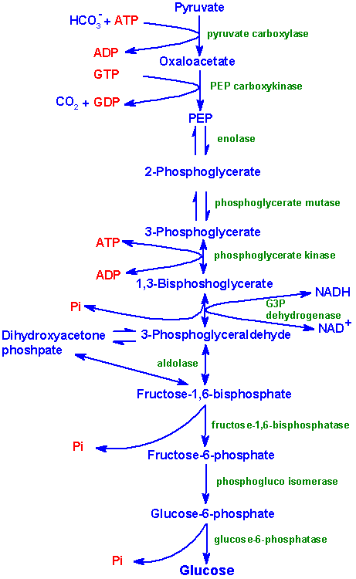
- The relevant features of the pathway of gluconeogenesis are diagrammed below:

Triglycerides

Fatty acids

glycerol

glycerol
-
P

Glycerol kinase

Glycerol
-
P
d
ehydrogenase

Lactate

Ala

Cys

Gly

Ser

Thr

- The relevant reactions of gluconeogenesis are depicted.
- It can be seen as a 3- bypass steps
- Pyruvate to Phosphoenolpyruvate (PEP), Bypass 1

Mnemonic for Gluconeogenesis
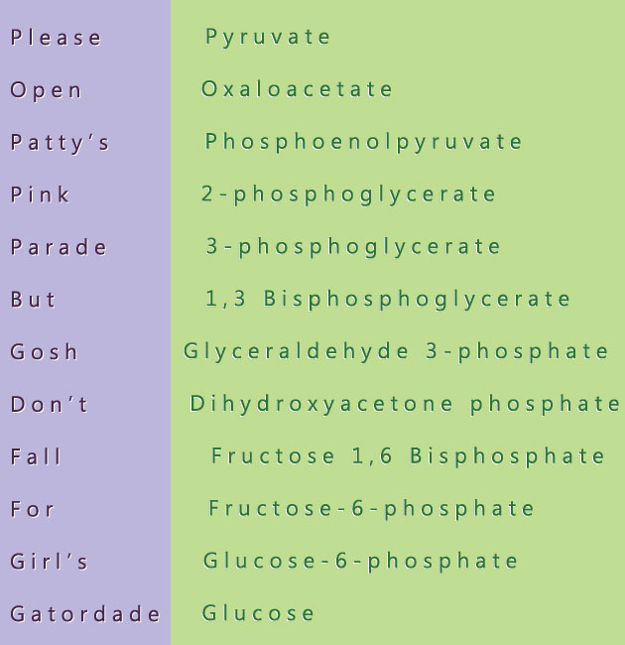
Comparison of Glycolysis and Gluconeogenesis
- Gluconeogenesis is NOT a simple reversal of glycolysis
  - Recall that there were 3 irreversible reactions of glycolysis
  - These must be bypassed for glucose to be formed
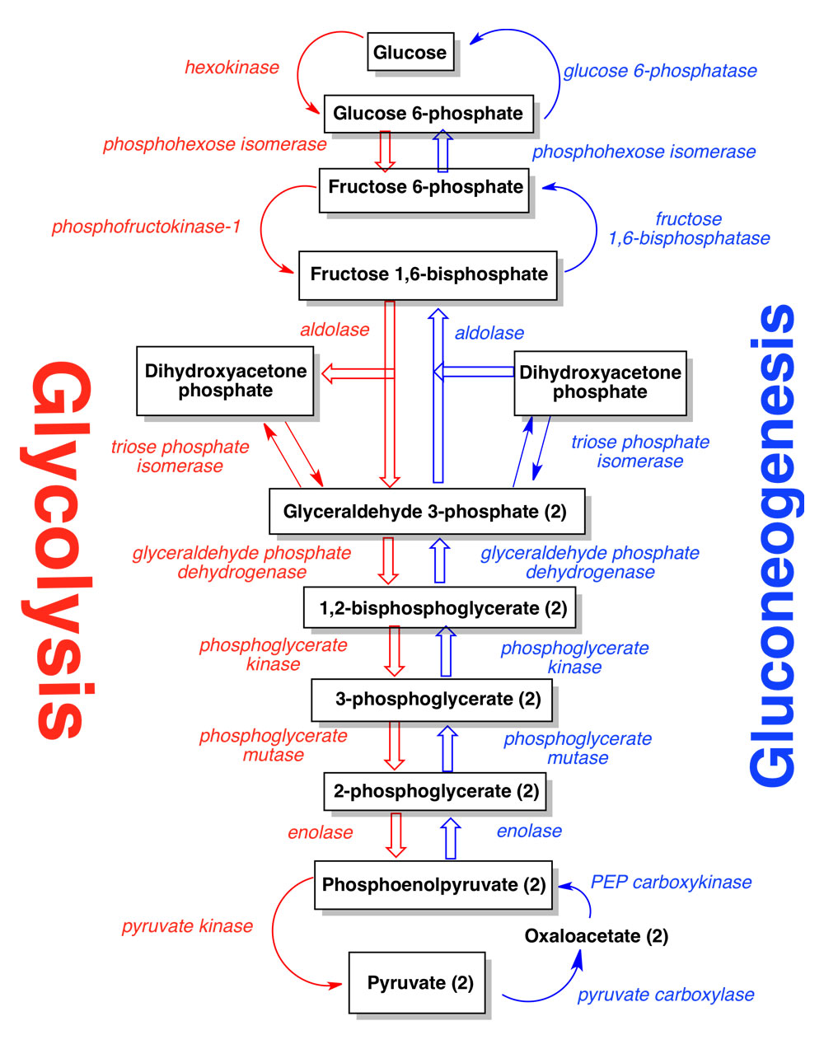

- Conversion of pyruvate to PEP, Bypass 1
- Requires the action of two mitochondrial enzymes.
- The first is an ATP-requiring reaction catalyzed by pyruvate carboxylase (PC)
- As the name of the enzyme implies, pyruvate is carboxylated to form oxaloacetate(OAA)
- The second enzyme in the conversion of pyruvate to PEP is PEP carboxykinase
- For gluconeogenesis to proceed, the OAA produced by PC needs to be transported to the cytosol.
- However, no transport mechanism exist for its' direct transfer and OAA will not freely diffuse.

- Fructose-1,6-bisphosphate to Fructose-6-phosphate, Bypass 2
- Fructose-1,6-bisphosphate (F1,6BP) conversion to fructose-6-phosphate (F6P) is the reverse of the rate limiting step of glycolysis.
- The reaction, a simple hydrolysis, is catalyzed by fructose-1,6-bisphosphatase (F1,6BPase).
- the F1,6BPase reaction is a major point of control of gluconeogenesis

- Glucose-6-phosphate (G6P) to Glucose, Bypass 3
- G6P is converted to glucose through the action of glucose-6-phosphatase (G6Pase).
- This reaction is also a simple hydrolysis reaction like that of F1,6BPase.
- Since the brain and skeletal muscle, as well as most non-hepatic tissues, lack G6Pase activity, any gluconeogenesis that occurs in these tissues is not utilized for blood glucose supply.
- In the kidney, muscle and especially the liver, G6P be shunted toward glycogen if blood glucose levels are adequate. The reactions necessary for glycogen synthesis are an alternate bypass series of reactions.

2. Describe glycogen synthesis and degradation and its physiological importance

GLYCOGEN SYNTHESIS (ALSO CALLED GLYCOGENESIS)
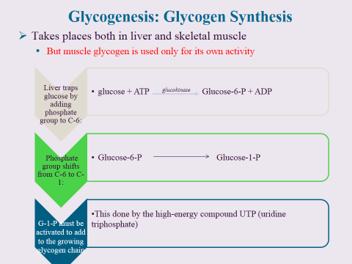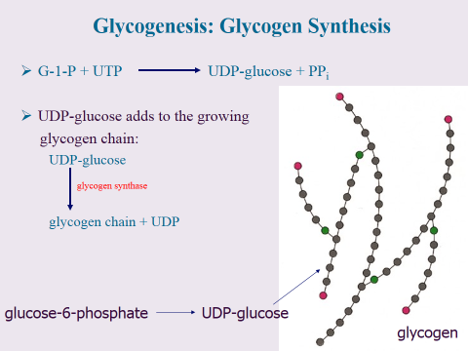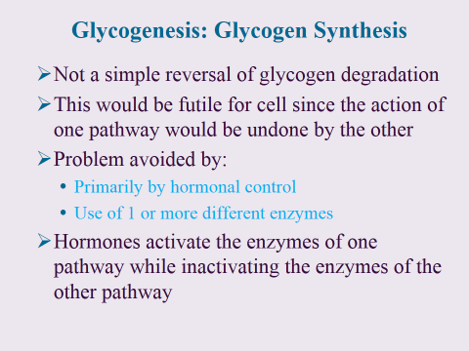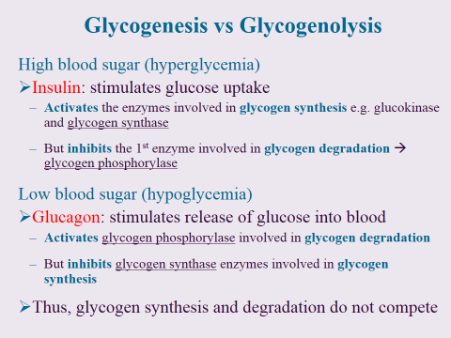
- Synthesis of glycogen from glucose is carried out by the enzyme glycogen synthase.
- This enzyme utilizes UDP-glucose as one substrate and the non-reducing end of glycogen as another. (Uridine diphosphate glucose (uracil-diphosphate glucose, UDP-glucose) is a nucleotide sugar. It is involved in glycosyltransferase reactions in metabolism).
- The activation of glucose to be used for glycogen synthesis is carried out by the enzyme UDP-glucose pyrophosphorylase.
- This enzyme exchanges the phosphate on C-1 of glucose-1-phosphate for UDP.
- The energy of the phospho-glycosyl bond of UDP-glucose is utilized by glycogen synthase to catalyze the incorporation of glucose into glycogen.
- UDP is subsequently released from the enzyme.
- The α-1,6 branches in glucose are produced by amylo-(1,4–1,6)-transglycosylase, also termed the branching enzyme.
- This enzyme transfers a terminal fragment of 6-7 glucose residues (from a polymer at least 11 glucose residues long) to an internal glucose residue at the C-6 hydroxyl position.
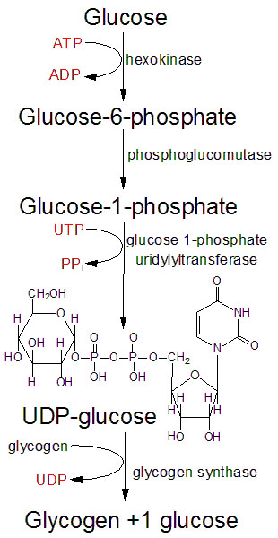

Addition of glucose to glycogen

GLYCOGEN DEGRADATION (ALSO CALLED GLYCOGENOLYSIS)
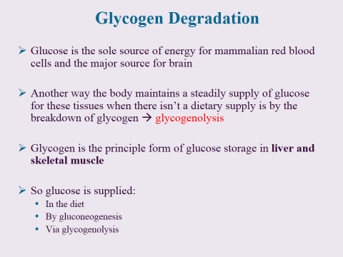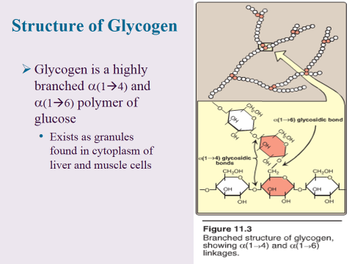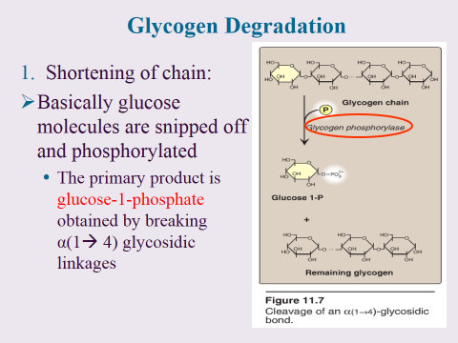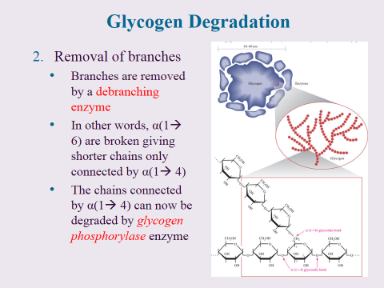
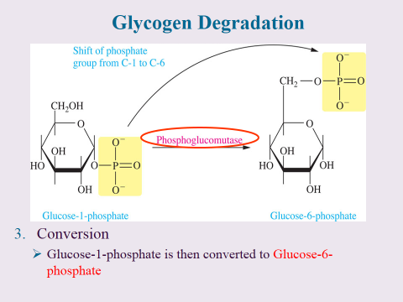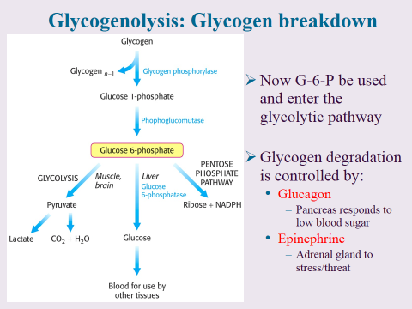

- Degradation of stored glycogen, termed glycogenolysis, occurs through the action of glycogen phosphorylase.
- The action of phosphorylase is to phosphorolytically remove single glucose residues from α-(1,4)-linkages within the glycogen molecules.
- The product of this reaction is glucose-1-phosphate.
The advantage of the reaction proceeding through a phosphorolytic step is that:
1. The glucose is removed from glycogen is an activated state, i.e. phosphorylated and this occurs without ATP hydrolysis.
- As mentioned above the phosphorylase mediated release of glucose from glycogen yields a charged glucose residue without the need for hydrolysis of ATP.
- An additional necessity of releasing phosphorylated glucose from glycogen ensures that the glucose residues do not freely diffuse from the cell.
- In the case of muscle cells this is acutely apparent since the purpose in glycogenolysis in muscle cells is to generate substrate for glycolysis.

2. The concentration of P_{i} in the cell is high enough to drive the equilibrium of the reaction in the favorable direction since the free energy change of the standard state reaction is positive.
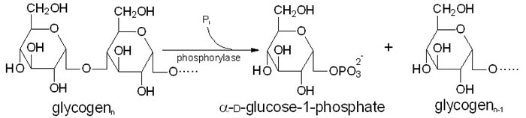
- The conversion of glucose-6-phosphate to glucose, which occurs in the liver, kidney and intestine, by the action of glucose-6-phosphatase does not occur in skeletal muscle as these cells lack this enzyme.
- Therefore, any glucose released from glycogen stores of muscle will be oxidized in the glycolytic pathway.
- In the liver the action of glucose-6-phosphatase allows glycogenolysis to generate free glucose for maintaining blood glucose levels.
- Glycogen phosphorylase cannot remove glucose residues from the branch points (α-1,6 linkages) in glycogen.
- The activity of phosphorylase ceases 4 glucose residues from the branch point.
- The removal of the these branch point glucose residues requires the action of debranching enzyme (also called glucan transferase) which contains 2 activities: glucotransferase and glucosidase.
- The transferase activity removes the terminal 3 glucose residues of one branch and attaches them to a free C-4 end of a second branch.
- The glucose in α-(1,6)-linkage at the branch is then removed by the action of glucosidase.
- This glucose residue is uncharged since the glucosidase-catalyzed reaction is not phosphorylytic.
- This means that theoretically glycogenolysis occurring in skeletal muscle could generate free glucose which could enter the blood stream.
- However, the activity of hexokinase in muscle is so high that any free glucose is immediately phosphorylated and enters the glycolytic pathway.
- Indeed, the precise reason for the temporary appearance of the free glucose from glycogen is the need of the skeletal muscle cell to generate energy from glucose oxidation, thereby, preventing any chance of the glucose entering the blood.

Physiological Importance Of Glycogen Synthesis And Degradation

Glycogen metabolism is important for several reasons:

- Glycogen stores in the liver are used to maintain a constant blood glucose concentration
- Muscles also maintain glycogen stores as a reservoir of glucose for strenuous muscular activity.
- The synthesis and degradation of glycogen occur by different metabolic pathways allowing for reciprocal regulation.
- In addition, the enzymes of glycogen metabolism are under hormonal regulation
The primary advantages of storage carbohydrates in animals are that:
1) energy is not released from fat (other major energy storage form in animals) as fast as from glycogen;
2) glycolysis provides a mechanism of anaerobic metabolism (important in muscle cells that cannot get oxygen as fast as needed); and
3) glycogen provides a means of maintaining glucose levels that cannot be provided by fat.

Breakdown of glycogen involves:
1) release of glucose-1-phosphate (G1P),
2) rearranging the remaining glycogen (as necessary) to permit continued breakdown, and
3) conversion of G1P to G6P for further metabolism.
Remember that G6P can be:
1) broken down in glycolysis,
2) converted to glucose by gluconeogenesis, and
3) oxidized in the pentose phosphate pathway.
- The concentration of reactants and products of glycogen breakdown are such that hydrolysis of glycogen to G1P in the cell is favored (though the reaction would not be favored if the ratios of products were not skewed).
- Just as in gluconeogenesis, the cell has a separate mechanism for glycogen synthesis that is distinct from glycogen breakdown.
- As noted previously, this allows the cell to separately control the reactions, avoiding futile cycles, and enabling a process to occur efficiently (synthesis of glycogen) that would not occur if it were simply the reversal of glycogen breakdown.
- Synthesis of glycogen starts with G1P, which is converted to an 'activated' intermediate, UDP-glucose.
- This activated intermediate is what 'adds' the glucose to the growing glycogen chain.
- Once the glucose is added to glycogen, the glycogen molecule may need to be rearranged to make it available for metabolism

3. Discuss the hormonal control of:
  - glycolysis
  - gluconeogenesis
  - glycogen synthesis and degradation

4. Discuss clinical condition related to defects in carbohydrates use eg. Diabetes mellitus, lactose intolerance and galactosemia (HOMEWORK ASSIGMENT)
Diabetes Mellitus
Diabetes mellitus (or diabetes) is a chronic, lifelong condition that affects your body's ability to use the energy found in food. There are three major types of diabetes: type 1 diabetes, type 2 diabetes, and gestational diabetes.
All types of diabetes mellitus have something in common. Normally, your body breaks down the sugars and carbohydrates you eat into a special sugar called glucose. Glucose fuels the cells in your body. But the cells need insulin, a hormone, in your bloodstream in order to take in the glucose and use it for energy. With diabetes mellitus, either your body doesn't make enough insulin, it can't use the insulin it does produce, or a combination of both.
Since the cells can't take in the glucose, it builds up in your blood. High levels of blood glucose can damage the tiny blood vessels in your kidneys, heart, eyes, or nervous system. That's why diabetes -- especially if left untreated -- can eventually cause heart disease, stroke, kidney disease, blindness, and nerve damage to nerves in the feet.
Type 1 Diabetes
Type 1 diabetes is also called insulin-dependent diabetes. It used to be called juvenile-onset diabetes, because it often begins in childhood.
Type 1 diabetes is an autoimmune condition. It's caused by the body attacking its own pancreas with antibodies. In people with type 1 diabetes, the damaged pancreas doesn't make insulin.
This type of diabetes may be caused by a genetic predisposition. It could also be the result of faulty beta cells in the pancreas that normally produce insulin.
A number of medical risks are associated with type 1 diabetes. Many of them stem from damage to the tiny blood vessels in your eyes (called diabetic retinopathy), nerves (diabetic neuropathy), and kidneys (diabetic nephropathy). Even more serious is the increased risk of heart disease and stroke.
Treatment for type 1 diabetes involves taking insulin, which needs to be injected through the skin into the fatty tissue below. The methods of injecting insulin include:
- Syringes
- Insulin pens that use pre-filled cartridges and a fine needle
- Jet injectors that use high pressure air to send a spray of insulin through the skin
- Insulin pumps that dispense insulin through flexible tubing to a catheter under the skin of the abdomen
A periodic test called the A1C blood test estimates glucose levels in your blood over the previous three months. It's used to help identify overall glucose level control and the risk of complications from diabetes, including organ damage.
Having type 1 diabetes does require significant lifestyle changes that include:
- Frequent testing of your blood sugar levels
- Careful meal planning
- Daily exercise
- Taking insulin and other medications as needed
People with type 1 diabetes can lead long, active lives if they carefully monitor their glucose, make the needed lifestyle changes, and adhere to the treatment plan.
Type 2 Diabetes
By far, the most common form of diabetes is type 2 diabetes, accounting for 95% of diabetes cases in adults. Some 26 million American adults have been diagnosed with the disease.

Type 2 diabetes used to be called adult-onset diabetes, but with the epidemic of obese and overweight kids, more teenagers are now developing type 2 diabetes. Type 2 diabetes was also called non-insulin-dependent diabetes.
Type 2 diabetes is often a milder form of diabetes than type 1. Nevertheless, type 2 diabetes can still cause major health complications, particularly in the smallest blood vessels in the body that nourish the kidneys, nerves, and eyes. Type 2 diabetes also increases your risk of heart disease and stroke.
With Type 2 diabetes, the pancreas usually produces some insulin. But either the amount produced is not enough for the body's needs, or the body's cells are resistant to it. Insulin resistance, or lack of sensitivity to insulin, happens primarily in fat, liver, and muscle cells.
People who are obese -- more than 20% over their ideal body weight for their height -- are at particularly high risk of developing type 2 diabetes and its related medical problems. Obese people have insulin resistance. With insulin resistance, the pancreas has to work overly hard to produce more insulin. But even then, there is not enough insulin to keep sugars normal.
There is no cure for diabetes. Type 2 diabetes can, however, be controlled with weight management, nutrition, and exercise. Unfortunately, type 2 diabetes tends to progress, and diabetes medications are often needed.
An A1C test is a blood test that estimates average glucose levels in your blood over the previous three months. Periodic A1C testing may be advised to see how well diet, exercise, and medications are working to control blood sugar and prevent organ damage. The A1C test is typically done a few times a year.
Gestational Diabetes
Diabetes that's triggered by pregnancy is called gestational diabetes (pregnancy, to some degree, leads to insulin resistance). It is often diagnosed in middle or late pregnancy. Because high blood sugar levels in a mother are circulated through the placenta to the baby, gestational diabetes must be controlled to protect the baby's growth and development.
According to the National Institutes of Health, the reported rate of gestational diabetes is between 2% to 10% of pregnancies. Gestational diabetes usually resolves itself after pregnancy. Having gestational diabetes does, however, put mothers at risk for developing type 2 diabetes later in life. Up to 10% of women with gestational diabetes develop type 2 diabetes. It can occur anywhere from a few weeks after delivery to months or years later.
With gestational diabetes, risks to the unborn baby are even greater than risks to the mother. Risks to the baby include abnormal weight gain before birth, breathing problems at birth, and higher obesity and diabetes risk later in life. Risks to the mother include needing a cesarean section due to an overly large baby, as well as damage to heart, kidney, nerves, and eye.

Treatment during pregnancy includes working closely with your health care team and:
- Careful meal planning to ensure adequate pregnancy nutrients without excess fat and calories
- Daily exercise
- Controlling pregnancy weight gain
- Taking diabetes insulin to control blood sugar levels if needed
Other Forms of Diabetes
A few rare kinds of diabetes can result from specific conditions. For example, diseases of the pancreas, certain surgeries and medications, or infections can cause diabetes. These types of diabetes account for only 1% to 5% of all cases of diabetes.

Lactose Intolerance & Galactosemia
 | Lactose Intolerance | Galactosemia
What is the underlying cause? | The enzyme that splits lactose into glucose and galactose is called lactase, and it is located on the surface of the cells lining the small intestine. Lactose intolerance is caused by reduced or absent activity of lactase that prevents the splitting of lactose (lactase deficiency). | Galactosemia is hereditary.
Who is most likely to develop each condition? | A person may be or may become lactose intolerant for different reasons:  Ethnic background. People of Asian, African, Native American, and Hispanic backgrounds are more likely to develop lactose intolerance at a young age.  Other problems with the digestive tract. People who have inflammation of their upper small intestine, such as celiac disease or Crohn's disease, have a reduced level of the lactase enzyme.  Medicines. Certain antibiotics can trigger temporary lactose intolerance by interfering with the intestine's ability to produce the lactase enzyme.  Infection. After a bout of infectious diarrhea, some kids can develop a temporary lactose intolerance that usually improves after a few days or weeks.  Age. As people get older, their bodies usually stop producing the lactase enzyme, and most people will naturally become lactose intolerant over time. | To have the disease, a child must inherit the tendency from both parents. The incidence of the disease is approximately 1 in 20,000 live births. For each pregnancy, in such a family, there is a 1 in 4 chance a baby will be born with the deficiency. Because of the potentially disastrous effects of late diagnosis, many provinces have mandatory neonatal screening programs for galactosemia.
What are the symptoms? | Symptoms of lactose intolerance can be mild or severe, depending on how much lactase your body makes. Symptoms usually begin 30 minutes to 2 hours after eating or drinking milk or milk products. If you have lactose intolerance, your symptoms may include:  - Bloating.  - Pain or cramps in the lower belly.  - Gurgling or rumbling sounds in the lower belly.  - Gas.  - Loose stools or diarrhea. Sometimes the stools are foamy.  - Throwing up. | The disease usually appears in the first few days of life following the ingestion of breast milk or formula. Vomiting, liver enlargement, and jaundice are often the earliest signs of the disease, but bacterial infections (often severe), irritability, failure to gain weight, and diarrhea may also occur. If unrecognized in the newborn period, the disease may produce liver, brain, eye and kidney damage.
How is it treated? | Treatment for lactose intolerance involves decreasing or completely removing milk products from the diet. Many people who are lactose intolerant can still have up to 1/2 cup of milk without experiencing any symptoms. Lactose-free milk products can also be found at most supermarkets. | Treatment is based on the elimination of galactose from the diet. This may be done in the early neonatal period by stopping breast feeding and by the administration of diets which contain no lactose or galactose, (NutramigenR, PregestimilR). This diet should be strictly followed, and continued for years, and possibly for life. The red blood cell levels of galactose or its metabolites (galactose-1-phosphate) may be used as a monitor to gauge the adherence to the diet and restriction of galactose. It is also recommended that mothers of affected infants be placed on a galactose-free diet during subsequent pregnancies. This may somewhat modify symptoms present at birth. With early therapy, any liver damage which occurred in the first few days of life will nearly completely heal.  Galactosemia should be considered in any jaundiced infant because of beneficial effects of early dietary restriction.

5. Distinguish between clinical conditions that result from defects in metabolism of carbohydrates based on simple laboratory tests and physical signs and symptoms (HOMEWORK ASSIGMENT)

6. Give the major products for one turn of the citric acid cycle
- 2CO₂
- 1 GTP
- 1 FADH₂
- 3NADH

The Citric Acid Cycle
(Also Known as the Tricarboxylic Acid Cycle and the Krebs Cycle)

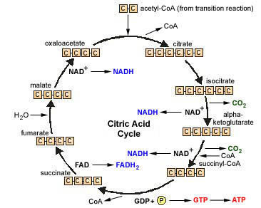

- Before the pyruvates from glycolysis can feed into the citric acid cycle, they must undergo a transition reaction. The pyruvate is converted into a 2-carbon acetyl group as the third carbon is lost as CO₂. The acetyl group is attached to coenzyme A to form acetyl-CoA.
- The 2-carbon acetyl-CoA combines with the 4-carbon oxaloacetate of the citric acid cycle to form 6-carbon citrate.
- Citrate is converted to isocitrate.
- The 6-carbon isocitrate is oxidized by NAD⁺ to produce reduced NADH and 5-carbon alpha-ketoglutarate. (One carbon is lost as CO₂.)
- The 5-carbon alpha-ketoglutarate is oxidized by NAD⁺ to produce reduced NADH and 4-carbon succinyl-CoA. (One carbon is lost as CO₂.)
- Oxidation of succinyl-CoA produces succinate and one GTP that is converted to ATP.
- Oxidation of succinate by FAD produces reduced FADH₂ and fumarate.
- Fumarate is converted into malate.
- Oxidation of malate by NAD⁺ produces reduced NADH and oxaloacetate.

7. Discuss the importance of the citric acid cycle as an avenue for the further production of ATP
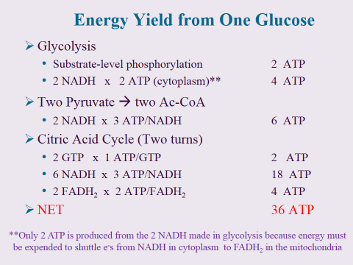
8. Name the site for the Electron Transport Chain (ETC) and the importance of oxidative phosphorylation in generating ATP from NADH and FADH₂
- The electron transport chain is located in the cristae of a mitochondria.
Read more: http://wiki.answers.com/Q/Where_is_the_Electron_transport_chain_located_in_the_mitochondria#ixzz27e0zvSXZ

Questions
1. The body synthesizes glucose from non-carbohydrate sources via gluconeogenesis. Pyruvate, oxaloacetate, and dihydroxyacetone phosphate are entry points for the gluconeogenesis pathway.
Although gluconeogenesis seems like the reverse of glycolysis, gluconeogenesis uses some different enzymes to bypass the irreversible reactions of glycolysis.
Complete the diagram of gluconeogenesis by moving the three compounds and four enzymes to their correct locations in the pathway.
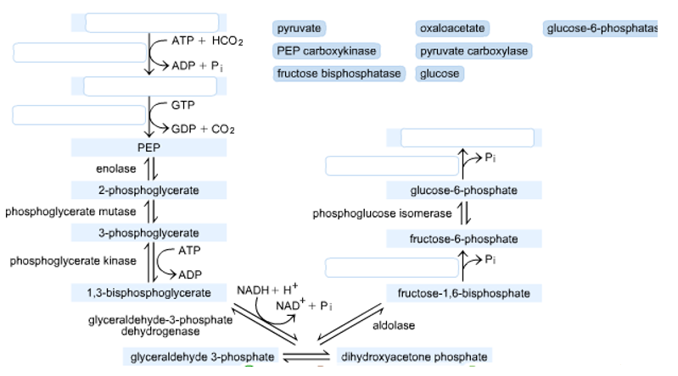
2. Observe Figure 1 below and answer the following questions:
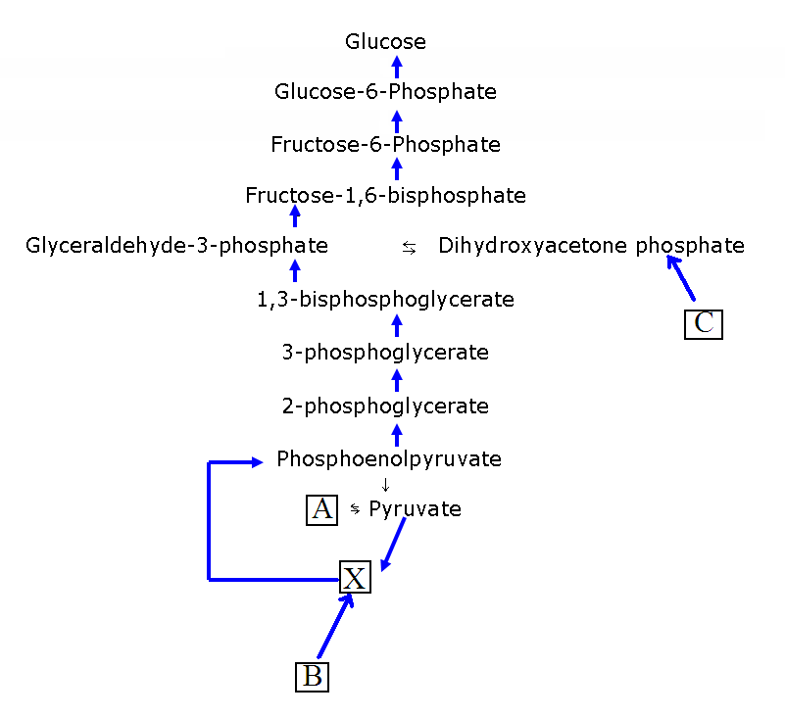

Figure 1
(a) The reaction pathway of carbohydrate metabolism which converts pyruvate into glucose is known as __________________________.

(b) The pathway occurs primarily in which organ? ___________________

(c) With respect to the levels glycogen and glucose, when would the pathway become activated?
_____________________________________________________________________
_____________________________________________________________________
(d) Which hormone activates this pathway? ____________________________

(e) Which hormone inhibits this pathway? __________________________

(f) This series of reactions is almost the reverse of what other pathway of carbohydrate metabolism? _____________________________________________
(g) Give the name of the biomolecule labelled X. _________________________________

(h) Non-carbohydrate substances can enter this pathway by being converted to some of the biomolecules present in it. State the names of these non-carbohydrate substances labelled A to C:
A: _______________________________
B: _______________________________
C: _______________________________

Multiple Choice Questions
1. Which of the following is not an important precursor of glucose in animals?
a) Lactate
b) Pyruvate
c) Glycerol
d) Glucose 6-phosphate
2. Which of the following statements is false about gluconeogenesis?
a) From the hydrolysis of tri-acyl-glycerol, fatty acids can be used as a carbon source
b) From red blood cells, lactate can be used as a carbon source
c) From the hydrolysis of tri-acyl-glycerol, glycerol is converted to glucose in gluconeogenesis
d) From muscle vigorous muscle activity, lactate can be used as a carbon source
3. The enzyme which catalyzes the conversion of pyruvate to oxaloacetate
a) Pyruvate carboxylase
b) Pyruvate dehydrogenase
c) Pyruvate kinase
d) Phosphofructokinase-1
4. Oxaloacetate is reduced to malate by
a) Pyruvate carboxylase
b) Malate dehydrogenase
c) Pyruvate kinase
d) Phosphofructokinase-1
5. Gluconeogenesis involves conversion of
a) Glucose to pyruvate
b) Pyruvate to glucose
c) Phosphoenolpyruvate to glucose
d) Pyruvate to fructose
6. Which of the following organisms cannot covert acetyl-coA derived from fatty acids into glucose?
a) Animals
b) Plants
c) Bacteria
d) Virus
7. Formation of one molecule of glucose from pyruvate requires
a) 4 ATP, 2 GTP and 2 NADH
b) 3 ATP, 2 GTP and 2 NADH
c) 4 ATP, 1 GTP and 2 NADH
d) 2 ATP, 2 GTP and 2 NADH
8. Ethanol is oxidized to acetaldehyde in the liver cytoplasm by
a) Alcohol dehydrogenase
b) Alcohol carboxylase
c) Pyruvate carboxylase
d) Pyruvate kinase
9. The main source of glucose carbons for gluconeogenesis is
a) Guanine
b) Alanine
c) Cysteine
d) Threonine
10. Which of the following statements about gluconeogenesis is correct?
a) Pyruvate is first converted to phosphoenolpyruvate by phosphoenolpyruvate carboxykinase
b) Fructose 1, 6-biphosphatase converts fructose 1, 6-bisphosphate into fructose 1-phosphate
c) Glucose 6-phosphatase hydrolyzes glucose 6-phosphate to release glucose into the blood
d) Glucose 6-phosphatase hydrolyzes glucose 6-phosphate and is found in liver and muscle

