Questions
1. (a) What is metabolism?
(b) What is the difference between catabolism and anabolism?
(c) What is the metabolic rate?

2. The diagram below shows the reactions of glycolysis. Write the correct enzyme in the appropriate label position. Some of the enzymes will not be used. Note that phophohexose isomerase is also called phophoglucose isomerase and glucose-6-phosphate. 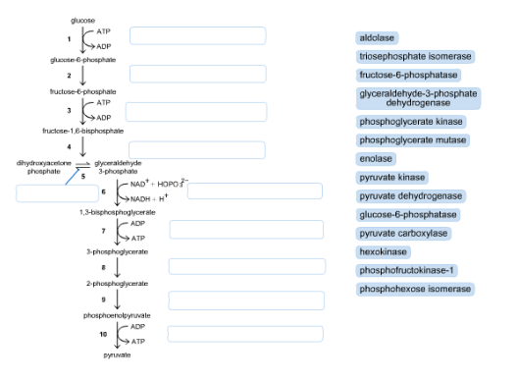
3. Use the diagram below to answer this question.
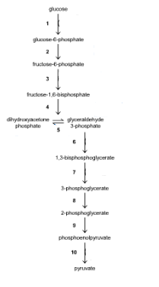
(a) (i) Label the diagram to show the steps where ATP is synthesized.
(ii) Name the enzyme(s) that catalyze the reactions where ATP is synthesized.
(b) (i) Label the diagram to show the steps where ATP is consumed.
(ii)Name the enzyme(s) that catalyze the reactions where ATP is consumed.

(c) Circle the arrows on the step(s) where NADH is made.
(d) Put boxes around the arrows that are regulated steps. (i.e. the steps which are irreversible).

4. Fill in the blanks on the right of the worksheet and in the steps of glycolysis. Also fill in the molecule names A to F.
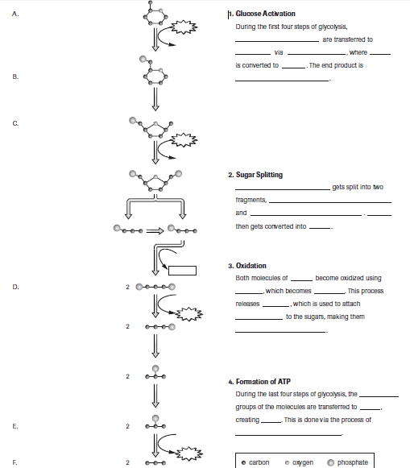

5. Classify the statements below as True or False.
1. Glycolysis takes place in the cristae of mitochondria __________
2. An end product of glycolysis is pyruvate. __________
3. A 6 carbon sugar is oxidized in glycolysis. __________
4. CO₂ is a waste product of glycolysis. __________
5. Sugar + NAD⁺ pyruvate + NADH + 2 ATP represents glycolysis – approximate reaction! __________
6. Glycolysis leads to fermentation in some bacteria and yeast. __________
7. Glycolysis involves an energy pay-off and then an energy investment phase. __________
8. A net of 4 ATP are produced in glycolysis. __________
9. Pyruvate contains 3 carbons. __________
10. Glycolysis involves 10 steps tightly controlled by enzymes. __________
11. Glycolysis does not use oxygen, it is anaerobic. __________
12. Glycolysis is the first step in cellular respiration. __________
13. It is likely that glycolysis was the method of ATP production in first organisms on Earth. __________
14. Organisms that engage in glycolysis cannot engage in fermentation. __________

