CHEM121
Unit 1: Introduction to Biochemistry & Structure of Carbohydrates
Lecture 1
At the end of this lecture, students should be able to:
· Define biochemistry
· Discuss the importance of biochemistry in understanding the living state
· Identify lifeless biomolecules that comprise living organisms
· Describe the complexity and variety of macromolecules of living organisms
· Classify monosaccharides as aldehydes or ketones
· Write the chemical and structural formula of monosaccharides such as glucose, fructose and galactose. Please pay attention to open chain forms and cyclic forms
Lecture will be done through: a) Lecturer and students follow with the use of notes
b) Open discussion among lecturer and students
c) Formative assessment through questions, students will
answer (orally/written)

1. Define biochemistry
- The study of the chemical compounds, reactions, etc, occurring in living organisms.
- The study of the chemical substances and vital processes occurring in living organisms.
- The chemical composition of a particular living system or biological substance.
- The scientific study of the chemical composition of living matter and of the chemical processes that go on in living organisms.

2. Discuss the importance of biochemistry in understanding the living state
Quite simply, biochemistry is the chemistry of living things. More precisely, the chemistry of living cells. Living cells are really nothing more than an isolated aqueous environment where a series of chemical reactions occur.
The reason biochemistry is important in terms of medicine is because, for example, many drugs exert their influence by altering cell chemistry, or biochemistry. Thus, it is important to understand biochemistry in order to understand how many drugs function.
In addition, many diseases, such as cancer, can be described in terms of biochemical changes in the cell that lead to changes in gene expression and cell physiology. Thus, if you can determine the biochemical changes that led to some disease state, perhaps you can design drugs to target those changes, and return cells to a "normal" state (in other words, reverse the disease state and restore health).
OR
Biochemistry is the collection of every organic chemical reaction in living organisms. Without functioning biochemical reactions, life in any form would not exist.
In humans, at the most basic level, properly functioning balances of chemical reactions within the body are responsible for health while disfunctioning balances of chemical reactions are responsible for diseases. Biochemical reactions are responsible for everything from metabolism to genetics. The study of biochemistry is important for deepening our understanding of how organisms function. Understanding biochemistry plays a large role in understanding the genetic basis for some diseases, the pharmacological effects of medications, the intricacies of metabolism, and the most basic differences between organisms.
OR
In modern science and society, biochemistry is absolutely essential. The study is defined as the chemistry of living things, whether they’re human or not. It is the study of how things work within the body and what happens to chemicals to perform the basic processes of all living bodies on the planet.
Chemical processes are always taking place within the body, and biochemistry looks at how these happen, and why these happen. If the study is taken into a more broad view, then it also studies the chemistry relating to living cells. The study of this kind of science plays a huge role in medicine as well as technology, as we will being to learn even more about the impact that drugs have on the body, and the different reactions that occur in different living cells. This, in turn, influences the biochemistry in the body.
In the field of biochemistry, the chemical properties of different kinds of cells and biological molecules, that have a huge role in the body, are studied in relation to other things. These incredibly important cells in the body are studied alongside the enzyme-catalysed reactions in the body. It’s a complicated study and indeed a specialised one, and without the work performed in this area of study, nobody would be able to continue progressing in the field of helping people life more healthily, and longer.
Science would come to a standstill without even more study, as diseased could not be properly looked at, the effect of everyday life on the body could not be studied, and the bodies will to some extent remain a mystery for the rest of the lifetime of humankind. It’s important the biochemistry continues so that we can continue to find out how the body works, and maybe even one day become successful in the field of robotics and artificial intelligence.
3. Identify lifeless biomolecules that comprise living organisms
a) Living organisms are composed of lifeless molecules. When they are isolated and examined individually, they conform to all the physical and chemical laws that describe the behavior of inanimate matter. Yet living organisms possess extraordinary attributes not exhibited by any random collections of molecules.
b) Thousands of different molecules make up a cell’s intricate internal structures.
c) Most of the molecular constituents of the living systems are composed of carbon atoms joined with other carbon atoms and with hydrogen, oxygen, or nitrogen. The special bonding properties of carbon permit the formation of a great variety of molecules. Organic compounds of molecular weight less than about 500, such as amino acids, nucleotides, and monosaccharides, serve as monomeric subunits of macromolecules: proteins, nucleic acids, and polysaccharides.
4. Describe the complexity and variety of macromolecules of living organisms
The 4 different varieties of macromolecules found in living organisms are:
· Carbohydrates,
· Lipids
· Proteins
· Nucleic Acids
(i) Carbohydrates: Are Molecules composed of carbon, hydrogen, and oxygen, and they include sugars and starches.
(ii) Lipids: Are non polar molecules that include fats, oils, and cholesterol.
(iii) Proteins: A Protein is a polymer made of monomers called amino acids.
(iv) Nucleic Acids: Are polymers that are made up of monomers called nucleotides.
Complexity of Macromolecules
Carbohydrates
Carbohydrates, which derive from plant photosynthesis, form from monosaccharides (i.e., simple sugars like glucose and fructose). Cells get energy from monosaccharides, or through the breakdown of disaccharides like lactose (milk sugar) and sucrose (cane sugar). Plants store these compounds by polymerizing them into long chains called polysaccharides, or starches. Animals store them in the liver as glycogen. Other polysaccharides comprise the cellulose structures of plants, and the chitin-based structures of fungi, insects and crustaceans.
Lipids
Although lipid compounds are highly diverse, they share an inability to mix with water. The three main classes of lipids are steroids, triglycerides (or triacylglycerols), and phospholipids. Steroids include hormones like estrogen and cortisol, as well as cholesterol, which serve as a hormone precursor and helps to keep animal cell membranes flexible. Triglycerides store energy more efficiently than starch, and comprise the myelin that surrounds nerve cells. Phospholipids are essential to cell membrane structure.

Proteins
Through the action of monomers called amino acids, proteins polymerize into short chains called peptides, or longer chains called polypeptides. Twenty amino acids occur in nature. A peptide comprising only eight amino acids has more than 25 billion possible amino-acid combinations. This huge number of possible sequences accounts for the astounding variety of functions that proteins play in practically every process of life. Proteins are structural components of cell membranes, and of skin, bone and muscle. They are the enzymes that catalyze almost every biochemical reaction. They also enable signaling within and among cells, including nerve cells, cells involved in hormone synthesis and suppression, cells that regulate growth and differentiation, and cells involved in immune response.
Nucleic Acids
Genes contain deoxyribonucleic acid, or DNA, which is famous for its double helix configuration. Ribonucleic acid, or RNA, transcribes information encoded in DNA and is also essential to protein synthesis. Monomers called nucleotides are responsible for assembling DNA and RNA. A nucleotide consists of a sugar unit, a phosphate unit, and a chemical ring structure called a heterocyclic base. DNA contains four kinds of nucleotides: adenine, cytosine, guanine and thymine. RNA contains the first three, but has uracil instead of thymine. 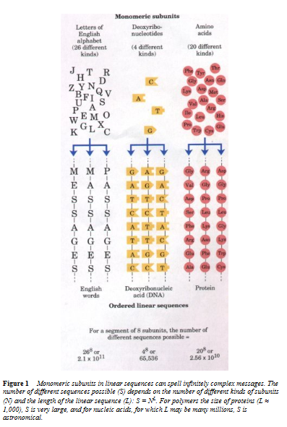

5. Classify monosaccharides as aldehydes or ketones

Important Background Information
(i) Ketones
A carbon double bonded to an oxygen is called a carbonyl group. Compounds in which the carbon of a carbonyl group is bonded to two other carbons are called ketones. Ketones are named the same way as are alkenes except that an -one ending is used.
(ii) Aldehydes
When one of the groups attached to the carbonyl group is a hydrogen instead of a carbon, the compound is called an aldehyde. Aldehydes are given an -al ending.
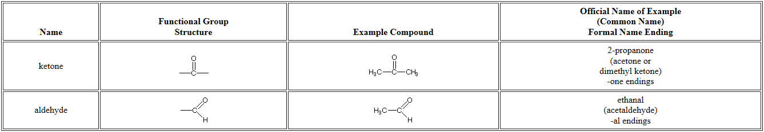
(iii) Chiral Carbon
- A chiral carbon atom is a carbon that has four different atoms or group of atoms bonded to it.
- Chiral molecules are molecules that contain at least one chiral carbon.
- If a carbon is not chiral, it is called achiral.
- Chiral carbons allow for lateral rotation about the axis of the carbon from left to right and vice versa
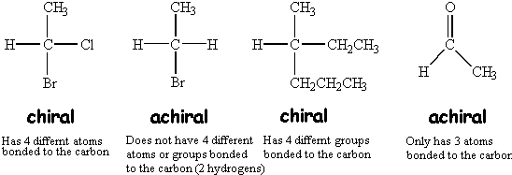
A chiral carbon or chiral center is usually denoted with an asterisk (*). Four chiral centers are shown in the glucose molecule below. Can you explain why carbons 2, 3, 4 & 5 are chiral and carbons 1 & 6 are achiral?
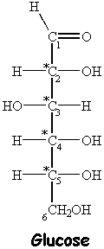
(iv) Stereoisomers
- Stereoisomers, like your hands, are mirror images of each other, but are not identical (they are nonsuperimposable).
- When a molecule is chiral, the mirror image of that molecule is a different molecule. The chiral molecule and its mirror image are stereoisomers of one another. More specifically, they are enantiomers of one another.
- Enantiomers are nonsuperimposable mirror images.
- Epimers are isomers that are formed when there is rotation occurring at a specific chiral carbon only.
(v) D& L Notation for Monosaccharides
- If the hydroxyl (OH) group on the last chiral carbon (or the chiral carbon furthest away from the carbonyl group) is on the right side, the sugar is the D enantiomer.
- If the hydroxyl (OH) group on the last chiral carbon is on the left side, the sugar is the L enantiomer.
- Note: Be sure to use the uppercase D& L; the lowercase d and l refers to something different.
- Biologically-relevant sugars are all D sugars.

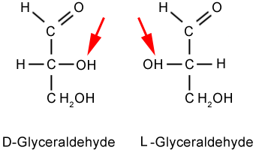
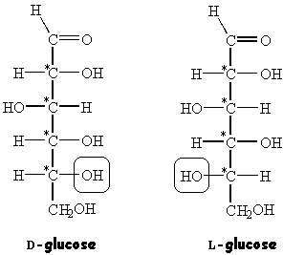

Monosaccharides
Monosaccharides, the simplest carbohydrates, are aldehydes or ketones that have two or more hydroxyl groups; the empirical formula of many is (C-H₂O)n, literally a “carbon hydrate.” Monosaccharides are important fuel molecules as well as building blocks for nucleic acids. The smallest monosaccharides, for which n = 3, are dihydroxyacetone and D- and L-glyceraldehyde.
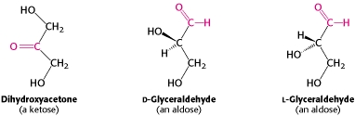
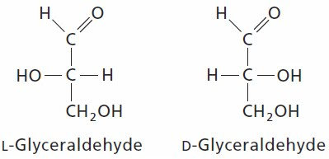
They are referred to as trioses (tri- for 3). Dihydroxyacetone is called a ketose because it contains a keto group, whereas glyceraldehyde is called an aldose because it contains an aldehyde group. Glyceraldehyde has a single asymmetric carbon and, thus, there are two stereoisomers of this sugar. D-Glyceraldehyde and L-glyceraldehyde are enantiomers, or mirror images of each other.
Monosaccharides and other sugars are sometimes represented by Fischer projections Recall that, in a Fischer projection of a molecule, atoms joined to an asymmetric carbon atom by horizontal bonds are in front of the plane of the page, and those joined by vertical bonds are behind (see the Appendix in Chapter 1). Fischer projections are useful for depicting carbohydrate structures because they provide clear and simple views of the stereochemistry at each carbon center.
Summary – Classifying Monosaccharides as Aldoses or Ketoses
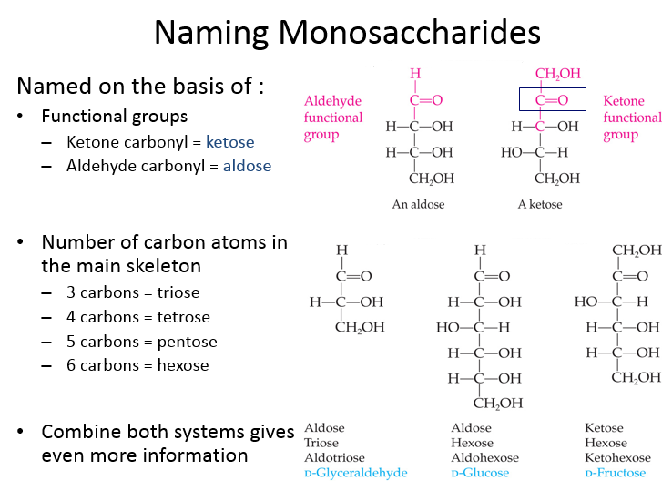

6. Write the chemical and structural formula of monosaccharide such as glucose, fructose and galactose. Please pay attention to open chain forms and cyclic forms
- Sugars have the ability to form cyclic structures
  - The alcohol group can readily react with aldehyde group
  - Forms six-membered, oxygen-containing ring
  - Called a pyranose ring
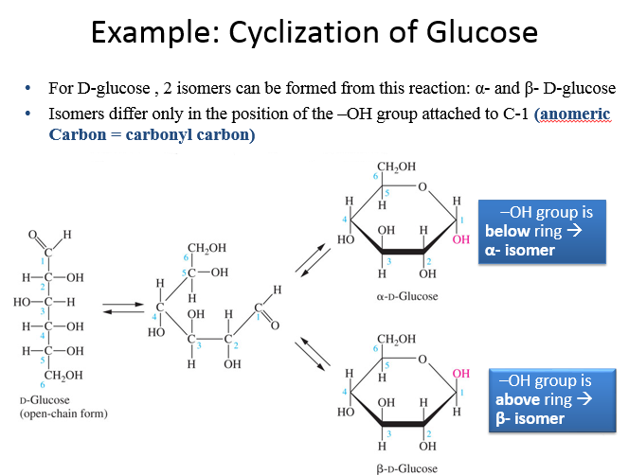
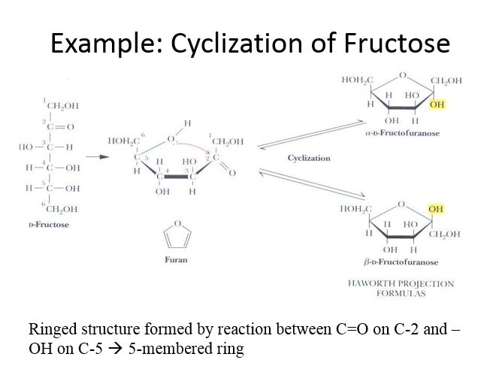
Summary - Open chain and ring forms of glucose, galactose and fructose
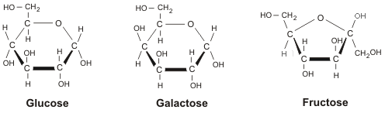
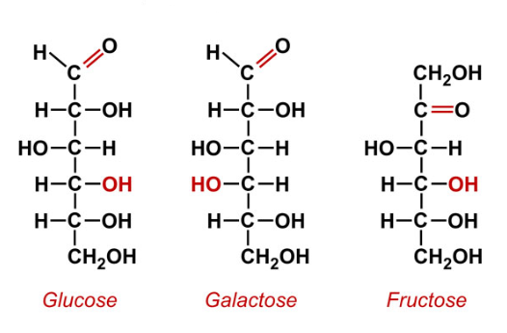
Monosaccharides are the simplest carbohydrates and are classified according to whether they are aldehyde or ketone derivatives, as well as the number of atoms contained in the molecule. Single hexoses, glucose and galactose require no digestion and can be absorbed directly into the bloodstream. Hexoses contain six carbon atoms, and are found in foods, while pentoses, ribose and deoxyribose contain five carbon atoms and are produced during the metabolism of foodstuffs.
Three common sugars—glucose, galactose, and fructose, share the same molecular formula: C₆H₁₂O₆. Because of their six carbon atoms, each is a hexose. Although all three share the same molecular formula, the arrangement of atoms differs in each case. Substances such as these three, which have identical molecular formulas but different structural formulas, are known as structural isomers.
- Glucose
"Blood sugar" is the immediate source of energy for cellular respiration. Glucose, which is also referred to as dextrose, is a moderately sweet sugar found in vegetables and fruit. When glucose is fermented by the enzyme zymase, in yeast, it results in the formation of carbon dioxide and ethyl alcohol. It is the basic structure to which all carbohydrates are reduced to in the end, for transport via the bloodstream and use by the cells of the body.
Two different pathways are involved in the metabolism of glucose: one anaerobic and one aerobic. The anaerobic process occurs in the cytoplasm and is only moderately efficient. The aerobic cycle takes place in the mitochondria and results in the greatest release of energy. As the name implies, though, it requires oxygen.
- Galactose
Galactose is not normally found in nature, but is mostly hydrolyzed from the disaccharide lactose, which is found in milk, as part of a disaccharide made by glycosidic linkage to a glucose molecule. The lactose disaccharide from milk is a major energy source for almost all animals, including human. Although not very water-soluble, and less sweet than glucose, it forms part of glycolipids and glycoproteins, which is found in many tissues. The body can change glucose to galactose in order to enable the mammary glands to produce lactose.
Galactose is natural and is a basic component of many things, being found in milk, tomatoes and many fruits and vegetables. There is only one product range in the world that uses galactose as a basic food and drink ingredient, and that is a brand new range of energy drinks.
Galactose has uniquely different properties compared to other sugars. These properties make it easier to lose and maintain weight; they are useful in warding off adult-onset diabetes; they give much steadier energy through time, and they provide the basis for products for athletes which allow them to perform better and longer. Galactose is a remarkable undiscovered sugar for the new Millennium.
- Fructose
Fructose's chemical name is levulose. Fructose is also called the fruit sugar. Fructose is found in fruits, honey, and the sole sugar in bull and human semen. It is the sweetest of sugars. It is used for preventing sandiness in ice cream. The compound's formula is C₆H₁₂O₆. It is shaped in orthorhombic, bispherodial prisms.
Fructose taken in large quantities is associated with gastrointestinal distress, and is also associated with increases in the fat content of blood following meals rich in this. A large quantity of fat in the blood is thought to be a major risk factor for heart disease.

Questions
1. What is biochemistry?
2. Why is it important for nursing students to study biochemistry?
3. List the four different varieties of macromolecules found in living organisms.
4. (i) What is the difference between an aldehyde and a ketone?
(ii) Classify the following monosaccharides as aldoses or ketoses:
(a) 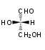(b) 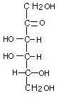(c) 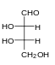(d) 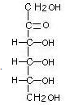(e) 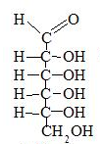
(f) 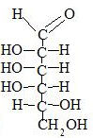(g) 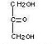(h)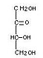

(iii) Classify the monosaccharides above as:
- Trioses (monosaccharides that contain 3 carbon atoms):
- Tetroses (monosaccharides that contain 4 carbon atoms):
- Pentoses (monosaccharides that contain 5 carbon atoms):
- Hexoses Tetroses (monosaccharides that contain 6 carbon atoms):
5. Draw the enantiomers of the monosaccharides shown below:
(a)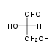 (b) 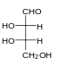(c) 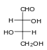(d) 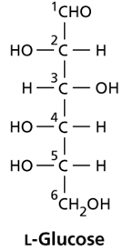

6. Write the chemical and structural formulas of glucose, fructose and galactose (open chain and cyclic).

