CHEM121 – Lesson 9
Worksheet
Multiple Choice Questions
1. Amino acids can be formed from the hydrolysis of:
(A) proteins
(B) carbohydrates
(C) lipids
(D) esters

2. Which of the following will NOT occur when a protein is denatured?
(A) The protein breaks up to forms amino acids
(B) The hydrogen bonds between protein chains are broken
(C) The protein changes shape
(D) Intermolecular forces of attraction are broken

3. Which terms correctly describes the reaction of amino acid molecules to form a protein?
(A) Hydrolysis
(B) Condensation
(C) Hydration
(D) Denaturation

Structured Questions
1. (a) What is the name of the overall three-dimensional structure of a polypeptide?

(b) List the FOUR(4) R group interactions that contribute to the structure in part (a).

2.
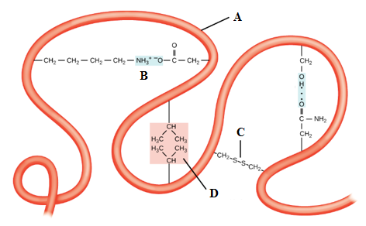
(a) What level of protein structure is shown above?
(b) (i) Which letter corresponds to the disulfide linkage.
(ii) Is the disulfide linkage covalent or ionic?
(iii) What is the importance of the disulfide linkage?

(c) (i) Which letter corresponds to hydrophobic interactions?
(ii) Explain what happens in hydrophobic interactions.

(d) (i) Which letter corresponds to the polypeptide backbone?
(ii) Which letter corresponds to an ionic bond?

Essay Question
1.
Nurse Johnson is concerned that her patient has a sustained, high temperature of 41.7ºC.Write an essay in which you explain why, from a biochemical perspective, a sustained, high fever in patients can be dangerous.
Hint: As a guide, follow the outline below.
- Paragraph 1, Introduction: Explain what is meant by protein denaturation, outline the circumstances under which proteins can be denatured & outline whether or not denaturation is permanent.
- Paragraph 2: Explain why proteins are important in the human body, explain the dangers of protein denaturation in the human body, explain the temperature at which proteins will denature and link it to the temperature of a fever.
- Paragraph 3: Explain the dangers and consequences of a high fever.
- Paragraph 4: Conclusion: Summarize main points of essay.

