**CHEM121 – BIOCHEMISTRY FOR NURSES**

**Lesson 8 – Worksheet**

1. Fill in the blank spaces below.

The linking of 2 or more amino acids forms a **__________.**

A **________________** is an amide bond that forms when the –COO- group of one amino acid reacts with the –NH3+ group of the next amino acid.

•        The amino acid on the left end of a peptide with an unreacted free amino group is the **_______________** amino acid.

•        The amino acid on the right end of a peptide with an unreacted free carboxyl group is the **______________** amino acid.

**Classification of peptides:**

•        **______________** = 2 amino acids linked together

•        **______________** = 3 amino acids linked together

•        **______________** = 4-9 amino acids linked together

•        **______________** = 10-50 amino acids linked together

2. Use the diagram below to draw the dipeptides listed.

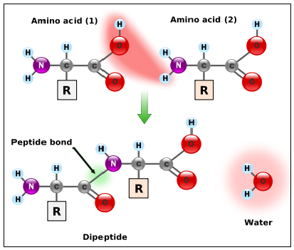

(a) Carnosine (alanylhistidine) - a dipeptide which is highly concentrated in muscle and brain tissues.

[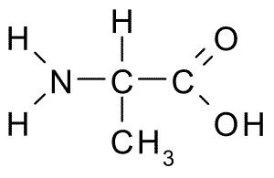](https://www.google.tt/url?sa=i&rct=j&q=&esrc=s&source=images&cd=&cad=rja&uact=8&ved=0ahUKEwix07Kcia3XAhXFcRQKHbW3DOIQjRwIBw&url=https://commons.wikimedia.org/wiki/File:Alanine.png&psig=AOvVaw2t2UGtEUiIgiJHwLrvd4_G&ust=1510165004969891) [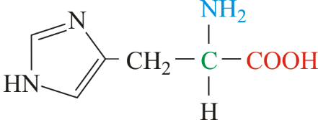](https://www.google.tt/url?sa=i&rct=j&q=&esrc=s&source=images&cd=&cad=rja&uact=8&ved=0ahUKEwiHs4ixia3XAhXCxlQKHaHtA8UQjRwIBw&url=https://glossary.periodni.com/glossary.php?en%3Dhistidine&psig=AOvVaw06J-NlayzAWQZ9m_4I0Hol&ust=1510165047378937)

(b) Kyotorphin (tyrosylarginine) - a neuroactive dipeptide which plays a role in pain regulation in the brain.

[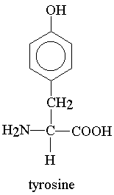](http://www.google.tt/url?sa=i&rct=j&q=&esrc=s&source=images&cd=&cad=rja&uact=8&ved=0ahUKEwjq4NjBi63XAhWGTSYKHc7QAw0QjRwIBw&url=http://groups.molbiosci.northwestern.edu/holmgren/Glossary/Definitions/Def-T/Tyrosine.html&psig=AOvVaw28NcFzR-zm45A8azCGORxF&ust=1510165617362528) [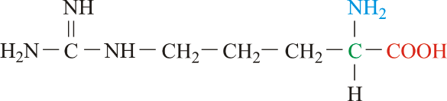](https://www.google.tt/url?sa=i&rct=j&q=&esrc=s&source=images&cd=&cad=rja&uact=8&ved=0ahUKEwikwbjQi63XAhUDRSYKHfdjCp4QjRwIBw&url=https://glossary.periodni.com/glossary.php?en%3Darginine&psig=AOvVaw1mbz1QAbDo6_W4z8R6AWjF&ust=1510165656110346)

(c) Aspartame (aspartylphenylalanine) – a dipeptide which is an artificial sweetener.

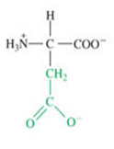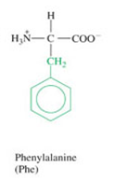

3. A **tripeptide** is a [peptide](https://en.wikipedia.org/wiki/Peptide) consisting of three [amino acids](https://en.wikipedia.org/wiki/Amino_acids) joined by [peptide bonds](https://en.wikipedia.org/wiki/Peptide_bond). Draw the tripeptide [Val](https://en.wikipedia.org/wiki/Valine)-[Gly](https://en.wikipedia.org/wiki/Glycine" \o "Glycine)-[Ala](https://en.wikipedia.org/wiki/Alanine" \o "Alanine)

[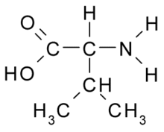](https://www.google.tt/url?sa=i&rct=j&q=&esrc=s&source=images&cd=&cad=rja&uact=8&ved=0ahUKEwiB4-Wdla3XAhWmhFQKHc4tANcQjRwIBw&url=https://en.wiktionary.org/wiki/valine&psig=AOvVaw1rYFcK_JFXap30tpTLh2JA&ust=1510168229192377) [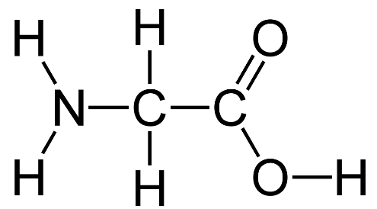](http://www.google.tt/url?sa=i&rct=j&q=&esrc=s&source=images&cd=&cad=rja&uact=8&ved=0ahUKEwjF5fmqla3XAhVIjFQKHfSiA0QQjRwIBw&url=http://www.hghgurus.com/ingredients/the-most-prominent-hgh-releaser-ingredients-what-is-glycine-and-how-does-it-work&psig=AOvVaw07POjQMjLuSVvkw2rpNte0&ust=1510168265209933) [](https://www.google.tt/url?sa=i&rct=j&q=&esrc=s&source=images&cd=&cad=rja&uact=8&ved=0ahUKEwjEipm7la3XAhXFi1QKHVUvDfcQjRwIBw&url=https://commons.wikimedia.org/wiki/File:Alanine.png&psig=AOvVaw0lY8MWbkg1GDpzV9ri2tQC&ust=1510168299110489)

4. The diagram below represents a portion of a protein structure **Ala-Tyr-Asp-Gly.**

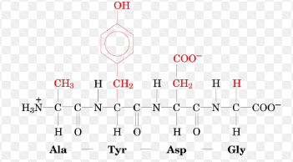

(a) Circle ALL the peptide bonds shown in the diagram.

(b) Circle the R group of a polar amino acid and label it ‘P’.

(c) Circle the R group of a non-polar amino acid and label it ‘NP’.

(d) Circle the R group of an acidic amino acid and label it ‘A’.

(e) Label the N terminus ‘N’.

(f) Label the C terminus ‘C’.

(g) What is the name of the reaction which forms peptide bonds?

(h) How many water molecules were produced in the reaction above?

(i) Is the peptide above a tripeptide, a tetrapeptide, a pentapeptide or a hexapeptide?