**COSTAATT**

**CHEM 092**

**ANSWERS - Revision Worksheet – Unit 3: Chemical Reactions**

**Lecturer: Ms. Romona Olton**

**Student Name:______________________________________**

**SECTION A – Multiple Choice**

**1.** The equation below represents the reaction of sodium metal with water.

Sodium + Water  Sodium hydroxide + Hydrogen

Which of the following chemical equations represents a complete balanced chemical

equation for the given word equation?

(A) 2Na(s) + H2O(l)  2NaOH(aq) + H2(g)

(B) Na(s) + 2H2O(l)   NaOH(aq) +2H2(g)

(C) 2Na(s) + 2H3O(l)  2NaOH(aq) + 2H2(g)

**(D) 2Na(s) + 2H2O(l)  2NaOH(aq) + H2(g)**

**2.** Identify the chemical equation which represents a complete balanced equation for

the reaction of barium chloride with sodium sulphate to produce barium sulphate and

sodium chloride.

**(A) BaCl2(aq) + Na2SO4(aq)  BaSO4(s) + 2NaCl(aq)**

(B) BaCl2(aq) + Na2SO4(aq)  2BaSO4(s) + 2NaCl(aq)

(C) 2BaCl2(aq) + Na2SO4(aq)  2BaSO4(s) + NaCl(aq)

(D) BaCl2(aq) + Na2SO4(aq)  BaSO4(s) + NaCl(aq)

**3.** Ferric oxide reacts with aluminum to produce aluminum oxide and iron. The balanced

chemical equation for the given reaction is:

Fe2O3 + 2Al  Al2O3 + 2Fe

Which of the following substances is oxidized in the given reaction?

(A) Al2O3 (B) Fe2O3 **(C) Al**  (D) Fe

**4.** White silver chloride changes to grey in sunlight because of the formation of silver

metal along with the evolution of chlorine gas. Identify the chemical equation that

gives a correct representation of the process.

**(A) 2AgCl  2Ag + Cl2**(B) AgCl  Ag + Cl2

(C) 2Ag + Cl2   2AgCl (D) Ag + Cl2  2AgCl

**5.** When copper oxide is treated with hydrogen gas copper is produced along with water.

The balanced chemical equation for the given reaction is:

CuO + H2  Cu + H2O

Which substance is oxidized in the given reaction?

**(A) H2** (B) Cu (C) H2O (D) CuO

**6.** What is the balanced chemical equation for the reaction of nitrogen with hydrogen to produce

ammonia gas?

(A) N2(g) + H2(g)  2NH3(g) (B) 2N2(g) + H2(g)  2NH3(g)

**(C) N2(g) + 3H2(g)  2NH3(g)**(D) 2N2(g) + H2(g)  2NH3(g)

**7.** Identify the chemical equation that correctly represents production of magnesium nitride

by burning magnesium metal in a pure nitrogen atmosphere.

(A) Mg3N2(s)  Mg(g) + N2(g) (B) Mg(s)  + N2(g)   Mg3N2(g)

**(C) 3Mg(g) + N2(g)  Mg3N2(g)**(D) Mg3N2(g)   3Mg(s)  + N2(g)

**8.** Which of the following reactions represents a combination reaction?

**(A) CaO(s) + H2O(g)  Ca(OH)2(aq)** (B) CaCO3(s)  CaO(s) + CO2(g)

(C) Zn(s) + CuSO4(aq)  ZnSO4(aq) + Cu(s) (D) 2FeSO4(s)  Fe2O3(s) + SO2(g) + SO3(g)

**9.** Which of the following reactions represents a double displacement reaction?

**(A) BaCl2(aq) + Na2SO4(aq)  BaSO4(s) + 2NaCl(aq)**

(B) 2FeSO4(s)  Fe2O3(s) + SO2(g) + SO3(g)

(C) 2Pb(NO3)2(g)  2PbO(s) + 4NO2(g) + O2(g)

(D) Zn(s) + 2AgNO3(aq)  Zn(NO3)2(aq) + 2Ag(s)

**10.** Ferric oxide reacts with aluminium metal as shown below:

Fe2O3(s) + 2Al(s)  Al2O3(s) + 2Fe(s)

What type of reaction is this?

(A) combination reaction (B) double displacement reaction

(C) decomposition reaction **(D) single displacement reaction**

**11.** Which of the following statements about the reaction below is correct?

2PbO(s) + C(s)  2Pb(s) + CO2(g)

(i) Lead is getting reduced (ii) Carbon dioxide is getting oxidized

(iii) Carbon is getting oxidized (iv) Lead oxide is getting reduced

(A) (i) and (ii) **(B) (iii) and (iv)**

(C) (i), (ii) and (iii) (D) (i), (ii), (iii) and (iv)

**12.** What happens when dilute hydrochloric acid is added to iron fillings?

**(A) Hydrogen gas and iron chloride are produced**

(B) Chlorine gas and hydroxide are produced

(C) heat is absorbed, i.e. test tube becomes cold.

(D) Iron salt and water are produced

|  |
| --- |
| **13.** Which of the following numbers represents an alkaline pH?  (A) 1 (B) 7 (C) 5 **(D) 11** |
|  |

**14.** What is the colour of litmus in alkali?

(A) red (B) green (C) colourless **(D) blue**

**15.** How does the Bronsted-Lowry theory define an acid?

**(A) A proton donor** (B) A proton acceptor

(C) A low pH (D) A high pH

**(15 Marks)**

**SECTION B – Structured Questions**

**1.** Carefully observe the diagram shown below and answer the questions that follow.



**Diagram showing iron nails dipped in copper sulphate solution**

**(a)** After ten minutes of keeping the set up as shown in the diagram, the colour of the iron nail changes. What does this indicate?

**This indicates a chemical reaction occurred.**

(1 Mark)

**(b)** Which of the two metals involved in this chemical reaction is more reactive?

**Iron**

(1 Mark)

**(c)** Write down two changes you would expect to see during the reaction of the iron nail with the copper sulphate solution.

**- Solid copper will be deposited on the iron nail**

**- The blue colour of the copper sulphate solution will become lighter**

(2 Mark)

**(d)** Write the full equation for the reaction between copper sulphate and iron nail.

**Fe(s) + CuSO4(aq) → FeSO4(aq) + Cu(s)**

(1 Mark)

**(e)** Write the ionic equation for the reaction between copper sulphate and iron nail.

**Fe(s) + Cu2+(aq) + SO42-(aq) → Fe2+(aq) + SO42-(aq) + Cu(s)**

**Fe(s) + Cu2+(aq) → Fe2+(aq) + Cu(s)**

(1 Mark)

**(f)** Name the type of chemical reaction that takes place between copper sulphate and iron nail.

**Single Displacement**

(1 Mark)

**(g)** What change would you expect in the reaction mixture if a copper wire is kept immersed in an iron sulphate solution?

**No reaction will take place since copper is lower than iron in the reactivity series and therefore will not be able to displace it.**

(1 Mark)

**2.** Complete the word reactions shown below and write a balanced symbol equation for each reaction.

**(a) Reaction of metal with acid.**

Calcium + Hydrochloric Acid  **Calcium chloride + Hydrogen**

Balanced equation: **Ca(s) + 2HCl(aq) → CaCl2(aq) + H2(g)**

(2 Marks)

**(b) Reaction of metal oxide with acid.**

Calcium oxide + Hydrochloric acid  **Calcium chloride + Water**

Balanced equation: **CaO(s) + 2HCl(aq) → CaCl2(aq) + H2O(g)**

(2 Marks)

**(c) Reaction of metal hydroxide with acid.**

Sodium hydroxide + Sulphuric acid  **Sodium sulphate + water**

Balanced equation: **2NaOH(aq) + H2SO4(aq) → Na2SO4(aq) + 2H2O(l)**

(2 Marks)

**(d) Reaction of carbonate with acid.**

Sodium carbonate + Hydrochloric acid  **Sodium chloride + carbon dioxide + water**

Balanced equation: **Na2CO3(aq) + 2HCl(aq) → 2NaCl(aq) + CO2(g) + H2O(l)**

(2 Marks)

**3.** Balance the following equations, and then classify the reactions as synthesis, decomposition, single displacement, ionic precipitation, neutralisation or reversible reactions:

**(a) Cl2 + 2KBr**  **KCl + Br2**

Type of reaction: **Single Displacement** (3 Marks)

**(b)** HCl + NaOH   H2O + NaCl

Type of reaction: **Neutralization** (3 Marks)

**(c)** MgCO3(s)   MgO(s) + CO2(g)

Type of reaction: **Decomposition** (3 Marks)

**(d) 2**Mg + O2   **2**MgO

Type of reaction: **Combination** (3 Marks)

**(e)** AgNO3 + NaCl  NaNO3 + AgCl

Type of reaction: **Double Displacement** (3 Marks)

**4.** Name the pieces of apparatus shown below.

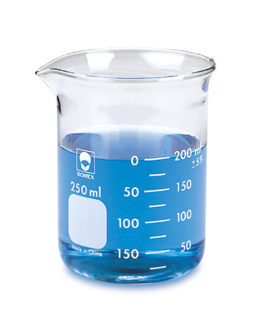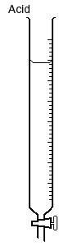

**Beaker Burette**

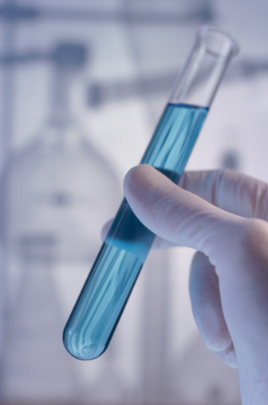

**Test Tube Conical Flask**

**(4 Marks)**

**Total = ______/ 50 = _________%**

**Calculate your overall score & review any necessary topics.**