**COSTAATT**

**CHEM 092**

**Revision Worksheet – Unit 3: Chemical Reactions**

**Lecturer: Ms. Romona Olton**

**Student Name:______________________________________**

**SECTION A – Multiple Choice**

**1.** The equation below represents the reaction of sodium metal with water.

Sodium + Water  Sodium hydroxide + Hydrogen

Which of the following chemical equations represents a complete balanced chemical

equation for the given word equation?

(A) 2Na(s) + H2O(l)  2NaOH(aq) + H2(g)

(B) Na(s) + 2H2O(l)   NaOH(aq) +2H2(g)

(C) 2Na(s) + 2H3O(l)  2NaOH(aq) + 2H2(g)

(D) 2Na(s) + 2H2O(l)  2NaOH(aq) + H2(g)

**2.** Identify the chemical equation which represents a complete balanced equation for

the reaction of barium chloride with sodium sulphate to produce barium sulphate and

sodium chloride.

(A) BaCl2(aq) + Na2SO4(aq)  BaSO4(s) + 2NaCl(aq)

(B) BaCl2(aq) + Na2SO4(aq)  2BaSO4(s) + 2NaCl(aq)

(C) 2BaCl2(aq) + Na2SO4(aq)  2BaSO4(s) + NaCl(aq)

(D) BaCl2(aq) + Na2SO4(aq)  BaSO4(s) + NaCl(aq)

**3.** Ferric oxide reacts with aluminum to produce aluminum oxide and iron. The balanced

chemical equation for the given reaction is:

Fe2O3 + 2Al  Al2O3 + 2Fe

Which of the following substances is oxidized in the given reaction?

(A) Al2O3 (B) Fe2O3 (C) Al (D) Fe

**4.** White silver chloride changes to grey in sunlight because of the formation of silver

metal along with the evolution of chlorine gas. Identify the chemical equation that

gives a correct representation of the process.

(A) 2AgCl  2Ag + Cl2 (B) AgCl  Ag + Cl2

(C) 2Ag + Cl2   2AgCl (D) Ag + Cl2  2AgCl

**5.** When copper oxide is treated with hydrogen gas copper is produced along with water.

The balanced chemical equation for the given reaction is:

CuO + H2  Cu + H2O

Which substance is oxidized in the given reaction?

(A) H2 (B) Cu (C) H2O (D) CuO

**6.** What is the balanced chemical equation for the reaction of nitrogen with hydrogen to produce

ammonia gas?

(A) N2(g) + H2(g)  2NH3(g) (B) 2N2(g) + H2(g)  2NH3(g)

(C) N2(g) + 3H2(g)  2NH3(g) (D) 2N2(g) + H2(g)  2NH3(g)

**7.** Identify the chemical equation that correctly represents production of magnesium nitride

by burning magnesium metal in a pure nitrogen atmosphere.

(A) Mg3N2(s)  Mg(g) + N2(g) (B) Mg(s)  + N2(g)   Mg3N2(g)

(C) 3Mg(g) + N2(g)  Mg3N2(g) (D) Mg3N2(g)   3Mg(s)  + N2(g)

**8.** Which of the following reactions represents a combination reaction?

(A) CaO(s) + H2O(g)  Ca(OH)2(aq) (B) CaCO3(s)  CaO(s) + CO2(g)

(C) Zn(s) + CuSO4(aq)  ZnSO4(aq) + Cu(s) (D) 2FeSO4(s)  Fe2O3(s) + SO2(g) + SO3(g)

**9.** Which of the following reactions represents a double displacement reaction?

(A) BaCl2(aq) + Na2SO4(aq)  BaSO4(s) + 2NaCl(aq)

(B) 2FeSO4(s)  Fe2O3(s) + SO2(g) + SO3(g)

(C) 2Pb(NO3)2(g)  2PbO(s) + 4NO2(g) + O2(g)

(D) Zn(s) + 2AgNO3(aq)  Zn(NO3)2(aq) + 2Ag(s)

**10.** Ferric oxide reacts with aluminium metal as shown below:

Fe2O3(s) + 2Al(s)  Al2O3(s) + 2Fe(s)

What type of reaction is this?

(A) combination reaction (B) double displacement reaction

(C) decomposition reaction (D) single displacement reaction

**11.** Which of the following statements about the reaction below is correct?

2PbO(s) + C(s)  2Pb(s) + CO2(g)

(i) Lead is getting reduced (ii) Carbon dioxide is getting oxidized

(iii) Carbon is getting oxidized (iv) Lead oxide is getting reduced

(A) (i) and (ii) (B) (iii) and (iv)

(C) (i), (ii) and (iii) (D) (i), (ii), (iii) and (iv)

**12.** What happens when dilute hydrochloric acid is added to iron fillings?

(A) Hydrogen gas and iron chloride are produced

(B) Chlorine gas and hydroxide are produced

(C) heat is absorbed, i.e. test tube becomes cold.

(D) Iron salt and water are produced

|  |
| --- |
| **13.** Which of the following numbers represents an alkaline pH?  (A) 1 (B) 7 (C) 5 (D) 11 |
|  |

**14.** What is the colour of litmus in alkali?

(A) red (B) green (C) colourless (D) blue

**15.** How does the Bronsted-Lowry theory define an acid?

(A) A proton donor (B) A proton acceptor

(C) A low pH (D) A high pH

**(15 Marks)**

**SECTION B – Structured Questions**

**1.** Carefully observe the diagram shown below and answer the questions that follow.



**Diagram showing iron nails dipped in copper sulphate solution**

**(a)** After ten minutes of keeping the set up as shown in the diagram, the colour of the iron nail changes. What does this indicate?

______________________________________________________________________

(1 Mark)

**(b)** Which of the two metals involved in this chemical reaction is more reactive?

______________________________________________________________________

(1 Mark)

**(c)** Write down two changes you would expect to see during the reaction of the iron nail with the copper sulphate solution.

______________________________________________________________________

(2 Mark)

**(d)** Write the full equation for the reaction between copper sulphate and iron nail.

______________________________________________________________________

(1 Mark)

**(e)** Write the ionic equation for the reaction between copper sulphate and iron nail.

______________________________________________________________________

(1 Mark)

**(f)** Name the type of chemical reaction that takes place between copper sulphate and iron nail.

______________________________________________________________________

(1 Mark)

**(g)** What change would you expect in the reaction mixture if a copper wire is kept immersed in an iron sulphate solution?

______________________________________________________________________

(1 Mark)

**2.** Complete the word reactions shown below and write a balanced symbol equation for each reaction.

**(a) Reaction of metal with acid.**

Calcium + Hydrochloric Acid  ___________________ + _____________________

Balanced equation:_____________________________________________________

(2 Marks)

**(b) Reaction of metal oxide with acid.**

Calcium oxide + Hydrochloric acid  ___________________ + _____________________

Balanced equation:_____________________________________________________

(2 Marks)

**(c) Reaction of metal hydroxide with acid.**

Sodium hydroxide + Sulphuric acid  ___________________ + _____________________

Balanced equation:_____________________________________________________

(2 Marks)

**(d) Reaction of carbonate with acid.**

Sodium carbonate + Hydrochloric acid  ___________________ + _____________________

Balanced equation:_____________________________________________________

(2 Marks)

**3.** Balance the following equations, and then classify the reactions as synthesis, decomposition, single displacement, ionic precipitation, neutralisation or reversible reactions:

**(a) ____Cl2 + ____KBr**  **KCl + _____Br2**

Type of reaction: ______________________________________________ (3 Marks)

**(b) ____** HCl + ____NaOH    H2O + _____NaCl

Type of reaction: ______________________________________________ (3 Marks)

**(c)** ____MgCO3(s)   MgO(s) + _____ CO2(g)

Type of reaction: ______________________________________________ (3 Marks)

**(d)** _____Mg + _____O2   _____MgO

Type of reaction: ______________________________________________ (3 Marks)

**(e) ____**AgNO3 + _____NaCl  _____NaNO3 + ______AgCl

Type of reaction: ______________________________________________ (3 Marks)

**4.** Name the pieces of apparatus shown below.

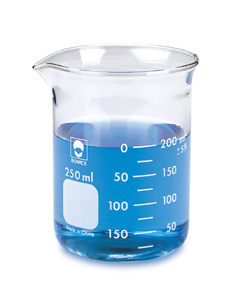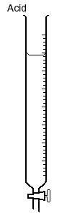

**_____________________________ ________________________________**

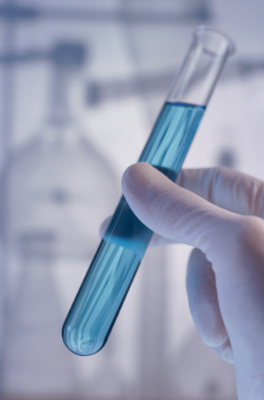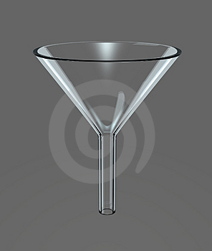

**_________________________________ _______________________________**

**(4 Marks)**

**Total = ______/ 50 = _________%**