COSTAATT
CHEM 090
Lesson 9 – Homework

1. Name the following ways of separating mixtures.
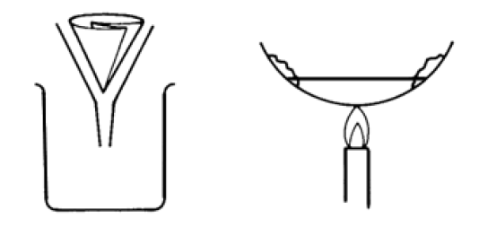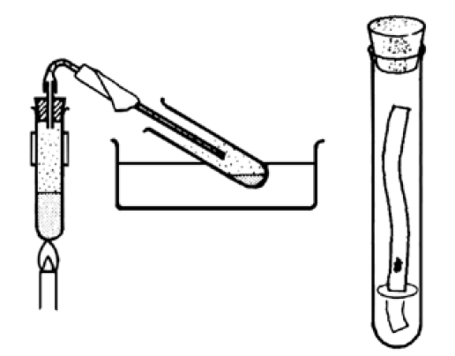
____________ ____________ ___________________ ______________

2. Complete the following sentences.
1 cent coins & 5 cent coins
ink
salt water & sand
salt water & pure water

(a) Filtering is used to separate
____________________________________ .
(b) Chromatography is used to separate
____________________________________ .
(c) Distillation is used to separate
____________________________________ .
(d) You can separate
____________________________________ by picking them up with your hands.
3.
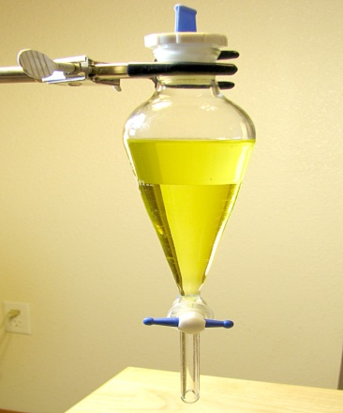
Tap
Liquid B
Liquid A
(a) What is the name of the piece of apparatus used in the separation above?
______________________________________________________________________
(b) Which liquid, A or B, is denser? Give a reason for your answer.
______________________________________________________________________
______________________________________________________________________
(c) Name two liquids that can be separated by the method shown above.
______________________________________________________________________
(d) A third liquid, C, is added to the mixture above. It is soluble in A but insoluble in B. Describe what happens when A, B and C are shaken together.
______________________________________________________________________
______________________________________________________________________
(e)Describe how you could collect A, B, and C separately.
______________________________________________________________________
______________________________________________________________________
______________________________________________________________________
(f) What is another method of separating liquid mixtures?
______________________________________________________________________

