COSTAATT
CHEM 090
Lesson 8 – Worksheet

1. 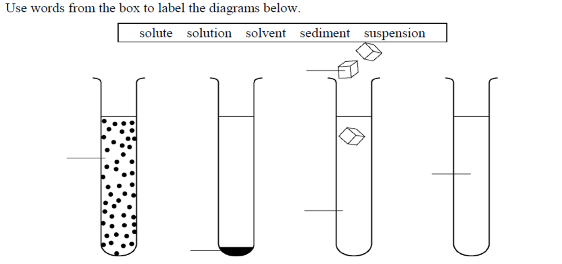

2. Underline the correct word from the choices given in each sentence below.
(a) A solute is dissolved in a solvent/solution.
(b) Soluble/insoluble substances do not dissolve.
(c) When an insoluble substance settles to the bottom of a liquid, it forms a suspension/sediment.
(d) A mixture in which some or all of the particles settle out is called a solution/suspension.
(e) A mixture in which the particles can be filtered out is called a solution/suspension.
(f) A colloid/suspension is a mixture that contains particles that are larger than the particles in a solution but smaller than those in a suspension.
(g) A colloid in which tiny droplets of one liquid are spread evenly throughout another liquid is called an emulsion/suspension.
3.(a) Use the data below to plot the solubility curve for potassium nitrate.
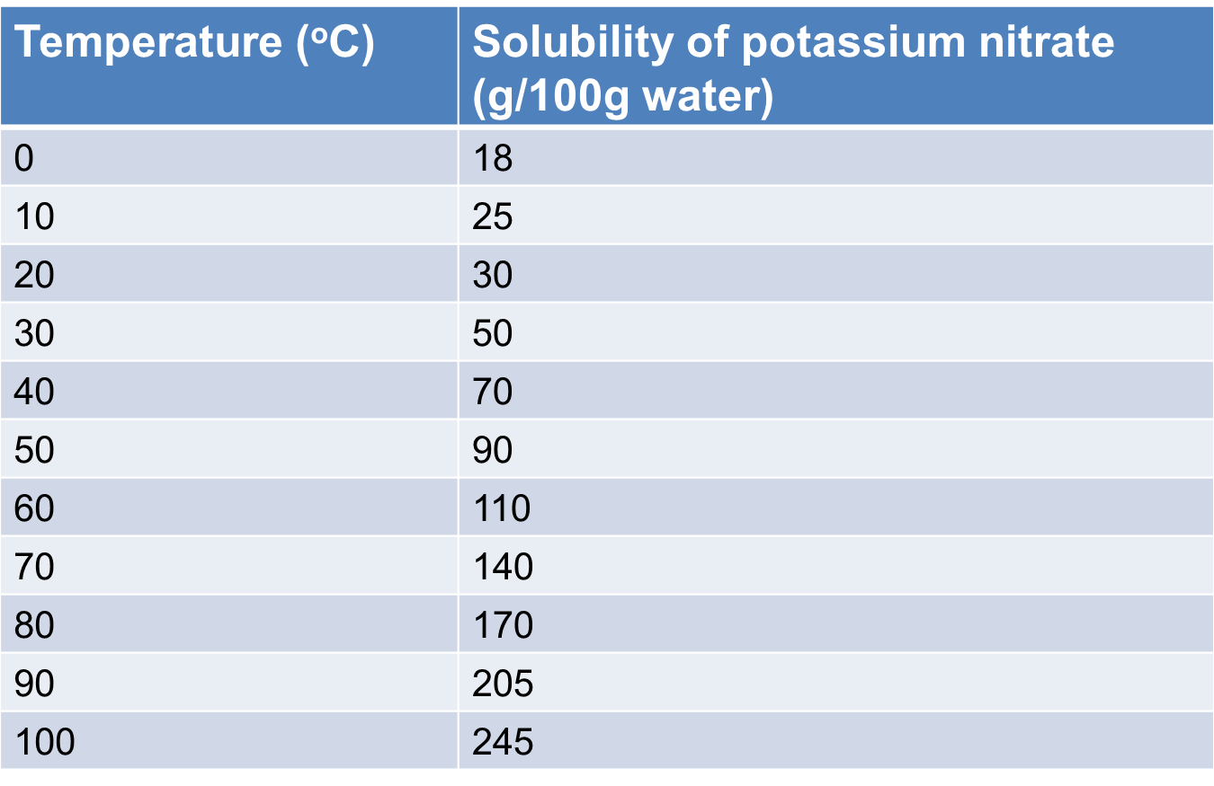

(b) (i) What is the solubility of potassium nitrate at 45⁰C?
(ii) What is the solubility of potassium nitrate at 85⁰C?

(iii) At what temperature will the solubility of potassium nitrate be 100g/100g of water?

(iv) At what temperature will the solubility of potassium nitrate be 150g/100g of water?

(v) What is the effect of temperature on the solubility of potassium nitrate?

