COSTAATT
CHEM092 – Introduction to Concepts in Chemistry II
Lesson 12 – Worksheet

1. What are organic compounds containing the –OH group called?
(A) esters (B) alkalis (C) carboxylic acids (D) alcohols

2. What are organic compounds containing the –COOH group called?
(A) esters (B) alkalis (C) carboxylic acids (D) alcohols

3.(a) What do you understand by the term structural isomerism?
(b) There are two structural isomers of C₄H₁₀. Draw their structures and name them.
(c) There are five structural isomers of C₆H₁₄. Draw their structures and name them.

4. Give the name of each compound shown below.
(a) (b)
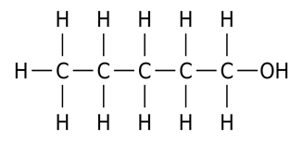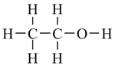

(c) (d)
