COSTAATT
CHEM092 – Introduction to Concepts in Chemistry II
Lesson 11 – Homework

1. How many bonds can a carbon atom form with other atoms?

2. Explain the difference between a saturated and an unsaturated hydrocarbon.

3. Define the terms functional group and homologous series.

4. Give the molecular formula for each organic compound shown below.
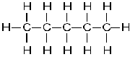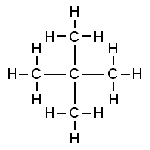

5. Draw the fully displayed formula and write the names of the following hydrocarbons:
(i) CH₄ (ii) CH₃CH₂CH₃ (iii) C₅H₁₂ (iv) CH₃CH=CH₂
(v) C₂H₄ (vi) CH₂=CHCH₂CH₃

6. Write fully displayed formulae (showing all the bonds) for:
(i) butane (ii) ethane (iii) but-2-ene (iii)hex-3-ene

