COSTAATT
CHEM111 –Concepts in Chemistry I
Lesson 10 – Worksheet

1. (a) Write displayed formulae for butane and hexane.
(b) Write displayed formulae for but-1-ene and hex-1-ene.

2. (a) Alkanes are saturated hydrocarbons. What do you understand by the term saturated?
(b) Undecane is an alkane with 11 carbon atoms.
(i) Write down the molecular formula for undecane.
(ii) Write the fully displayed formula (showing all the bonds) for undecane.

3. X is an alkane with 5 carbon atoms.
(a) Write down the molecular formula for X.
(b) Write a fully displayed formula (showing all the bonds) for X.

4. Y is an alkene with 7 carbon atoms.
(a) Write down the molecular formula for Y.
(b) Write a fully displayed formula (showing all the bonds) for Y.

5. Give the molecular formula for each organic compound shown below.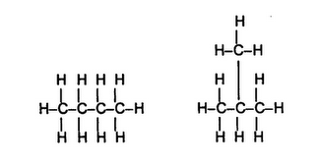
6. What are organic compounds containing the –OH group called?
(A) esters (B) alkalis (C) carboxylic acids (D) alcohols

7. What are organic compounds containing the –COOH group called?
(A) esters (B) alkalis (C) carboxylic acids (D) alcohols

8. (a) What do you understand by the term structural isomerism?
(b) There are two structural isomers of C₄H₁₀. Draw their structures and name them.
(c) There are five structural isomers of C₆H₁₄. Draw their structures and name them.

9. Give the name of each compound shown below.
(a) (b)
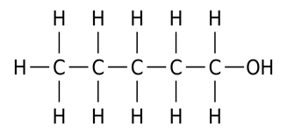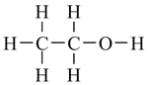

(c) (d)
