CHEM 210: Analytical Chemistry
IR SPECTROSCOPY QUESTIONS
1. You are given a series of organic samples A, B, and C. You are told that one compound is methanol, CH₃OH, another is cyclohexane, C₆H₁₂, and the third is octanal, C₈H₁₆O. You are to identify A, B, and C using the IR spectra. Justify your choices by telling what band was used to verify the identities, and which functional group produced the band.
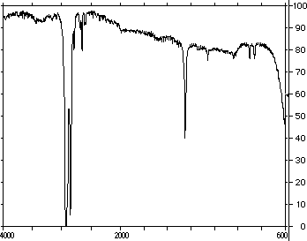A
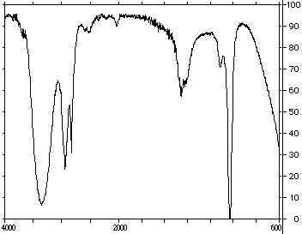B

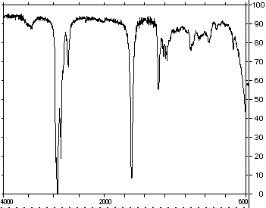C

2. You have the IR spectra for an organic liquid that was found on the clothes of a criminal defendant. The crime scene was heavily contaminated with a mixture of hydrocarbons, but there were no ketones, aldehydes, acids or alcohols present. Is the defendant's clothing contaminated with a hydrocarbon? Would this spectral evidence put the suspect at the crime scene? Justify your answer using IR functional group information.
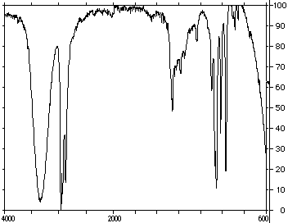

3. Assign the following molecules to the IR spectra A-E below. Justify your assignments.
