COSTAATT
CHEM 092
Final Revision Worksheet
Lecturer: Ms. Romona Olton
Student Name:______________________________________

SECTION A – Multiple Choice

1. What is the mass of calcium in 100g of calcium carbonate, CaCO₃?
(Relative Atomic masses: Ca = 40; C = 12; O = 16)

(A) 40g (B) 20g (C) 12g (D) 100g

2. Calculate the relative formula mass of iron(III) oxide, Fe₂O₃.
(Relative Atomic masses: Fe = 56; O = 16)

(A) 128 (B) 104 (C) 72 (D) 160

3. Calculate the percentage of aluminium in aluminium oxide, Al₂O₃.
(Relative Atomic masses: Al = 27; O = 16)

(A) 62.8% (B) 26.5% (C) 52.9% (D) 42.9%

4. Metal ions always have a charge that is:
(A) Negative (B) Neutral (C) Positive (D) Variable

5. A big number 3 in front of a formula means:
(A) the same as a small number 3
(B) you multiply the formula by 3
(C) you must add 3
(D) you only multiply the atom next to the number 3 by 3

6. The formula CaCO₃ means:
(A) three atoms of everything
(B) three carbon atoms and three oxygen atoms
(C) one calcium atom, one carbon atom and three oxygen atoms
(D) a bracket is missing

7. The equation below represents the reaction of sodium metal with water.
Magnesium + Water → Magnesium hydroxide + Hydrogen

Which of the following chemical equations represents a complete balanced chemical
equation for the given word equation?

(A) 2Mg_{(s)} + 2H₂O_{(l)} → Mg₂(OH)_{2(aq)} + H_{2(g)}

(B) Mg_{(s)} + 2H₂O_{(l)} → Mg(OH)_{2(aq)} + H_{2(g)}

(C) 2Mg_{(s)} + 2H₂O_{(l)} → 2MgOH_{(aq)} + 2H_{2(g)}

(D) Mg_{(s)} + H₂O_{(l)} → MgO_{(aq)} + H_{2(g)}

8. Ferric oxide reacts with aluminum to produce aluminum oxide and iron. The balanced
chemical equation for the given reaction is:
Fe₂O₃ + 2Al → Al₂O₃ + 2Fe
Which of the following substances is reduced in the given reaction?
(A) Al₂O₃ (B) Fe₂O₃ (C) Al (D) Fe

9. White silver chloride changes to grey in sunlight because of the formation of silver
metal along with the evolution of chlorine gas. Identify the chemical equation that
gives a correct representation of the process.
(A) 2AgCl → 2Ag + Cl₂ (B) AgCl → Ag + Cl₂
(C) 2Ag + Cl₂ → 2AgCl (D) Ag + Cl₂ → 2AgCl

10. What is the colour of litmus in alkali?
(A) red
(B) green
(C) colourless
(D) blue

11. Which of the following is a property of all nitrates?
(A) They are soluble
(B) They are coloured
(C) They are insoluble
(D) They are hydrated

12. When copper oxide is treated with hydrogen gas copper is produced along with water.
The balanced chemical equation for the given reaction is:
CuO + H₂ → Cu + H₂O
Which substance is oxidized in the given reaction?
(A) H₂ (B) Cu (C) H₂O (D) CuO

13. What is it called when one compound breaks down into two or more compounds?
(A) Displacement
(B) Synthesis
(C) Decomposition
(D) Neutralization

14. What is the balanced chemical equation for the reaction of nitrogen with hydrogen to produce
ammonia gas?
(A) N_{2(g)} + H_{2(g)} → 2NH_{3(g)} (B) 2N_{2(g)} + H_{2(g)} → 2NH_{3(g)}
(C) N_{2(g)} + 3H_{2(g)} → 2NH_{3(g)} (D) 2N_{2(g)} + H_{2(g)} → 2NH_{3(g)}

15. In which reaction is sulphur dioxide acting as an oxidising agent?
(A) SO₂ + 2H₂O + Cl₂ → H₂SO₄ + 2HCl
(B) SO₂ + 2NaOH → Na₂SO₃ + H₂O
(C) 2SO₂ + O₂ → 2SO₃
(D) SO₂ + 2H₂S → 2H₂O + 3S

16. Which of the following reactions represents a combination reaction?
(A) CaO_{(s)} + H₂O_{(g)} → Ca(OH)_{2(aq)} (B) CaCO_{3(s)} → CaO_{(s)} + CO_{2(g)}
(C) Zn_{(s)} + CuSO_{4(aq)} → ZnSO_{4(aq)} + Cu_{(s)} (D) 2FeSO_{4(s)} → Fe₂O_{3(s)} + SO_{2(g)} + SO_{3(g)}
17. Which of the following reactions represents a double displacement reaction?
(A) BaCl_{2(aq)} + Na₂SO_{4(aq)} → BaSO_{4(s)} + 2NaCl_{(aq)}
(B) 2FeSO_{4(s)} → Fe₂O_{3(s)} + SO_{2(g)} + SO_{3(g)}
(C) 2Pb(NO₃)_{2(g)} → 2PbO_{(s)} + 4NO_{2(g)} + O_{2(g)}
(D) Zn_{(s)} + 2AgNO_{3(aq)} → Zn(NO₃)_{2(aq)} + 2Ag_{(s)}

18. What is the general formula for an alkane?
(A) C_{n}H_{2n+2} (B) C_{n}H_{2n} (C) C_{n}H_{2n+4} (D) C_{n}H_{3n}

19. What is the name of the straight chain alkane containing six carbon atoms?
(A) sextane (B) hexane
(C) pentane (D) heptane

20. What is the name of the organic compound shown below?
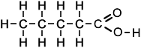
(A) Pentanoic acid
(B) Butanoic acid
(C) Propanoic acid
(D) Hexanoic acid

21. What is the functional group in the compound shown below?
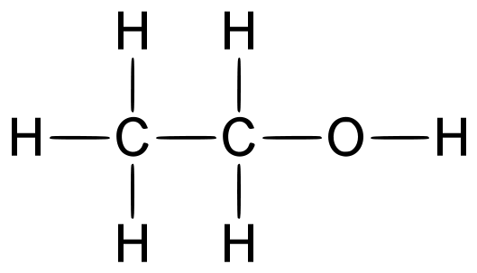
(A) Ethanol
(B) Hydroxyl
(C) C_{n}H_{2n+1}OH
(D) Homologous series
22. Which electrode would a positive ion be attracted to?

(A) The anode
(B) The cathode
(C) The top electrode
(D) The bottom electrode

23. Which of the following numbers represents an alkaline pH?

(A) 1 (B) 7 (C) 5 (D) 11
24. What is the most abundant gas in the atmosphere?

(A) oxygen
(B) nitrogen
(C) carbon dioxide
(D) water vapour

25. Given the redox reaction:
2I⁻(aq) + Br₂(l) -> 2Br⁻(aq) + I₂(s)
What occurs during this reaction?
(A) The I⁻ ion is oxidized, and its oxidation number increases.
(B) The I⁻ ion is oxidized, and its oxidation number decreases.
(C) The I⁻ ion is reduced, and its oxidation number increases.
(D) The I⁻ ion is reduced, and its oxidation number decreases.

(25 Marks)

SECTION B – Structured Questions
1. Athletes sometimes take drugs because the drugs improve their performance.
(a) One of these drugs is ephedrine. Ephedrine has the formula:

C₁₀H₁₅NO

Calculate the relative formula mass of ephedrine. Show clearly how you work out your answer.
Relative atomic masses: H = 1; C = 12; N = 14; O = 16. 165
______________________________________________________________________________
______________________________________________________________________________
______________________________________________________________________________
(2 Marks)
(b) Another drug is amphetamine which has the formula:
C₉H₁₃N
The relative molecular mass (Mr) of amphetamine is 135.
Calculate the percentage by mass of nitrogen in amphetamine.
(Relative atomic mass: N = 14) 10.37%
______________________________________________________________________________
______________________________________________________________________________
______________________________________________________________________________
(3 Marks)
(c) In an experiment a chemist calculated that the maximum yield of amphetamine is 200g.The chemist did the experiment but only made 120g of amphetamine.
Calculate the percentage yield of amphetamine for this experiment. 60%
______________________________________________________________________________
______________________________________________________________________________
______________________________________________________________________________
(3 Marks)

2. Use oxidation numbers to determine if the following reactions are redox reactions.
If they are redox reactions, give the reactant which has been oxidised and the reactant which has been reduced:
(a) 2KI_{(aq)} + Cl_{2(g)} → 2KCl_{(aq)} + I_{2(aq)}

2K⁺(aq) + 2I⁻(aq) + Cl_{2(g)} → 2K⁺(aq) + 2Cl⁻(aq) + I_{2(aq)}

2I⁻(aq) + Cl_{2(g)} → 2Cl⁻(aq) + I_{2(aq)}

I: moving from -1 to 0, therefore it is oxidised
Cl: moving from 0 to -1, therefore it is reduced
Since both oxidation and reduction are taking place this is a redox reaction.

(b) 2Fe_{(s)} + 3Cl_{2(g)} → 2FeCl_{3(s)}

2Fe(s) + 3Cl₂(g) → 2Fe³⁺(s) + 6Cl⁻(s)
Fe: moving from 0 to +3, therefore it is oxidised
Cl: moving from 0 to -1, therefore it is reduced
Since both oxidation and reduction are taking place this is a redox reaction

(c) FeCl_{2(aq)} + (NH₄)₂S_{(aq)} → FeS_{(s)} + 2NH₄Cl_{(aq)}

Fe²⁺(aq) + 2Cl⁻(aq) + 2NH⁴⁺(aq) + S²⁻(aq) → Fe²⁺(s) + S²⁻(aq) + 2NH⁴⁺(aq) + 2Cl⁻(aq)
All of the ions are spectator ions, therefore this is not a redox reaction

(d) BaCl_{2(aq)} + H₂SO_{4(aq)} → BaSO_{4(s)} + 2HCl_{(aq)}

Ba²⁺(aq) + 2Cl⁻(aq) + 2H⁺(aq) + SO₄²⁻(aq) → Ba²⁺(aq) + SO₄²⁻(aq) + 2H⁺(aq) + 2Cl⁻(aq)
All of the ions are spectator ions, therefore this is not a redox reaction

(8 Marks)
3. In each of the following reactions give the reducing and the oxidising agents:
(a) 2Fe₂O_{3(s)} + 3C_{(s)} → 3CO_{2(g)} + 4Fe_{(s)}
Fe₂O₃ : loses oxygen, therefore it is reduced, therefore it is the oxidising agent
C: gains oxygen, therefore it is oxidised, therefore it is the reducing agent

(b) 2NO_{(g)} + 2CO_{(g)} → N_{2(g)} + 2CO_{2(g)}
NO: loses oxygen, therefore it is reduced, therefore it is the oxidising agent
CO: gains oxygen, therefore it is oxidised, therefore it is the reducing agent

(c) Zn_{(s)} + 2HCl_{(aq)} → ZnCl_{2(aq)} + H_{2(g)}
Oxygen does not appear in the equation, therefore we need to write the ionic equation.

Zn(s) + 2H⁺(aq) + 2Cl⁻(aq) → Zn²⁺(aq) + 2Cl⁻(aq) + H₂(g)
Zn(s) + 2H⁺(aq) → Zn²⁺(aq) + H₂(g)

Zn: moving from 0 to +2, therefore it is oxidised, therefore it is the reducing agent
H: moving from +1 to 0, therefore it is reduced, therefore it is the oxidising agent

(6 Marks)

4. Concentrated sodium chloride is electrolysed using the apparatus shown below.
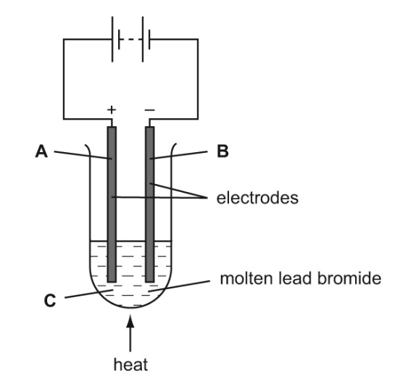
Concentrated sodium chloride solution

- Which letter, A, B or C represents the cathode?
B
(3 Marks)
(b) Which letter, A, B or C represents the anode?
A
(3 Marks)
(c) Give a non-metal which can be used for the electrodes.
Carbon or graphite
(3 Marks)
5. (a) Draw the fully displayed formula and write the names of the following hydrocarbons:
(i) CH₃CH₂CH₂OH
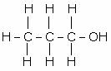
Propanol
(ii) CH₃CH₂CH₂ CH₂CH₂CH₂CH₃
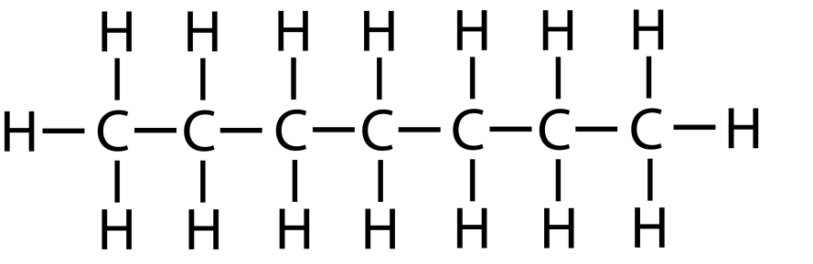
Heptane
(iii) CH₃CH₂CH₂CH₂CH₂CH=CH₂

Hept-1-ene
(iv) CH₃OH
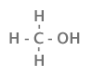
Methanol

(8 Marks)
(b) Look carefully at the four compounds in part (a). Which two belong to the same homologous series?
Propanol and Methanol
(1 Mark)
(c) What do you understand by the term ‘structural isomerism’?
Structural isomers are compounds with the same molecular formula but different structural formulae. (2 Marks)
(d) Draw and name a structural isomer of the compound shown in 5(a)(ii).
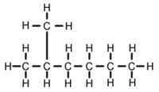
2-methyl hexane

(3 Marks)
Total = ______/ 70 = _________%

